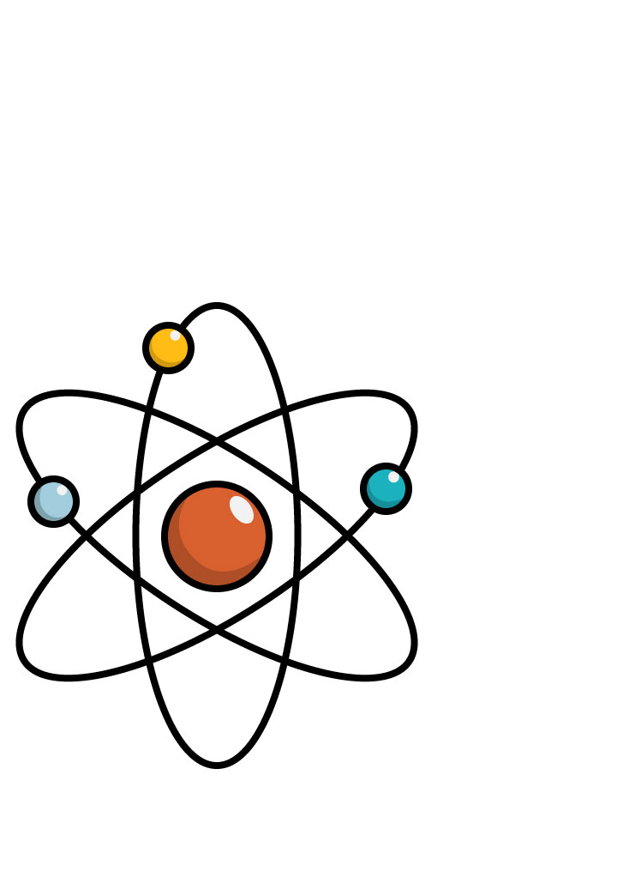
Q: Why can’t you trust an atom?

A: They make up everything.

