Name_____________________________ date___/___ LAB # ____
Partner________________________ Fine Motor Skills
You are going to build an electric motor. Read the instructions carefully! Look at the diagrams!
Get 66 cm of 20-gage magnet wire. This wire has an enamel insulation on it.
Also get a battery, scissors, a cup, 3 magnets, tape, 2 large paper clips, and 2 connector wires.
I. If you build it, it will run.
coils
battery
about 3 cm

3 cm

1. Get supplies from your teacher.
wrap ends around coil to hold it together
coil
2. Wrap the wire into a tight coil around the battery. Leave about 3 cm at the ends.
3. Remove coils from battery. Wrap ends of wire once around coil on opposite sides to hold coil together.
4. Lay the coil horizontally with the ends resting on two fingers. Adjust the coils until they “balance.”
Coil must lay balance horizontally:
finger
finger
coil

***Good balance is VERY IMPORTANT!!!
coil
With coil held
VERTICALLY,
scrape ONLY
THE TOP HALF.
Do NOT scrape
the lower half
Scrape ALL the enamel off of this end only:
5. Use scissors to scrape ALL of the enamel off of one of the ends only. All of the way from the coil to the end. Current cannot flow through the enamel.
6. Next, hold the coil vertically as shown at right.
Scrape the enamel off of only the upper half of the end that was not scraped before.
--> Scrape all the way from the coil to the end.
7. Afterwards, re-check the balance!
8. See diagram at right.
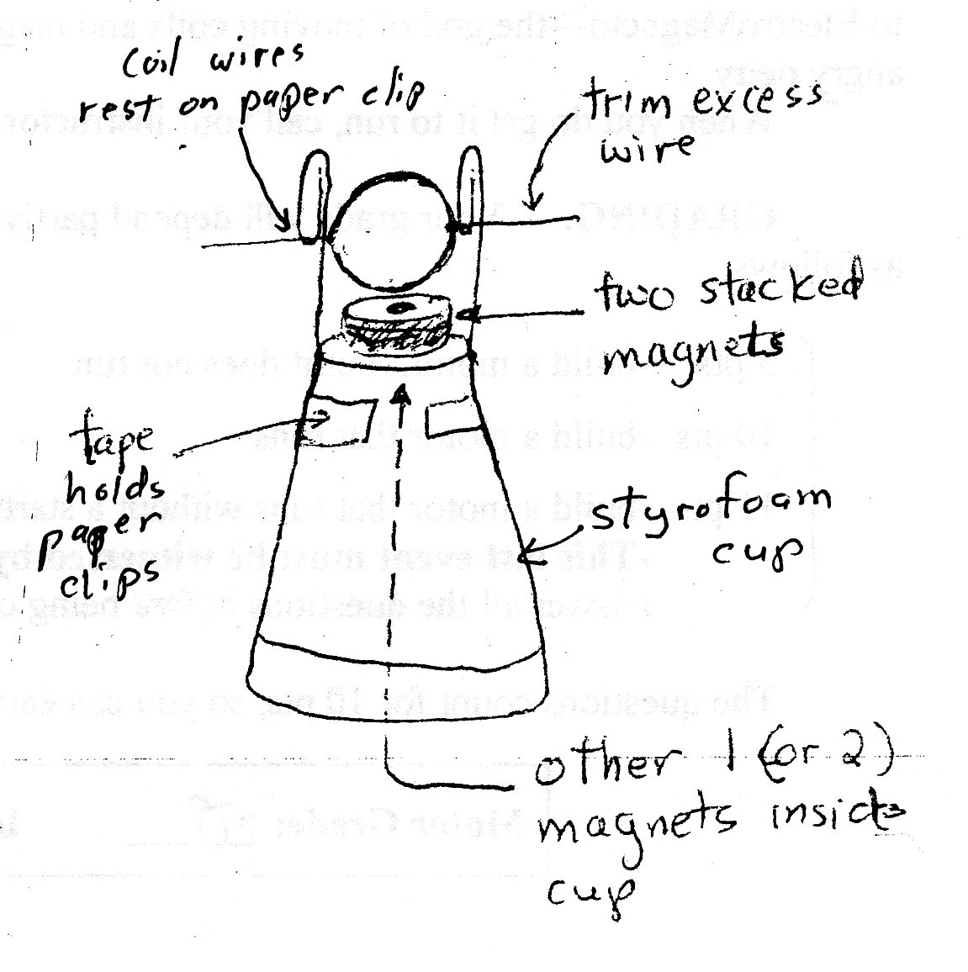
Turn cup upside down. Stack 2 magnets on top of the cup bottom. Place other magnet inside cup beneath.
Put battery in here:
Bend paper clips to form supports for your coil. Tape the paper clips to the side of the cups. The paper clips need to be vertical and parallel to each other!
coil axis must
be horizontal.

9. Place the ends of coil in the paper clips.
Adjust the paper clips so that:
A) the coil axis is horizontal, and
B) the coil just clears the top magnet if you spin the coil.
The coil must be able to spin freely and easily.
wire
connector

10. Connect one end of each wire connecter to the bottom of a paper clip.
11. Connect the other end to either side of a battery.
12. Gently spin the coil of your motor one way or the other. Your motor should continue to spin. If it does, call your instructor to sign your paper on the back.
If it doesn’t, work through the list below. Fix each problem and try again. Be patient.
wire
connector
II. If it does not work, do this:
1) Scrape the enamel more. Scrape harder. Current cannot flow through the enamel.
A) Scrape all the way around on the one end of the coil.
B) Scrape on the top half of the other end. It helps to scrape slightly more than just the top half.
C) Scrape from the end all the way down to the coil.
2) Balance the coil better.
3) Lower the paper clips so that the coil is as close as possible to the magnets when it spins.
4) The paper clips must be vertical. The coil axis must be horizontal. The coil must turn freely.
III. GRADING: Your motor score is determined as follows. The questions below are worth 20 points, so you can still get a 90 even if you tried but your motor does not work.
Motor grade: _____
Instructor initials: _____
0 pts - Did nothing, wandered around, socialized, left the room, etc.
12 pts - Followed instructions to build motor, but it does not work. Must be built properly.
15 pts - Built a motor that runs. Instructor must witness.
Your teacher will collect your coil when you are done. Return supplies. Clean up your area.
Do the Analysis to earn the rest of your points.
IV. Analysis.
The diagrams below show the coil in two positions above the magnet: Initial and Half Turn Later
Each of these has 2 views: ¾ View and Side View.
To easily understand how it works, imagine your coil is rectangular. The ideas are the same.
Also, the I in the ¾ view is shown as v in the Side View. This is the direction of positive current.
Initial Position:
¾ View:
Side View:
N magnet
N magnet
axis
I
I
v
x
v
axis
Half
Turn
Later:
¾ View:
Side View:
N magnet
N magnet
axis
I
I
v
x
v
axis

B
1. Assume the top of your magnet is a N pole as shown. This means that B will be UP at the coil:
A) Look at the Side View of the Initial Position. What direction is the v in the bottom of the coil?
B) B is up. Use the 3rd RH rule to determine the direction of the magnetic force F on this current.
On the Side View, draw this F as an arrow that acts on the bottom of the coil.
C) Likewise, determine the direction of the F on the v in the top of the coil. Draw it on the diagram also.
D) Circle the answer: Both these forces tend to turn the coil (CW/CCW).
2. Now look at the Side View of the Half Turn Later. The coil has turned around 180⁰.
A) What is different about the I’s and v’s compared to the Initial Position?
B) Use the 3rd RH rule to determine the direction of the F acting on the v in the bottom of the coil now.
On the Side View, draw this F as an arrow that acts on the bottom of the coil.
C) Repeat this to find the direction of F on the v in the top of the coil. Draw it on the diagram also.
D) Circle the answer: Both these forces tend to turn the coil (CW/CCW).
3. Your answers to Questions 1.D) and 2.D) should be opposite. If this were true for your coil, it would be pushed in opposite directions every half turn! To prevent this, the current turns off every ½ turn. What did you do in building the motor that makes this happen?

4. If you finish everything, you may continue to improve your motor. If you can get it to start and run from rest by simply connecting the battery—without a starting push or table bump—you will earn 2 extra points.
This last event MUST BE WITNESSED by your instructor to receive credit.

