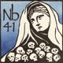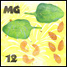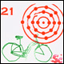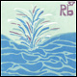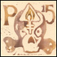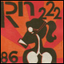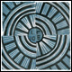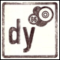

MMSTC Periodic Table Tissue Box Project

- In honor of the National Chemistry week and the anniversary of the periodic table, we are going to create an artistic tribute to the periodic table. Everyone will be assigned an atomic number. This is your assigned element for this project. 2022 Periodic Table Project Student List . Projects completed using the wrong element will receive a zero.

Objective:
Materials:
- Square Tissue Box (not used – it should have tissues in it)
- Paper. Pens, markers, crayons, colored pencils, etc. to decorate
- If you would like to type certain elements and print out graphics you may.

Directions and requirements: Create a representation of your element using the following information. You will need to research your element for inspiration. Cut paper and glue to each side of the box. Place your name and hour on the BOTTOM.

Orientate yourself: Square 5 x 5 x 4.5 FULL tissue box provided by student
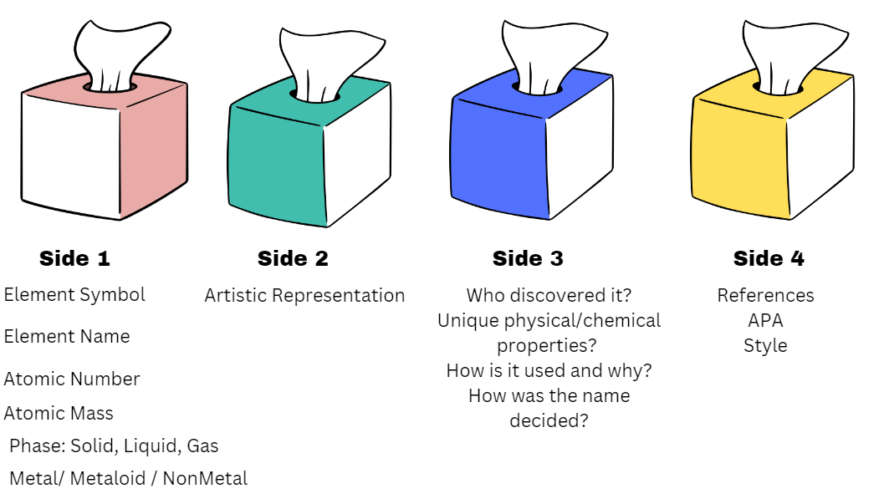

The viewer should be actively engaged with your dynamic project. Include multiple mediums (photos, maps, and diagrams). The internet is your oyster, use it to make something really interesting.

Name :________________________Class:_____________

ELEMENT:__________________________________

MMSTC Periodic Table Tissue Box Project Rubric

/10 | Side 1:  Element symbol  Element Name  Atomic number  Phase  Metal, nonmetal, metalloid
/10 | Side 2:  Artistic Representation  Color, meaning in choice of representation demonstrates research into the history, uses, application, name, discovery of the element.
/10 | Side 3:  Who discovered it?  Unique physical/chemical properties?  How is it used and why?  How was the name decided?  Interesting facts/ information
/10 | Side 4:  References cited using APA 9
/10 | Overall details, presentation, creativity:  The finished project clearly follows all of the directions, demonstrates time, effort, proofreading, creativity, and solid overall understanding. Name and class are clearly written on the bottom of the box. The correct size box was used, rubric includes name, class and element name
TOTAL:

/50

*Adapted from J. Pillsbury, Adams High School, 2024

