Form and Function of Animal Bodies: Proportions

In nature, animals have to survive. It makes sense therefore, that the exact way the animal body is put together has a direct impact on the function of that body and by extension on behavior. For example, kangaroos will have a hard time RUNNING at full speed whereas horse are incapable of HOPPING on their two hind legs for more than two or three small hops.

Today we will look at the form (proportion) and function (behavior) relationship between the length of our legs in relationship to the length of our strides.
Is leg length (shape) related to stride-length (function, behavior)?
To answer this question, we will measure the leg length and stride length of humans. Later we will also measure leg length and stride length for horses and goats.
- There are two ways leg length can be measured for humans.
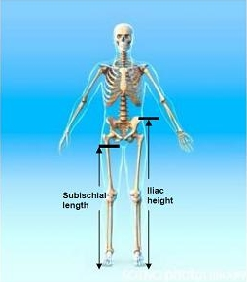  Stride length is measured as the distance from the base of one footprint to the base of the next footprint of that same foot; in other words, the distance of TWO steps. We will use Excel next week to help us calculate stride length. | For the human we will use the iliac height to make the measurement more comparable to leg length of the horse and goat.  - Measure RIGHT iliac leg length in cm on a flat surface with your shoes on. Record the data in column A on the data table.  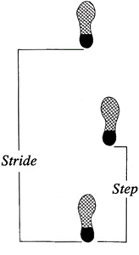

Measuring Leg Length in Horses
- We will do this outside on the cement to get more accurate measurements on a flat, hard surface. As the humans will be wearing shoes for this exercise, we will measure leg length including the shoes.

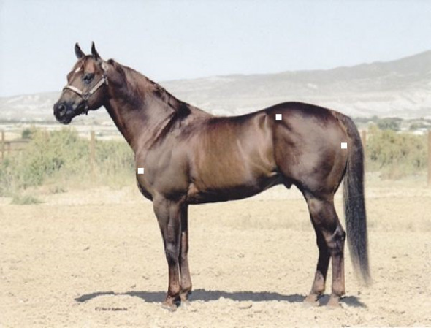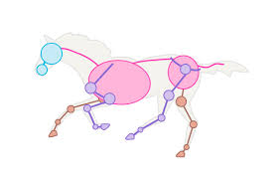
The black line indicates how to measure leg length for a horse in two sections – though we will be using the animal’s right hind leg (the picture shows the left hind leg). Add the two values to get leg length.

Protocol

- Measure and mark off a distance of 20 meters (= 2000 cm).
- Walk the length while counting each step (record in column B). For the horses we will count each step with each hind foot.
- Trot/Jog the length while counting each step (record in column C). For horses we will count each step with each hind foot.

Name of human | A  Right Leg Length  cm | B  # of steps in 2000 cm (20 m)  walk | C  # of steps in 2000 cm (20 m)  trot
You

- Everyone will enter their data into a spreadsheet so we can graph it.
Name of horse | A  Leg Length  in cm | B  # of steps in 2000 cm (20 m)  Walk | C  # of steps in 2000 cm (20 m)  Trot

