Candy Container Package Design Project

You and your partner for a graphic design firm and have been asked by a newly established candy manufacturer to design a new package for their candy products. They consider themselves to be innovative, bold, and creative and want something that reflects this. The company wants to something beyond the traditional “rectangle or square” box shape and the primary colors that will appeal to children. You will be creating a new package design utilizing your knowledge of the design process (7 steps), design elements and art principles, typography, and hierarchy. You will be creating a three-dimensional model of your package and a die-line template. We will build your package and put it to the test. If you impress the manufacturer with your design, they will give you a contract to design more packaging for them. Say hello to a promotion!

*Create a folder on your Google Drive titled Graphic Design Candy Box Project. Within the folder, create individual folders for each of the 7 steps of the design process. This is where you will place the components you create for each step in the project. It will make it easy for you to find, as well as easier for me to grade because it will all be in one place. I will be grading each stage individually and then at the end, the points will be added up for one letter grade.

Work you will do with your partners:

Step 1/2: Create a product brief. REMEMBER- the more specific you can be in these first two stages, the better your final result will be. Problems usually occur later on as a result of poor planning.

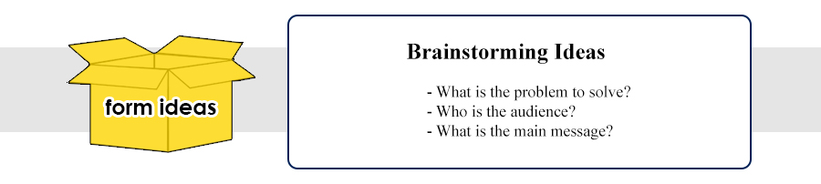
In this stage, you should aim to know what the product looks like, feels like, tastes like (only if applicable), its purpose, and the most important element: what emotions should/does it evoke in the target demographic.

Your package brief should answer the following questions:
  - What is the problem you are trying to solve?
  - Who is your target audience (sex, age, income, geography)?
  - The customer profile will give you an indication as to how to actually design the package – shape, how to seal/open package, colors, type, language, etc.
  - What is the main message the package is trying to convey?
  - What emotion do you want your package to convey?

Packaging Requirements- what is the function of the packaging besides to market the product?
What is the client willing to spend on each package? How many packages are being produced and where will they be produced?

With your partner, decide who will be responsible for each task and set a deadline for when it needs to be done. You will have around two weeks to finish this assignment. There will be some steps where each partner will need to create a few designs or create a 3-D version of their project before you design one design together with your partner.

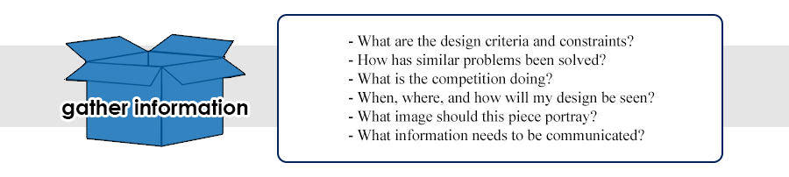
Step 3: Research
Remember that your package design must not only attract attention, encourage the consumer to pick the product up off the shelf and look at it, tell the brand’s story, and convince the consumer to make a purchase.
The purpose of this stage is to ensure that you win both of your battles. It pays to do your research!

The following questions need to be answered in this stage:
What is my competition doing in terms of packaging?
When, where, and how will my design be seen?
What is the style of the package—minimalist, chic, fun and whimsical?
What materials will work best for your package?
What are the visual deliverables that need to be on the package? Ex: logo, professional photos, graphics, guidelines?
What order should our visual deliverables appear? Text on top, graphic in middle, text or graphic followed by text.
What color palette is most appropriate for my design and will help convey my message?
What shape is most appropriate for your package?
How can I make my design environmentally sound and only use what I need?

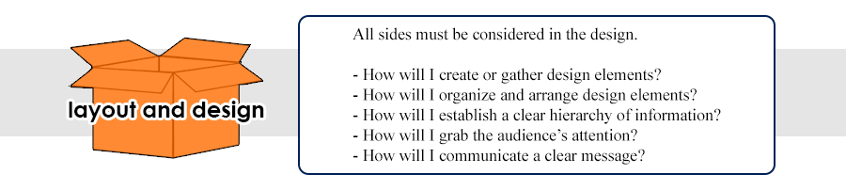

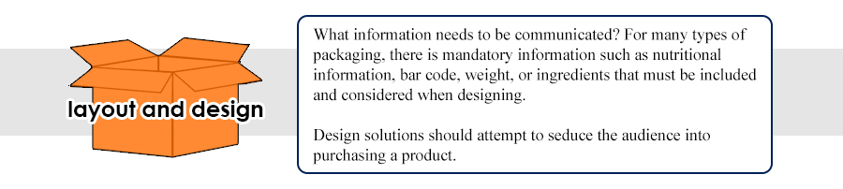

Step 4: Concept Development - * In this stage, don’t focus on the specifics, but on your options for color palettes, package shape, graphic/images, types of material you can use.

- Create 3 thumbnail sketches of potential package designs on paper. Each partner needs to have 3 different design ideas. You will need to design all sides. Be sure to consider the following questions when creating your designs.
- Where are you going to place the logo? You will have to create the logo and the slogan.
- How can you use design to make an emotional connection?
- What shape should your package be? It cannot be a square or rectangle. Think OUTSIDE the box! ;)
- Select your package colors- Color is 85% the reason why someone will purchase a product.
- Select a font or two fonts to create contrast. Remember that there should be a balance between visual appeal and legibility.
- What images should be included on the package? Should it be an image of the product inside or a simple graphic or symbol? Are you going to have a window to allow them to view the contents?
- Are there any brand or product guidelines you should be following? Ex: nutritional information, ingredients, barcode, country of origin or manufacturer, weight. You will need to look up what information is required on a package and placement (if applicable) to have for a candy/ food product.
** Out of your 3 designs and your partner’s 3 designs (total of 6), select a design that you would like to do as your final package design. Try to make minor revisions to it to incorporate elements from both of your designs into the final package design.
You will need to pick a design and reach a consensus on name, logo, shape, font, and colors before moving to the next phase.

*You will create a 3-D model of your final design shape in the program, Sketch-up. This will help you view your package design from 360 degrees and get your measurements and dimensions down before we create the die-line. Each partner will need to complete this step. Save your Sketch-up design in your Candy Box folder labeled Step 4: Concept Development.

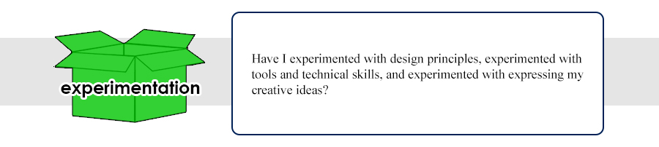

Step 5: Refinement: Make minor revisions and polish your design for the last time. You will need to ensure the following are carefully considered before moving to step 6:
Structural dimensions
Shapes of the letterforms, ensuring that they are balance and spaced
Layout and positioning of copy and images
Colors and graphics are reviewed
Copy is proofread and error-free
All legal and regulatory requirements are met and guidelines are followed
Would your design stand out among competitors when placed on a shelf?
Does your package create an emotional connection?
Does your packaged convey the intended message?

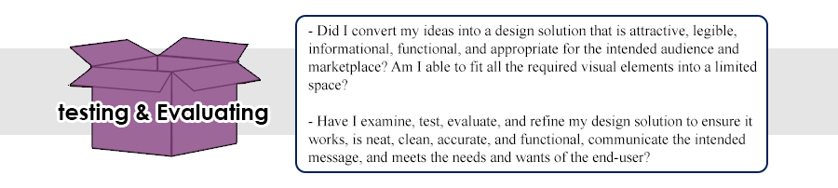
Step 6: Creating the Die-line
The die-line is a flat diagram of the packaging conveying the shape and structural specifications that include: folds, cut lines, seams, creases, overlaps, and cut lines. This is what would use as template to prepare and print our packages for actual production. (We will be printing our design out and gluing it to our final packaging since our printers cannot print on materials other than paper). These die-lines would then be assembled by a person or a machine---cutting on the cut line and folding/creasing, etc. using the markings. Miss Kupferschmid will show you how to create this die-line template in Adobe Illustrator.

Step 7 Finished Art
This is the final stage in the design process where your package design becomes a reality. Your artwork has been revised and approved for the last time. Your die-lines are ready to be sent to the printed to be printed with your designs. During this phase, considerations are taken for the print settings and finishes. We will print your die-line and trace it onto the cardboard to make it sturdy, so you have something to put your treats in. You will then actually cut on the cut lines and fold on the fold lines you have made on your die-line and seal it to actually create your package. Since we are unable to actually print your design on the cardboard, we will print out all of your sides and glue them on to your final product.

Stage 7.5 Fill your package with sweet treats and ENJOY! The reward for your hard work!

Example:
Here is an example of a candy box that includes information on all sides of the object. You will need have something on each side of your package that is visible to the customer. This example also provides you with an example of the front of the box that non only contains text, but also a graphic and a pattern to help convey the theme. 