Lesson 4: Answer Key 4

Field Visualization Key

Part 1
The criteria included in the following rubric applies to students’ answers in Static Field Visualization, Arrows and Line Field Visualization, and Full Field Visualization.
For all visualizations | 1. What do you notice changing at each position (A, B, C, D, E) as electron 1 moves?  2. From A to E, do you see energy transferring, increasing, or decreasing? What evidence does this visualization provide to support your idea?  3. In this visualization, what is unclear about how the antenna causes energy to transfer from A to B? B to C? C to D and E?  4. Change the “Transmitter Movement” to “Manual” so the electron stops moving. What changes do you notice?
  A | B | C | D | E
  Electron 1 moves | (see table below) | (see table below) | (see table below) | Electron 2 moves
   | Foundational Pieces | Linked Understanding | Organized Understanding
  3D elements | Look for:  Describe changes in energy transfer using evidence about visible changes in the motion of electrons. (SEP: 2.4; CCC: 1.5) | Look for:  Use evidence from the simulation about changing patterns in magnitude and/or direction of electric fields and the motion of electrons to describe changes in energy transfer from the antenna. (SEP: 2.4; CCC: 1.5; DCI: PS4.B) | Look for:  Use evidence from the simulation about changing patterns in magnitude and direction to describe the patterns of changing electric fields as energy transfers from the antenna. (SEP: 2.4; CCC: 1.5; DCI: PS4.B)  AND  Use evidence from the simulation about the motion of electrons and the magnitude of forces over distance to suggest mechanisms that account for the damping of energy transferred from the transmitting antenna. (SEP: 2.4; CCC: 1.5; DCI: PS4.B)
  Examples | Energy decreases because the second electron moves less than the first electron.  Energy transfers from A to E because if the first electron moves, the second electron moves, and moving is evidence of energy. | Energy decreases because the amplitude of the second electron is lower than the amplitude of the first electron.  Energy decreases because the forces are spreading as they move from B to C, to D. These forces transfer the energy to the second electron, making it move. | When energy transfers from one antenna to another, it decreases and increases at all locations, so the total energy decreases as the wave travels. You can see this by looking at the arrows--they get smaller as they travel farther, and the second antenna doesn't have as much energy as the first one did because the forces causing the second electron to move have a smaller amplitude.  There is damping from location to location as the forces move from the first to the second electron. This means the energy at E is lower compared to the energy at A.
  Feedback | Linking:  Suggest students describe changes in energy transfer within each location. | Organizing:  Suggest students describe patterns within each location, between two locations, and overall. | Extending:  Invite students to compare the behavior of this system to the Wave on a String system.
   | Foundational Pieces | Linked Understanding | Organized Understanding
  3D elements | Evaluate the models they used by describing the difficulty to explain some of the patterns observed within one location.  (SEP: 2.4; CCC: 1.5) | Evaluate the models they used by describing the difficulty to develop a cause and effect mechanism between observable changes in two adjacent parts of the system due to gaps in evidence.  (SEP: 2.4; CCC: 1.5, 2.2) | Evaluate the models they used by describing the lack of evidence to establish cause and effect relationships throughout the system using what we know about the behavior of electric fields and the relationship between matter and energy during energy transfer. (SEP: 2.4; CCC: 1.5, 2.2; DCI: PS4.B)
  Examples | The amplitude of the second electron is lower in E, but the visualization does not show why.  There are no visible changes between C and D, so it is hard to know what is happening. | The size of the arrows suggest a decrease in energy, but it is hard to know why the energy decreases.  There is a gap between the red line representing the field that extends all the way to the second electron, and the first electron (Arrows and Line Field Visualization). How can the electron change this field if there is a clear gap? | The force field decreases as you move away from the electron, so the electric field of the first electron should not be able to reach the second electron. The visualization does not show why the second electron moves when the first electron moves.  The force field starts moving away from the first electron, but it is not clear how it can travel (in the string, energy transfers through fields between particles; here, there is nothing in between the changing fields).
   | Linking:  Suggest students find evidence to explain the changes between patterns observed at two proximal locations (e.g., A-B, C-D). | Organizing:  Suggest students consider whether what we know about fields can explain the different behavior from static to moving electron. | Extending:  Ask students to consider how they could test whether electric fields need matter to transfer through space.
   | Foundational Pieces | Linked Understanding | Organized Understanding
  3D elements | Describe observable patterns in the system. (CCC: 1.5) | Connect observed patterns to cause and effect relationships between parts of the system. (CCC: 1.5, 2.2) | Describe a mechanism that connects changes in the fields to the observed patterns caused by the change in motion. (CCC: 1.5, 2.2; DCI: PS4.B)
   | The arrows move away from the first electron, and no new arrows are produced.  The arrows stop moving. | The second electron stops moving a bit after the first electron stops moving. This means that the second electron only moves when the first electron moves.  When the first arrow stops moving, the arrows stop radiating away from the antenna, and when there are no more arrows, the second electron stops moving. | The electric field around the first electron stops shifting directions and radiating. As long as the first electron is moving, the electric field that radiates will cause the second electron to move.  Forces radiate when the electron is moving, and stop radiating when the electron stops. These forces can cause the second electron to move.
   | Linking:  Suggest considering changes between two adjacent locations. | Organizing:  Suggest considering what we know about electric fields and forces to make sense of patterns we have observed. | Extending:  Ask students to consider the limitations of the simulation to help explain why the fields radiate only when the first electron moves.

Part 2
1. As a Jigsaw group, complete the table to summarize the changes in the system you observed at these locations:
 | A | B | C | D | E
1: Static Field Visualization | Electron 1  moves | Electric fields increase and decrease, and change directions along this space. | Nothing happens. | Nothing happens. | Electron 2  moves
2: Arrows and Line Radiated Field Visualization | Electron 1  moves | Electric fields increase and decrease, and change directions along this space. | Forces increase and decrease up and down like a wave. | Forces increase and decrease up and down like a wave. | Electron 2  moves
3: Full Radiated Field Visualization | Electron 1  moves | Electric fields increase and decrease, and change directions along this space. | Forces increase and decrease like a ripple. | Forces increase and decrease like a ripple. | Electron 2  moves

2. Based on your observations, what changes would you make in our consensus energy transfer model?

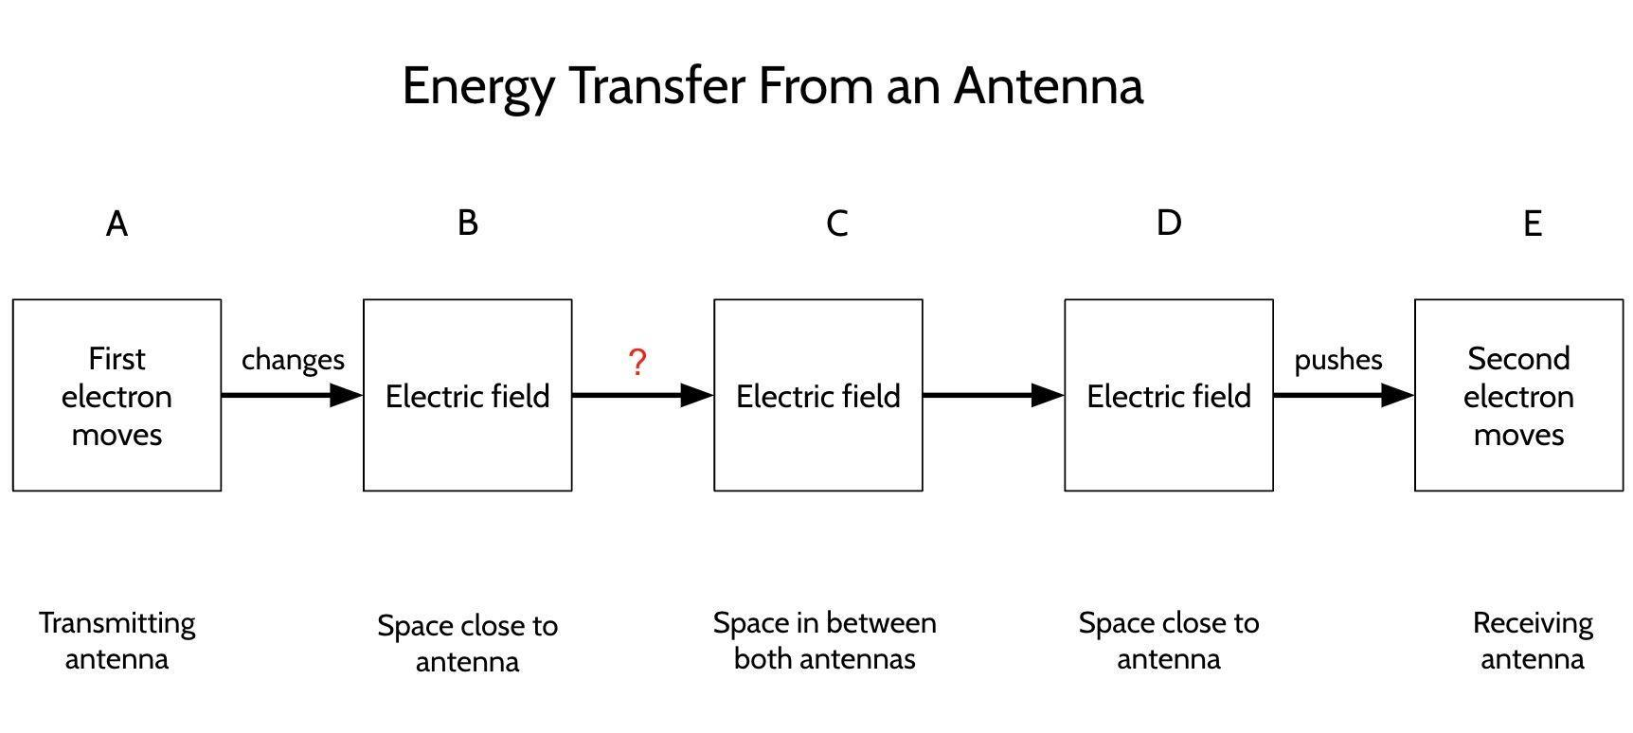

3. What differences did you notice between Visualizations 1-3 (1: static field, 2: arrows and line, 3: full field) when you stopped the electron? What conclusions can you make about “static fields” versus “radiated fields” from these observations?

- When moving the first electron, the static field moves along (not outward), but the second electron moves anyway. This means that forces to make the second electron move are transferred. This is shown by the radiated field visualizations. Something is transferring. Moving the electron causes the field to radiate.
- Electric fields radiate only when the first electron moves in the antenna.

4. What questions did the simulation raise for you and your Jigsaw group about how energy transfers from the antenna to distant electrons?

- Are there two types of electric field? One that moves away and one that moves along?
- Why does the field radiate only when the first electron moves?
- What are the flat lines that radiate in the Arrows and Line radiated visualization?
- What does this have to do with food in the microwave oven?
- How can they make sound with radio waves?
- Does a radio wave travel through matter like the other waves?

