Lesson 3: Answer Key

L3 Electronic Exit Ticket Key

This Electronic Exit Ticket addresses 3D elements associated with the lesson-level performance expectations (LLPEs) from Lesson 3. This assessment is designed to make it easy to gather information about where your students are still struggling to understand wave characteristics. The relevant LLPEs are:

3.A Plan and conduct an investigation to produce data to serve as evidence to support claims about how certain wave properties affect energy transfer in waves. (SEP: 3.2, 6.1; CCC: 5.2; DCI: PS3.A.4, PS4.A.1, PS4.B.1)

3.B Use algebraic techniques to develop a mathematical model to identify and test the relationship between frequency, wave speed, and wavelength. (SEP: 5.2, 5.3; CCC: 1.4; DCI: PS4.A.1)

The elements of these LLPEs assessed in this exit ticket are:

3D Elements Addressed in the Assessment | 1 | 2 | 3 | 4 | 5
5.3 Using Mathematics and Computational Thinking: Apply techniques of algebra and functions to represent and solve scientific and engineering problems. | X | X
5.2 Energy and Matter: Changes of energy and matter in a system can be described in terms of energy and matter flows into, out of, and within that system. |  |  | X | X | X
PS4.A.B Wave Properties: The wavelength and frequency of a wave are related to one another by the speed of travel of the wave, which depends on the type of wave and the medium through which it is passing. (HS-PS4-1) | X | X | X

We figured out that wave speed is related to wavelength and wave frequency by the equation: Speed = Wavelength x Frequency. We can apply this equation to any kind of wave, including seismic waves. During an earthquake, waves transfer energy deep under Earth’s surface. The speed at which they travel changes depending on the rigidity of the medium through which they are traveling. The table below shows the average peak velocities of P-type seismic waves in various natural materials during an earthquake:

Material | P-wave speed (m/s)
Granite | 5,900
Basalt | 6,400
Sandstone | 4,300
Limestone | 6,100

Question 1
Use the equation we developed in class to determine what will happen to the wavelength of the seismic waves as they move from a layer of basalt to a layer of sandstone.
A. The waves will get smaller (shorter wavelength).
B. The waves will get bigger (longer wavelength).
C. The wavelength of the waves will not change.
D. There is no way to predict the change in wavelength.
What to look for:
The correct answer is: The waves will get smaller (shorter wavelength).

What to do: Encourage students to revisit the poster we made today. Help them set up an algebraic equation to see that if the speed gets smaller, the wavelength must also get smaller.

Question 2
Seismologists used data to determine the frequency of P-waves at one seismic station during a small earthquake to be 8 Hz, with a wavelength of about 762.5 meters. Using the table above and the equation we developed in class, suggest a likely candidate for the material of Earth’s crust directly beneath the seismology station.
A. Granite
B. Basalt
C. Sandstone
D. Limestone
What to look for:
The correct answer is: The waves will get smaller (shorter wavelength). Students must solve for the speed of the wave using the equation above. They should get about 6,100 m/s, which matches limestone.

What to do: Encourage students to revisit the poster we made today. Help them set up an algebraic equation to solve for the speed of the wave.

The energy transferred by an earthquake determines the amount of destruction. The energy of a seismic wave is determined by its amplitude. The image below shows a seismograph from a real earthquake. The first waves to arrive are the P-waves. The S-waves arrive next. The interactions between these waves and Earth’s crust then create surface waves.

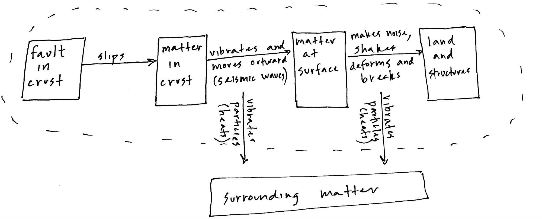

Question 3
According to the seismograph, which type of waves will probably cause the most damage?
A. P-waves
B. S-waves
C. Surface waves
D. Not enough information to determine
What to look for:
The correct answer is: Surface waves.

What to do: Encourage students to revisit the poster we made today and consider the relationship between amplitude and energy transfer.

Question 4
Seismic waves transfer through Earth’s crust, causing sound and motion at the surface that strain the bonds in the materials holding together land and buildings, resulting in deformation and breaking. Eventually this energy will dissipate as thermal energy in the surrounding matter. One way of showing this is through an energy transfer diagram, like the one below.

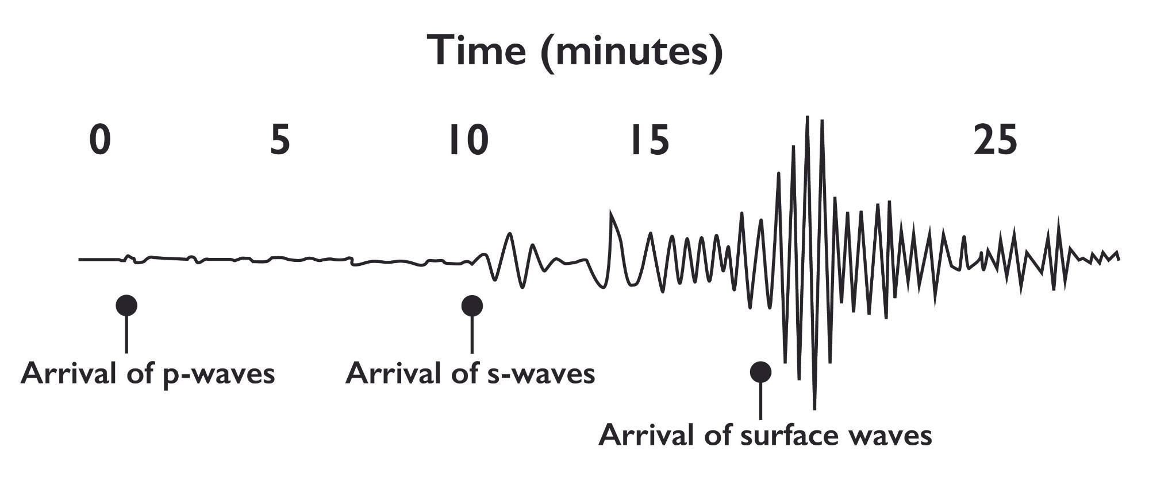
Adapted from: MIT OpenCourseWare. CC BY-NC-SA 2.0

How do you think this might be similar to or different from how energy transfers from the magnetron to the food inside the microwave oven?
What to look for:
Do not score this question. Look for students to suggest that energy probably transfers as waves of something inside the microwave oven. Students might suggest waves of air or some other matter at this point. They may suggest that some of the energy ends up as thermal energy in the food. They might also mention radiation, or microwaves.

What to do: Keep track of patterns in student ideas. You will use these ideas as the navigation into this lesson.

Question 5
An earthquake is caused by unbalanced forces at a fault (boundary) between two pieces of Earth’s crust. What unbalanced forces might be causing energy transfer in the microwave oven? Make a guess based on what you have figured out so far.
What to look for:
Do not score this question. Accept all ideas. This question is designed to support students in using matter, energy, and forces to think through a phenomenon, and to get them wondering about the forces involved. They do not yet have sufficient information to figure out the forces at play.

What to do: Keep track of patterns in student ideas. You will use these ideas as the navigation into this lesson.

