Lesson 13: Answer Key

Evaluating 5G Safety

Performance expectation being assessed: HS-PS4-4. Evaluate the validity and reliability of claims in published materials of the effects that different frequencies of electromagnetic radiation have when absorbed by matter. (SEP: 7.3, 8.4; CCC: 2.2; DCI: PS4.B.2)

In addition to the SEP, CCC, and DCI associated with this PE, this assessment also addresses one additional SEP element, as described below:

3D Elements Addressed in This Assessment | Q1 | Q2 | Q3 | Q4
SEP 7.3 Engaging in Argument from Evidence. Respectfully provide and/or receive critiques on scientific arguments by probing reasoning and evidence, challenging ideas and conclusions, responding thoughtfully to diverse perspectives, and determining additional information required to resolve contradictions. |  |  |  | X
SEP 8.4 Obtaining, Evaluating, and Communicating Information. Evaluate the validity and reliability of and/or synthesize multiple claims, methods, and/or designs that appear in scientific and technical texts or media reports, verifying the data when possible. |  | X | X
CCC 2.2 Cause and Effect. Cause-and-effect relationships can be suggested and predicted for complex natural and human-designed systems by examining what is known about smaller scale mechanisms within the system. |  | X | X | X
PS4.B.2 When light or longer wavelength electromagnetic radiation is absorbed in matter, it is generally converted into thermal energy (heat). Shorter wavelength electromagnetic radiation (ultraviolet, x-rays, gamma rays) can ionize atoms and cause damage to living cells. (HS-PS4-4) | X | X | X | X

You have probably heard the phrase “5G” thrown around a lot lately. It’s in cell phone commercials and on the news. Many people are calling it a game-changer for wireless technology. A 5G network should be able to offer significantly faster data transmission speeds than 3G or 4G, and can accommodate much more traffic. This is possible, in part, because 5G networks use a portion of the electromagnetic (EM) radiation spectrum to transmit digital information that isn’t currently being used by other wireless communication devices. Companies are racing to increase their 5G coverage nationwide. To support this transition, some companies are building as many as 1 5G tower per block!

How does 5G technology work compared to older technology?
Cell phone companies use the terminology 3G, 4G, or 5G to identify which generation of network frequencies they are using to send their signals. These different generations of the technology all work in the same way, with a cell phone tower antenna sending and receiving signals to or from receiver antennas in our cell phones or other devices.

Cell phone towers are large antennas, much like the ones in microwave ovens or on the roof of a radio station. They transmit information by moving charged particles, changing their electric fields, which then generates changing magnetic fields, which generate electric fields, and so on. These changing fields constitute EM radiation, which transfers energy through space to the antennas in our cell phones or other devices.

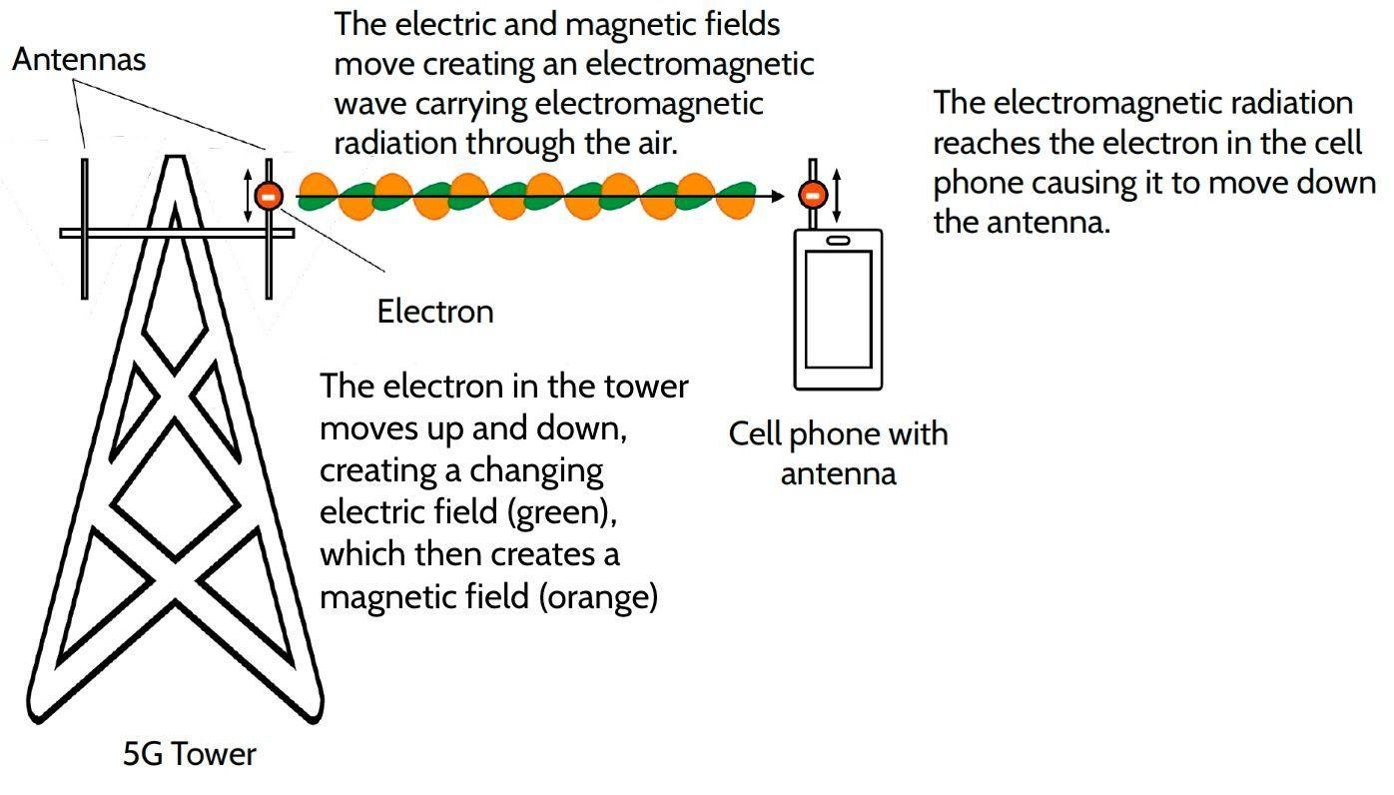

Question 1: Some people claim that 5G radiation could be dangerous to people’s health.
1a. What information would be important to determine whether 5G radiation is dangerous or not? Circle all that apply.
- frequency/wavelength
- amplitude/intensity
- duration of exposure
- length of antenna
Note to teachers: Do not score this question. As long as students mark frequency/wavelength as one of the options, they should be able to thoughtfully reply to Question 1b below. They can also discuss the implications of amplitude and duration, and make an argument that the length of the antenna might impact amplitude.

1b. Why is that information important?
Foundational understanding: Because frequency tells us what kind of radiation it is.

Linked understanding: Frequency/wavelength tells us if it is ionizing or not, which will tell us if it’s dangerous.

Organized understanding: We need its frequency/wavelength, and how much exposure there is (time and amount). This is important because the frequency/wavelength tells us if it is ionizing or not, and/or because more exposure means more energy transferred. This will mean either more thermal energy over time (if the radiation frequency is low) or more ionization risk to our DNA (if the frequency is high).

The table below shows the frequencies used by each of the networks in Gigahertz (GHz), or 1x10⁹ Hz.

Cell Phone Network | 3G | 4G | 5G
Frequency | 1.7 GHz - 2.1 GHz | 0.7 GHz - 2.5 GHz | 24 GHz - 54 GHz

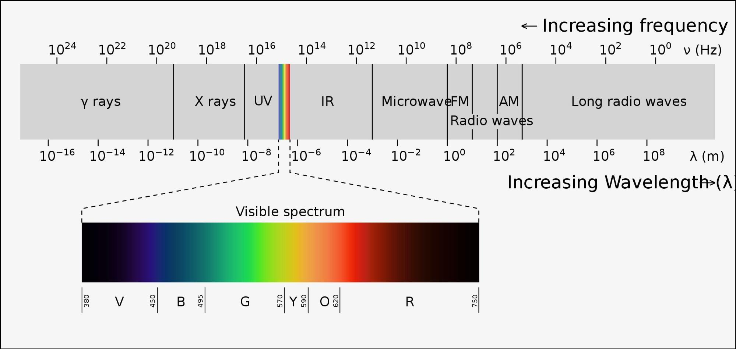
Philip Ronan, CC BY-SA 3.0

1c. Look at the electromagnetic spectrum above. What kind of EM radiation is 5G, and how is this different from or similar to 3G or 4G?

They are all microwave radiation (or radio waves). 5G is higher frequency, but still in the same part of the spectrum.

Question 2: Evaluating a Claim about the Risks of 5G
Look at the first set of screenshots from social media provided by your teacher (#1 Social Media Post). The transcript is also provided below. Respond to the prompts that follow to determine whether the claims being made by the poster are valid and/or reliable.

Social Media Transcript 1: Cell Phone Companies Must Be Stopped
The facts on 5G cell phone radiation are clear. 5G is very dangerous. Researchers are concerned about the effect of 5G on our brains. Our brains need sugar (glucose) in order to function. But sugar burns easily. Exposure to enough low-frequency radiation over a long enough time could burn up the glucose in our brains, causing issues long-term, like dementia. Electromagnetic radiation transfers energy into matter. One study found that cell phone use could raise the temperature in our brains by up to 0.1 °C (0.18 °F). The International Commission of Non-Ionizing Radiation Protection (ICNIRP) warns that people who spend more than 50 minutes a day using a cell phone could have early dementia or other thermal damage due to the burning of glucose in the brain.

The highest band of 5G operates at a frequency of 24 GHz to 39 GHz. That is 10x more energy being transferred than the earlier networks! The electromagnetic spectrum shows that the higher the frequency of EM radiation, the more energy it carries. Scientists say that the more energy transferred into our bodies, the more DNA will be ionized. Ionized DNA can cause cancer. For example, gamma ray radiation has the most energy, and it is very carcinogenic (it causes cancer). 5G cell phone technology uses higher frequencies than 4G. That means 5G will ionize more of our DNA, and put us at higher risk for cancer. I am not on board!

Citations
- International Commission on Non-Ionizing Radiation Protection (ICNIRP). (2009). Statement on the "Guidelines for limiting exposure to time-varying electric, magnetic and electromagnetic fields (up to 300 GHz)".
- The Electromagnetic Spectrum. (2023, March 14). In Wikipedia. https://en.wikipedia.org/wiki/Electromagnetic_spectrum.
- Breller, Zaura. (2021). 5G will give everyone cancer: What scientists don’t want you to know. Social media video.

2a. Fill in the table below by doing the following:
- Identify 2 effects that the first poster claims 5G can have on human health, and record them in the first column.
- Identify the mechanisms that the first poster claims will cause the effects you identified above, and record them in the second column.
- Is this mechanism consistent with science ideas we have figured out in class? Why or why not? Record your ideas in the third column.

 | Effects that the first poster claims 5G can have on human health | Mechanisms that the first poster claims will cause the effect | Is this mechanism consistent with science ideas we have figured out in class? Why or why not?
Effect on human health #1 | Rising temperatures in people’s brains. | EM radiation transfers energy into matter. | Yes, because microwave radiation heats food. As long as glucose is polar, this could be true.
Effect on human health #2 | Higher risk of cancer. | 5G radiation will ionize our DNA. | No, because only frequencies above a certain threshold will ionize parts of our DNA, and 5G is not above that threshold.

2b. Valid claims are supported by evidence and consistent with scientific ideas. Reliable claims use evidence that comes from credible sources and can be verified either against data sets or through additional experiments. Is the first post valid and/or reliable? Why or why not?
The post is not valid. They are right that EM radiation could heat things up, but they don’t present evidence that this could be dangerous. 0.1 degree doesn’t seem like a lot. And they are right that high-energy radiation could ionize parts of our DNA to cause cancer, but 5G radiation is below the ionizing threshold.

The post is sort of reliable. They cite the International Commission of Non-Ionizing Radiation Protection (ICNIRP), but the citations they give for the data are other posts, not credible sources. But it is a social media post, so we should be careful.

Note to teachers: The distinction between valid and reliable is murky, and we do not expect students to be able to draw a clear line between them. What is important is for students to be able to critique arguments by applying the principles of reliability and validity, not to be able to make hard distinctions between them.

Question 3: Evaluating Another Claim about the Risks of 5G
Look at the second set of screenshots from social media provided by your teacher (#2 Social Media Post).

Social Media Transcript 2: Conspiracy, or Reality?
Can all the conspiracy theorists just stop it with the 5G? First it was TV that was going to burn out our kids’ eyes, now they think low-frequency radiation can cause cancer. 5G radiation is not dangerous. The frequency of 5G is still relatively low compared to radiation that we know is dangerous, like X-rays, so it is below the threshold of ionization. Take a look at the evidence.

A large, long-term study has been comparing all of the people in Denmark who had a cell phone subscription between 1982 and 1995 (about 400,000 people) to those without a subscription to look for a possible increase in brain tumors. The most recent update of the study followed people through 2007. Cell phone use, even for more than 13 years, was not linked with an increased risk of brain tumors, salivary gland tumors, or cancer overall, nor was there a link with any brain tumor subtypes or with tumors in any location within the brain.

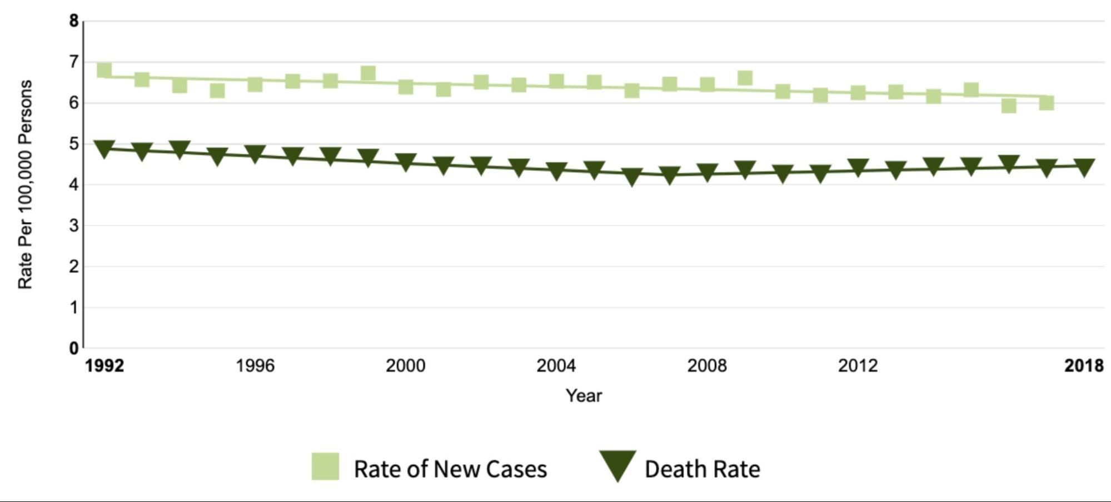
Just think about it. We have been placing antennae that emit low-frequency EM radiation on our bodies and next to our heads almost 24 hours a day for two decades, and the world has not seen an epidemic of brain cancer. In fact, in the U.S., the rate of new brain cancer cases was lower in 2017 than in 1992, as you can see in the data below. If cell phone radiation does not cause cancer, there is no reason to believe that these new 5G frequencies will be any different.

Citations
- Frei, P., Poulsen, A. H., Johansen, C., Olsen, J. H., Steding-Jessen, M., & Schüz, J. (2011). Use of mobile phones and risk of brain tumours: Update of Danish cohort study. British Medical Journal, 343.
- Miller K. D., Ostrom Q. T., Kruchko C., Patil N., Tihan T., Cioffi G., Fuchs H. E., Waite K., Jemal A., Siegel R. L., Barnholtz-Sloan J. S. Brain and other central nervous system tumor statistics, 2021. CA: A Cancer Journal for Clinicians. doi: 10.3322.caac.21693.

3a. What claim does poster #2 make that contradicts a cause-effect mechanism claimed by poster #1?
Poster #2 says that 5G will not ionize parts of our DNA. This contradicts poster #1’s claim that 5G will cause cancer.

3b. What evidence does poster #2 present to support this claim?
A study from Denmark shows no correlation between cell phone use and cancer.
Data from the U.S. shows that brain cancer is more rare since 1992.

3c. Valid claims are supported by evidence and consistent with scientific ideas. Reliable claims use evidence that comes from credible sources and can be verified either against data sets or through additional experiments. Is the second post valid and/or reliable? Why or why not?

The post is valid. It is consistent with the science ideas that we developed in class about low-frequency radiation.

The post is reliable. It cites 2 sources from scientific journals. But it is also a social media post, so we should be careful.

Note to teachers: The distinction between valid and reliable is murky, and we do not expect students to be able to draw a clear line between them. What is important is for students to be able to critique arguments by applying the principles of reliability and validity, not to be able to make hard distinctions between them.

Question 4: Providing a Critique
Choose a poster whose argument you would like to critique. Write a comment that you would add to their post. In the comment, respectfully critique the post by doing the following:
- First tell the poster about something in their argument that you believe to be valid, based on the model of EM radiation that we developed in this unit.
- Then tell the poster where you disagree with their argument, and why. Critique their argument using science ideas related to the electromagnetic spectrum.
- Explain what additional evidence the poster would need in order to make a more reliable argument.

Rubric for Question 4
 | Foundational Pieces | Linked Understanding | Organized Understanding
3D Elements | Look for:  Students provide critique to 1 post by identifying at least 1 area of disagreement. (SEP: 7.3)  Or  Students identify at least 1 area of agreement. (SEP: 7.3)  Students may reference evidence from the post. (SEP: 7.3) | Look for:  Students respectfully provide critique to 1 post by identifying at least 1 area of agreement and 1 of disagreement. (SEP: 7.3)  Students who demonstrate a linked understanding should also include at least 1 of the following:  - Students explain their disagreement using reference to the evidence. (SEP: 7.3)  - Students identify that the frequency used for 5G technology is not high enough to be ionizing. (DCI: PS2.B.2)  - Students identify that additional data is needed to increase the reliability of the claims made. (SEP: 7.3, 8.4) | Look for:  Students respectfully provide critique to 1 post by identifying at least 1 area of agreement and 1 of disagreement. (SEP: 7.3)  Students explain their disagreement using reference to the evidence in the post. (SEP: 7.3)  Students apply evidence from the EM radiation spectrum to identify that the frequency used for 5G technology is not high enough to be ionizing and cause damage to living tissues. (SEP: 7.3; CCC: 2.2, DCI: PS2.B.2)  - Students identify additional data that could be used to increase the reliability of the claims made. (SEP: 7.3, 8.4)
Example | If they choose post #1:  You are wrong that 5G is dangerous.  If they choose post #2:  I agree that 5G is safe, because the data you have shows it is safe. | If they choose post #1:  I agree that thermal radiation might be a problem. But 5G will not cause cancer. Just because radiation is higher frequency doesn’t necessarily mean it is more dangerous. There is a threshold over which radiation becomes ionizing, and 5G is not above that threshold. You need more data about whether 5G is dangerous.  If they choose post #2:  I agree that 5G is safe. But you don’t say anything about thermal effects. More data about other possible health effects would strengthen your argument. | If they choose post #1:  It is valid that sometimes higher frequency radiation is more dangerous. For example, X-rays and gamma rays have higher frequency, and they are known to cause cancer.  But just because radiation is higher frequency doesn’t necessarily mean it is more dangerous. There is a threshold over which radiation becomes ionizing, and 5G is not above that threshold. Also, there is evidence contradicting your claim. Rates of brain cancer in the U.S. have gone down since cell phones became common in the early 1990s. Also there was a study in Denmark with no evidence linking cancer to cell phones.  You may cite a real study, but just because the temperature goes up doesn’t mean that it will damage our brains. More data about how temperature could be harmful would strengthen your argument.  If they choose post #2:  I agree that low-frequency radiation is not as dangerous as high-frequency radiation like X-rays and gamma rays that have been proven to cause cancer because they transfer enough energy to ionize.  But even though 5G radiation isn’t ionizing, low-frequency radiation still has enough energy to cause thermal damage if there is enough of it, and if you are exposed for long enough. Or maybe it can hurt our brains in another way, we aren’t sure. The EM spectrum shows that there is a threshold over which radiation becomes ionizing. Ionizing radiation can cause cancer because it has enough energy to damage DNA. But lower frequency radiation still interacts with matter, so it could still be damaging.  You do not address this in your post. More data about other possible health effects would strengthen your argument.
Feedback | Linking:  Ask students to look for evidence in the social media posts that the authors use to support their claims. | Organizing:  Encourage students to think about how it is possible for some EM radiation to cause harm and how those types of radiation differ from the type used in 5G. | Extending:  Challenge students by asking them to consider the tone with which they are responding. How do they think the original poster would respond to their critique?

 | Foundational Understanding | Linked Understanding | Organized Understanding
Suggestions for instruction | If the majority of the class demonstrates a foundational understanding, spend some time analyzing the posts as a class, taking apart the evidence provided and comparing it against our Progress Trackers. | If the majority of the class demonstrates a linked understanding, ask students to work with a partner to go back to their Progress Trackers and look for evidence related to the information in the social media posts. | If the majority of the class demonstrates an organized understanding, challenge students by asking them to provide a critique to both posts. Ask students to search social media or the internet for claims being made about 5G and related technologies. Always encourage students to be safe online, and consult a school counselor and/or a technology professional before encouraging students to respond to anything directly.

