Name: ______________________________________ | Date: ___________________

Lesson 7: Answer Key

Bus Collision Key

Performance expectation being assessed

HS-PS2-2 Use mathematical representations to support the claim that the total momentum of a system of objects is conserved when there is no net force on the system. [Clarification Statement: Emphasis is on the quantitative conservation of momentum in interactions and the qualitative meaning of this principle.] [Assessment Boundary: Assessment is limited to systems of two macroscopic bodies moving in one dimension.]

 | 3-D elements addressed in this assessment | Q1 | Q2 | Q3 | Q4 | Q5 | Q6 | Q7
SEP | 5.2 Using Mathematics and Computational Thinking: Use mathematical, computational, and/or algorithmic representations of phenomena or design solutions to describe and/or support claims and/or explanations. | X |  | X | X |  | X
CCC | 4.2 Systems and System Models: When investigating or describing a system, the boundaries and initial conditions of the system need to be defined and their inputs and outputs analyzed and described using models. |  |  |  |  |  | X
DCIs | PS2.A.2 Momentum is defined for a particular frame of reference; it is the mass times the velocity of the object. (HS-PS2-2) | X |  |  | X |  | X
 | PS2.A.3 If a system interacts with objects outside itself, the total momentum of the system can change; however, any such change is balanced by changes in the momentum of objects outside the system. (HS-PS2-2), (HS-PS2-3) |  | X | X |  |  | X

A study published in the peer-reviewed Journal of Urban Health by researchers from the Université de Montréal Public Health Research Institute found that riding the bus is much safer than driving a car. Not only are buses safer for the people riding inside, they also pose a lower risk for pedestrians and other vehicles.

But even the safest forms of transportation come with a certain level of risk. Buses move in and out of traffic to drop people off, pick people up, and make frequent stops that distracted drivers may or may not notice in time.

To investigate how to make buses even safer, researchers Gerardo Olivares and Vikas Yadav used computers to simulate a bus that is stopped at a bus stop. They simulated the bus being rear-ended by a vehicle going 20 mph (8.94 m/s). They simulated several types of vehicles hitting the bus, including (a) another bus, (b) a minivan, and (c) a compact car, as shown below.

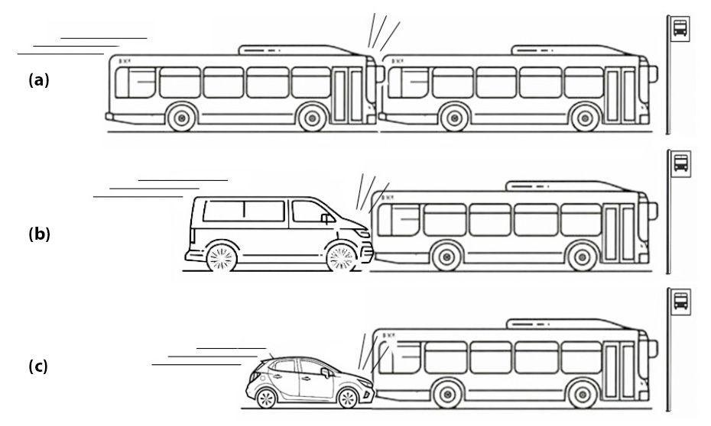

In this assessment, you will use the results from their published paper to evaluate whether the outcomes of each collision can be predicted using what you learned about momentum conservation.

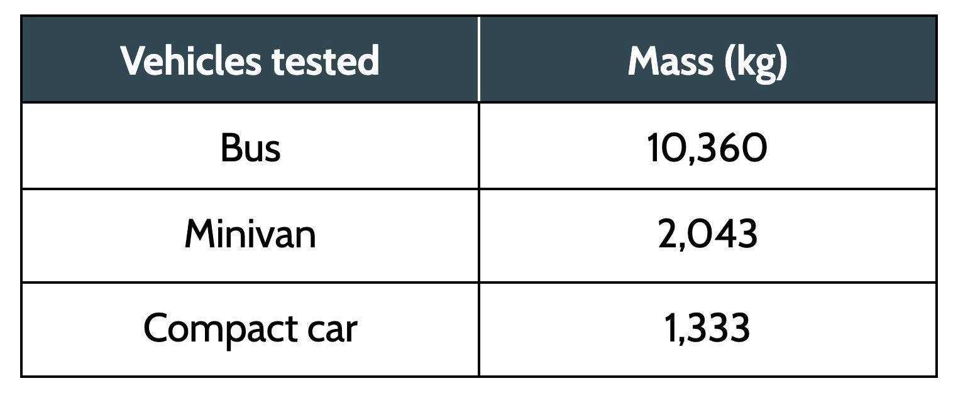
Here are the masses of the vehicles involved in each collision. You can assume that both buses have the same mass.

The velocity over time graph below shows the changes in velocity for the bus when it was struck by another vehicle (either another bus, the minivan, or the compact car) going 20 mph. The bus is not moving at time 0, so the velocity starts at 0.

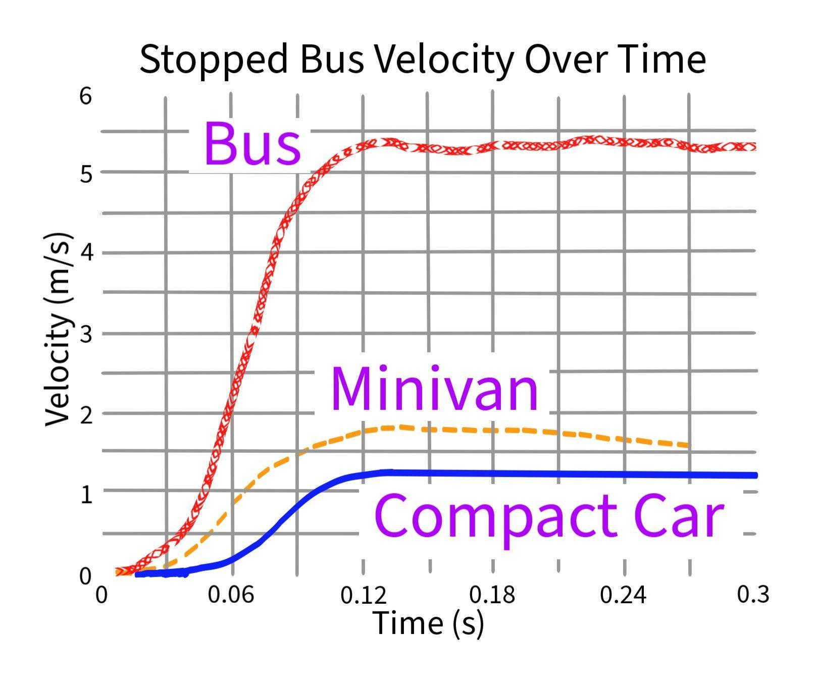
Data Source: Olivares, G. & Yadav, V. (2007)

1. What is the momentum of the stopped bus before the collision? How do you know?
Momentum will be zero because the velocity is zero, and momentum is mass times velocity.

2. As a result of each collision, the stopped bus started moving. Which of the following describes why the stopped bus will start moving?
- The second vehicle will become part of the stopped bus system. The more objects in a system, the higher the momentum, so the momentum of the system will go up and the stopped bus will move.
- The momentum of the stopped bus system will change because the second vehicle exerts an unbalanced force. Unbalanced forces cause changes in motion.
- The net force on a system is always zero. When the second vehicle collides with the system, the stopped bus must move to balance it and keep the net force of the system at zero.

3. Assuming all three simulated moving vehicles (the second bus, the minivan, or the compact car) have the same velocity (20 mph) before the collision, which collision will result in the largest change in momentum for the stopped bus, and how do you know?

+ The bus will result in the largest change in momentum for the stopped bus because it will have the most momentum before the collision since it has the most mass, and momentum is mass*velocity, and the velocity is the same across all three vehicles.
+ Students might also apply ratio-reasoning, for example: Before the collision the total momentum for the moving bus is 5 times that of the minivan and approximately 8 times that of the compact car.

4. Identify which vehicle struck the bus in the “Stopped Bus Velocity Over Time” graph by labeling each line with the type of vehicle it represents. Then explain how you determined which vehicle matched which line.

The change in momentum is highest for the second bus. This means that the change in velocity for the stopped bus will be the highest in this collision. Next will be the change in velocity from the collision with the minivan, and then the compact car.

The velocity over time graph below represents the simulated velocities of the minivan and the compact car after the collision. The compact car is represented by the solid line. The minivan is represented by the dashed line.

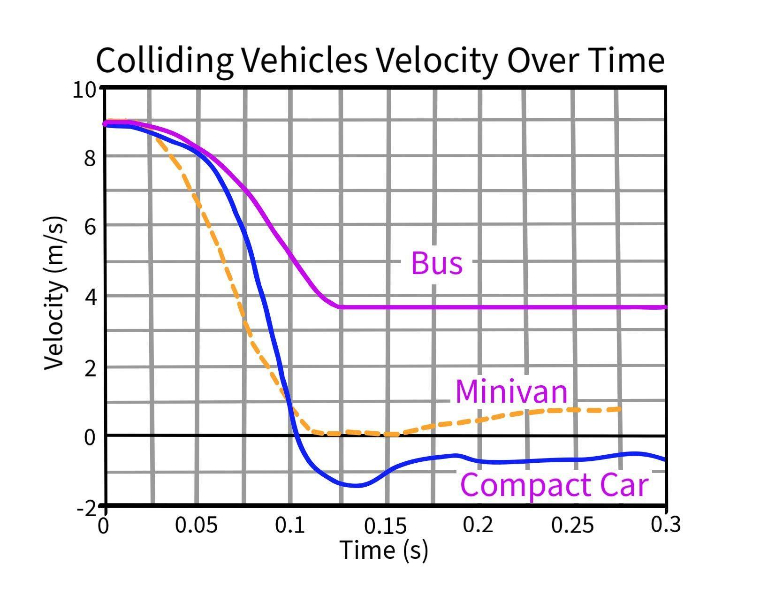
Data Source: Olivares, G. & Yadav, V. (2007)

5. After the collision, what happens to the velocity of the compact car according to the “Colliding Vehicles Velocity Over Time” graph?
- The compact car will slow down very quickly and then stop. After stopping it will begin rolling forward very slowly at about 1 m/s.
- The compact car will slow down very quickly and then bounce backward, rolling backward slowly at about 1 m/s.
- The compact car will stop immediately and not move after colliding with the bus.

6. What will happen to the colliding bus after it hits the bus that was stopped? Follow the steps below to figure it out:
- Set up an equation that describes the change in momentum of the two-bus system.
- Use the values given in the data table to fill in the mass of each bus. Use the “Stopped Bus Velocity Over Time” graph above to determine the change in velocity of the stopped bus, and fill that in as well.
- Use algebraic techniques to solve for the change in velocity of the colliding bus.

m_{colliding}*Δv_{colliding} + m_{stopped}*Δv_{stopped} = 0
Δv_{colliding} * 10,360 kg + 5.3 m/s * 10,360 kg = 0
Δv_{colliding} * 10,360 kg = -5.3 m/s * 10,360 kg
Δv_{colliding} = -5.3 m/s

- The initial velocity of the colliding bus given above is 20 MPH, or 8.94 m/s. Use the change in velocity that you calculated to determine its velocity after the collision.

v_{colliding} = 8.94 m/s - 5.3 m/s = 3.6 m/s

- On the “Colliding Vehicles Velocity Over Time” graph above, sketch a prediction showing what the line would look like for the colliding bus. Then explain your prediction below by describing what will happen to the motion of the colliding bus over time.
+ Important features of the line drawn on the graph include the following:
+ A velocity at 0 seconds of 8.94 m/s, which should match the y value of the other two lines already on the graph
+ A decrease in velocity occurring from 0 seconds to around 0.11 to 0.13 seconds
+ A relatively stable final velocity beyond 0.13 seconds of around 3.6 m/s

 | Foundational understanding | Linked understanding | Organized understanding
3-D elements | Look for the following:  Students make a claim about how the velocity of a bus would change due to a collision with another bus, but they have not reasoned about change in momentum to support their claim. Instead they rely on experience or intuition. | Look for the following:  Students use mathematical representations of the conservation of momentum for a system of two buses.  and  Students make a claim about how the velocity of a bus would change due to a collision with another bus. | Look for the following:  Students use mathematical representations of the conservation of momentum in a system of two buses to support a claim about how the velocity of a bus would change due to a collision with another bus.
Example | Students do not set up or solve an equation for momentum, or they do not set up the equation accurately.  Students’ graphs include  - a velocity at 0 seconds of 8.94 m/s, which should match the y value of the other two lines already on the graph and  - a decrease in velocity after 0 seconds.  and/or they explain the following:  The bus will start at 8.94 m/s (or 20 mph). When it hits the stopped bus, it will slow down. | Students set up an equation for momentum, but the equation is not set up correctly, or they do not use their answer to reason about the motion of the bus.  Students’ graphs include  - a velocity at 0 seconds of 8.94 m/s, which should match the y value of the other two lines already on the graph and  - a decrease in velocity occurring from 0 seconds to around 0.11 to 0.13 seconds.  and/or they explain the following:  The bus will start at 8.94 m/s (or 20 mph). When it hits the stopped bus, it will slow down very quickly. | Students’ graphs include  - a velocity at 0 seconds of 8.94 m/s, which should match the y value of the other two lines already on the graph,  - a decrease in velocity occurring from 0 seconds to around 0.11 to 0.13 seconds, and  - a relatively stable final velocity beyond 0.13 seconds of around 3.6 m/s, possibly with a downward slope.  and they explain the following:  The bus will start at 8.94 m/s (or 20 mph). When it hits the stopped bus, it will slow down very quickly (negative acceleration), but it will still be moving forward at about 3.6 m/s.
Feedback | Linking  Ask students: How can we draw connections between the cart-collision we were modeling then and the vehicle collision we are modeling now? | Organizing  Give students a chance to work (or rework) through the equations and be more precise with their graphs. Press students to explain a numerical answer in the context of the phenomenon. | Extending  Ask students to be explicit about what they included in their system, and then ask them to imagine how their approach might be different if they had bounded the system differently. A 2-bus system leads to an approach that sets the momentum in the system before and after, while a 1-bus system leads to an approach that sets the change in momentum of the first bus system equal to the change in momentum of the bus that transferred that momentum into the system.

 | Foundational Understanding | Linked Understanding | Organized Understanding
Suggestions for instruction | If the majority of the class demonstrates a foundational understanding, invite students to revisit their progress tracker with a partner for Lessons 4-5, and use it to draw connections between the cart-collision we were modeling then and the vehicle collision we are modeling now. | If the majority of the class demonstrates a linked understanding, work some of the equations together as a class. You may choose to give students additional practice solving momentum equations. | If the majority of the class demonstrates an organized understanding, challenge students by asking them to design their own investigation using a simulation like this one. What problem could they investigate like this?

7. Choose a question from the DQB that you can answer with science ideas that we figured out. Write the question below, and then answer it.

