Name: ______________________________________ | Date: ___________________

For Weight Limits

Heavy payloads of trucks are dangerous and destructive. We should not allow truck weight limits to be increased. Increasing truck weights would put drivers of other vehicles at risk. It also would cause damage to roads and the environment.

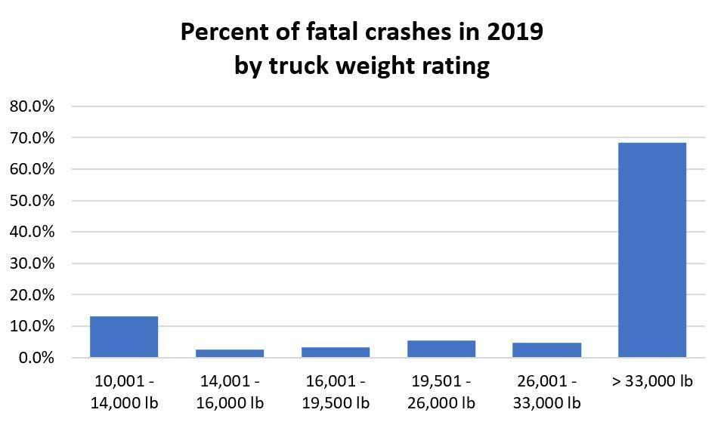
Increasing truck weights would cause more risk for other drivers on the road. As seen in the bar chart, the majority of fatal truck crashes in 2019 involved trucks over 33,000 pounds. Increasing truck weights would make crashes even more dangerous for personal vehicles sharing the roads.

Heavier trucks also cause more damage to the roads they drive on. This is especially important when discussing state-level weight restrictions. This is because if a state has a higher weight limit than the federal limit, the heavy trucks are forced to use the state roads instead of interstates. This can force the dangerous trucks onto more-dangerous, two-lane highways that at times can only be repaired using state funds. Rural communities are especially affected by this. In states such as Texas, rural roads are deteriorating quickly due to the state having higher large truck weight limits.

Truck drivers in the United States are typically paid by the mile. This means drivers would not get paid more to haul heavier loads. Their operation costs for these loads, however, would increase. Heavier loads require more fuel to move. This makes higher weight limits a significant cost to drivers.

Current trucks also require costly upgrades before they can haul heavier loads. Trucking companies or truck owners would be required to spend thousands of dollars upgrading each truck if the truck was not already suited for those loads. The upgrades to trucks necessary for heavier loads would add weight to the vehicle as well. Unfortunately, the increased weight of the vehicle does not match the weight it can carry. Increasing the weight limit by 11,000 pounds would only increase payload capacity by about 8,500 pounds.

Increasing weight limits will not solve supply chain problems. We should focus on training and retaining qualified drivers and protecting our noninterstate roads.

References
FreightWaves. (2018). "Would increasing U.S. truck weight limits make sense?" Retrieved from https://www.freightwaves.com/news/drivers/increasing-us-truck-weight-limits

US Department of Transportation: Federal Motor Carrier Safety Administration. (2023). "Vehicles Table 7. Large Trucks in Fatal Crashes by Truck Weight Rating, 2017-2019." Retrieved from https://www.fmcsa.dot.gov/safety/data-and-statistics/vehicles-table-7-large-trucks-fatal-crashes-truck-weight-rating-2017

