Lesson 8: Teacher Reference 1

Site Location Modifications

The image on the right is used on slide E and in the Age of Rocks handout. It is a redrawn image that represents an approximation of the two maps in Modes of rifting in magma-rich settings: Tectono-magmatic evolution of Central Afar. One of the maps used for this approximation is Figure 1 on page 4. That map covers 4 or more degrees of latitude and longitude. The second map used for this approximation is Figure 2 on page 6. It is a smaller-scale map that covers close to 1 degree of latitude and longitude. The locations of all the sample sites are based on best estimates of where they are located in Figure 6, except for these: G1, G2, G3, and G4. These last four sites were added by the authors of the lesson for educational purposes of the field test. The OpenSciEd development team intends to do further research on these to find published site locations for equivalent samples for the public release. The related radiometric composition of those samples for those sites is as cited in Zircon U–Pb ages, δ¹⁸O and whole-rock Nd isotopic compositions of the Dire Dawa Precambrian basement, eastern Ethiopia: Implications for the assembly of Gondwana. | 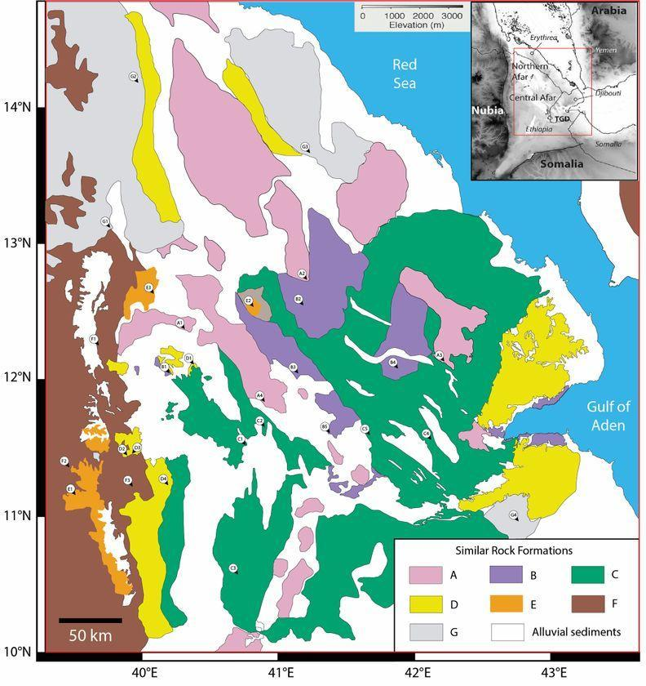

The table to the right is used on slides F, G, N, EE, and HH, as well as in Rock Transformation Process. It includes data from four samples reported in Table 1 on page 10 and two samples reported in Table 2 on page 11 of Modes of rifting in magma-rich settings: Tectono-magmatic evolution of Central Afar.  The first five samples had 2-3 aliquots that are measured and reported in the original paper. The measurement for the first aliquot listed is the only one included in the table to the right.  Potassium (K-40) concentration is reported under a column heading of K (wt %) in table 1 in the original paper, rather than K-40 (ppm). This was converted by this relationship: ppm = 10,000 x % wt to provide a consistent unit for the last two columns. For example, in the original table sample, AF12-02 is reported as K-40 (wt %) of 1.167, whereas in this table, that value is reported as K-40 (ppm), which is 11,670.
   |  | Radioactive elements
  Sample | Label | K-40 (ppm) | U-238 (ppm)
  AF12-02 | C1 | 11,670 | N/A
  AF12-11 | D1 | 1260 | N/A
  AF13-98 | D2 | 890 | N/A
  AF13-102 | E3 | 5650 | N/A
  AF12-15 | B1 | N/A | 163.58
  AF12-21 | D3 | N/A | 216

