Coal Impacts

How does burning coal impact people, animals, and our environment?
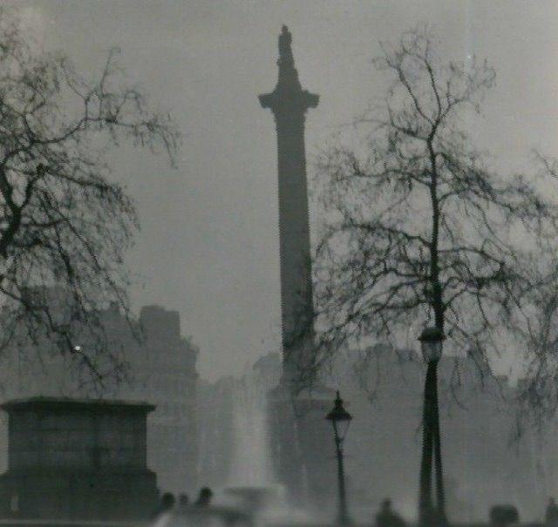
Smog is the most obvious way that harnessing energy from Earth’s systems impacts our environment. After the Industrial Revolution, smog from burning coal hung over industrial cities such as London like thick, black clouds. Nobody thought it was a problem. In fact, many people believed that a smoggy city was a mark of progress and scientific achievement. Residents took pride in the smog because it showed how “civilized” their city was.

But in these “civilized” cities, people began to die. In 1948, a toxic fog descended on a small town called Donora, Pennsylvania, and 20 people died. Less than a decade later, a toxic fog in London known as the Great Smog took 3,000 lives. In both communities, an investigation revealed that the fog contained sulfur dioxide, a product of burning coal. The evidence was clear. But even so, it wasn’t until 1970 that President Richard Nixon created the Environmental Protection Agency. The reaction to environmental destruction tends to be slow.

The major advantage of burning fossil fuels like coal is that power plant operators can dispatch energy whenever it is needed. If there is an unexpected rise in demand that does not match the forecasts, the power company can simply burn more coal to meet this demand, as long as the power plants are functioning normally.

Coal is most commonly collected through a process called “surface mining,” in which miners blast off the tops of mountains and collect the coal underneath. This process provides jobs to local people in communities that depend on the coal economy. It is also very destructive to huge areas of land. The more coal we use, the more land is needed to mine, transport, and store that coal. Technically, coal is a nonrenewable resource, meaning that it will eventually be depleted. But estimates say that we have enough coal to last at least another 100 years, if we continue to burn it at the same rate that we do today.

