Lab: Oreo Stoichiometry Name________________________

Over 9.1 billion OREO cookies are consumed each year!
Over 95% of Americans have eaten OREO cookies.

An Oreo cookie is composed of 2 chocolate wafers and a creme center. For many people, an Oreo is eaten by the decomposition method. The original Oreo is manually decomposed into 2 wafers (W) and one creme filling (C). Then, each component of the Oreo is relished separately.
- Write the decomposition of an Oreo as a balanced reaction:
_________________________________________________________________

- Write the reaction if several Oreos are decomposed instead of one
Two cookies → ____________________________________________________
Three cookies → ____________________________________________________
Four cookies → _______________________________________________________
Six cookies → ______________________________________________________

- If I have 8 wafers and 2 cremes.

- How many Oreos can I make from the wafers? ____________________
- How many Oreos can I make from the cremes? _____________________
- The limiting reactant is __________________________.
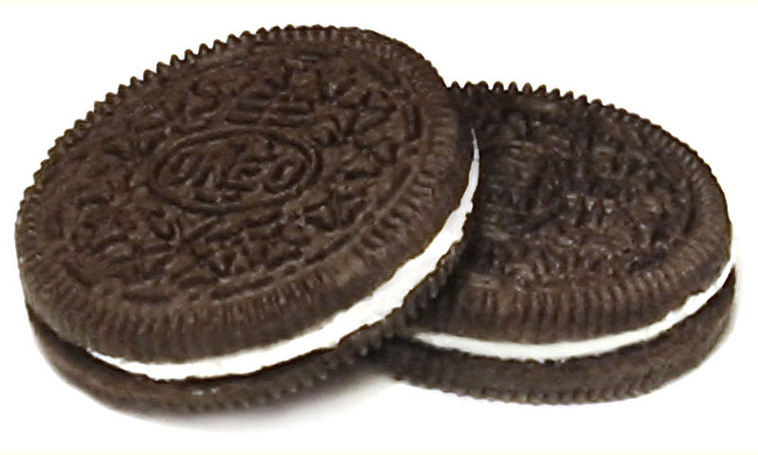
- The excess reactant is ____________________________.

- Another day my lunch had 8 wafers and 3 cremes.
  - The limiting reactant is ___________________________.
  - The excess reactant is ____________________________.

- Let’s assume that a regular Oreo is 14 grams.
  - How many Oreos do I have if I have approximately 224 grams of cookies? Show your work below using the conversion factor method.

  - If I have 2,184 grams of Oreo cookies, how many wafers do I have?

Directions: The following questions should be answered by collecting lab data using an Oreo cookie. Please keep in mind that any Oreo cookie used for a lab is considered inedible, as lab equipment has been exposed to materials that should be considered poisonous and dangerous.

Data:
Mass of 1 Oreo cookie | grams
(Average) Mass of 1 Wafer | grams
Mass of crème filling | grams

Procedure:

- Take an Oreo cookie and place it on the balance. Record the mass.

- Proceed to scrape the crème filling off of the wafers. Mass each wafer. Calculate the average mass of your wafers by adding the two masses and dividing by two. Record the average in the table above. Show your work below.

- Solve for the mass of the crème using the following equation. Record it in the table above.
Mass of Oreo – mass of both wafers = mass of crème

Analysis: Answer the following questions. Use your data and show all your work. (Remember, a mole represents 6.022 x 10²³ of anything, even Oreos. It’s just a number!)

- If I have a mole of Oreos, what would be the mass (or molar mass)?

- If I have a mole of wafers, what would be the mass (or molar mass)?

- If I have a mole of crème fillings, what would be the mass (or molar mass)?

- If I have a mole of Oreos, how many moles of crème fillings would I have?

- If I have a mole of Oreos, how many moles of wafers would I have?

2 Wafers + 1 Crème → 1 Oreo

- Using the equation above, answer the following questions. Assume that the mass of one crème filling is 3.0 grams, the mass of one wafer is 5.5 grams, and the mass of one Oreo is 14.0 grams.

  - If I have 6 moles of wafers and unlimited crème fillings, how many Oreos can I make?

  - If I have 12 moles of crème fillings and unlimited wafers, how many Oreos can I make?

  - If I have 36.0 grams of crème filling, how many grams of Oreos could I produce, assuming unlimited wafers?

  - If I have 159.5 grams of wafers, how many grams of Oreos could I produce, assuming unlimited crème?

  - If I have 2,348.5 grams of wafers, how many grams of crème do I need to complete use all the wafers for Oreos?

  - If I have 792 grams of wafers, how many dozens of Oreos will I make assuming unlimited crème?

