AP Physics – Geometric Optics
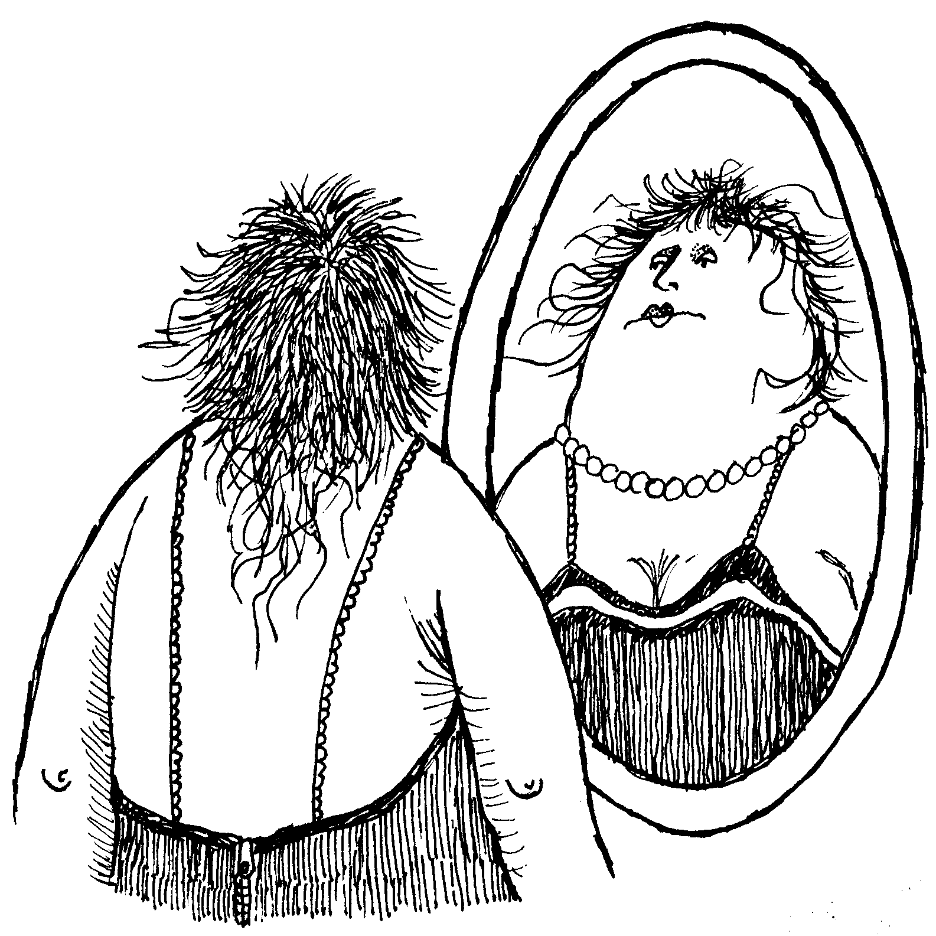
We’ll start off our exploration of optics with the topic of mirrors. The type of mirror you are most familiar with is called a plane mirror. Your first thought is probably, “What do we care about mirrors on airplanes for?” Well, not that kind of plane mirror. Although this stuff would certainly apply to mirrors on planes. Anyway, plane mirrors are flat and have a metal surface. Some times they are made of metal – the first mirrors found by archeologists were made of polished brass. Jason (owner of the good ship Argo) used a polished metal shield as a mirror when he chopped off the head of the Gorgon Medusa (he had to use a mirror because if you look at a Gorgon, they like turn you into stone). Modern mirrors are made of glass or clear plastic and have a thin, very smooth layer of metal on one side. Nowadays the metal is usually aluminum but it mostly used to be silver, so the metal surface is called the silvered surface. Most mirrors have the silvering on the far side under glass so it won’t get scratched. Mirrors for very precise applications (like in projection TV’s) are front silvered.

Plane mirrors form images. When you look into the mirror you see all sorts of wondrous things.

Remember that the only way you see anything is for light rays to enter your eyes. When you look at a mirror, everything that you see in the mirror is being reflected off the surface of the mirror. Our eyes, primitive as they are, do not understand that light rays can be reflected. Our eye/brain system is convinced that light rays always travel in straight lines. When we look into a mirror, light rays seem to be coming from objects that are on the other side of the mirror. In reality the objects are on the same side of the mirror as we are and the light rays are reflected into our eyes. The drawing below shows how an image of an arrow is formed. Two rays are shown coming off the object (the arrow). A ray from the top and a ray from the bottom. The ray from the top reflects off the mirror into our eye and the ray from the bottom does the same. Our brain “ray traces” the reflected rays back behind the mirror. We call these the back rays. Your eye and brain are back ray tracing.

The image is formed in our brain on the opposite side of the mirror. It is the same size as the object and the same distance from the mirror as the object.

The image is called a virtual image. Think of virtual image as meaning that the image is made by phantom rays. No real light rays form the virtual image.

Plane mirrors form images that are erect, non magnified, and virtual.
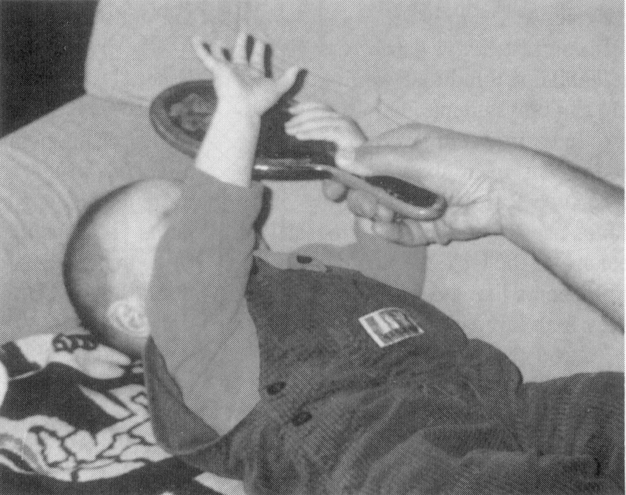

Here is a baby, the baby does not understand about virtual images and is foolishly trying to grab its image (which it thinks is behind the mirror) with its free hand.

Spherical Mirrors: Spherical mirrors produce a very different type of image. So first things first, what is a spherical mirror?

A spherical mirror has a curved surface. The surface has a constant radius of curvature. You could think of it as sort of like a circular part of a mirror that is a true sphere. Sort of a cookie cut out of the thing. The little round cookie has a curved surface. So the mirrored surface is part of sphere.

There are two types of spherical mirrors, convex mirrors and concave mirrors. The type a mirror depends on where the silvering is placed.

On the drawing above, you can see that on a convex mirror, the silvering is on the side that bulges out. A concave mirror has the silvering on the side that caves in. In fact the cute little way to remember which is which is that a “concave mirror makes a cave” or some such nonsense.

Here is a drawing showing the geometry of a concave mirror.

C is the center of curvature. Its distance from the center of the mirror is equal to the radius of curvature R for the mirror.

The principle axis is a line that goes through the center of curvature to the center of the mirror.

f is the principle focus. It is also called the focal point or sometimes simply the focus.

The focal length is the distance from the principle focus to the center of the mirror. It is equal to one half of the radius.

Rules For Ray Reflection: The reflection of light rays that enter spherical concave mirrors follow certain specific rules. Here followith those very rules.

- Rays that enter the mirror parallel to the principle axis are reflected off the mirror through the principle focus.

- Rays that pass through (or appear to originate from) the principle focus are reflected parallel to the principle axis.

- Rays that pass through (or appear to originate from) the center of curvature enter the mirror and are reflected back through the center of curvature.

Ray 1 -- Comes in parallel to the principal axis, is reflected through f.

Ray 2 -- Enters by passing through the focal point, is reflected off the mirror parallel to the principle axis.

Ray 3 -- Goes through center of curvature, is reflected off the mirror through the center of curvature. It retraces itself.

Image Formation: Let’s look at a typical image formed by a concave spherical mirror.

The object is located between the center of curvature and the principle focus.

The object has a humungeous number of rays reflecting off it in all directions. We are only interested in the rays that follow our rules.

So the first ray we look at is one coming off the top of the object parallel to the principle axis. It will be reflected off the mirror through the focal point.

The next ray that we draw is the one that goes through the principle focus. It is reflected off the mirror parallel to the principle axis.

These two rays fix the image, the top of the object (the arrowhead) is located where the two rays intersect. The bottom of the object is fixed by the principle axis. Rays from the principle axis that travel through the focal point are parallel to the principle axis, they also appear to originate from the center of curvature, so the base of the object stays attached to the principle axis.

This is a real image because it is made up of real light rays that actually intersect each other. It is inverted. Also note that for this specific example that the distance from the image to the mirror center is greater than the object distance. Also the image is magnified.

Be sure to remind the Physics Kahuna to show you his real image demonstrations.

As the object is moved about in front of the mirror, the image size and image distance will vary. The image can be smaller or larger than the object.

It is interesting to look at what happens when the object is placed at the focal point:

Note that the two rays are parallel. They will never intersect, so there can be no image. Thus no image is formed of an object that is at the principle focus of the concave mirror.

What happens when the object is placed inside the principle focus? Let’s look at the rays and see what happens.

When we trace out the three rays, they don’t cross in front of the mirror. So what is going on?

Did you see it? Yes, your brain appraises the situation and says to itself, “Hey these rays all look like they’re coming from behind the mirror!” Your brain does a bit of back ray tracing is what happens. So we end up with a virtual image that is erect and magnified.
People buy these mirrors so that they can get a virtual image of their faces in the thing. The manufacturers call them makeup mirrors (if the market is women) or shaving mirrors (if the market is men).

Concave mirrors are also known as converging mirrors because reflected light rays can converge to form real images.

Convex Mirror Images: Convex mirrors also form images. But the image that forms is always virtual and smaller. Convex mirrors are also known as diverging mirrors because the reflected rays always diverge and can never form a real image.
Here we see a convex mirror with an object placed in front of it. The main difference here is that the principle focus is on the opposite side of the mirror from the object.

The rules for the rays are pretty much the same, but there are a couple of little differences. Notice also that we don’t really care about the center of curvature.

Rays that are parallel to the principle axis are reflected as if they originated from the principle focus. The ray is reflected off the mirror as if it had started out at the principle focus.

Rays that look as if they are going to go through the principle focus are reflected off the mirror parallel to the principle axis. Let’s look at this ray.

Note that the rays will never cross in front of the mirror. So, the old brain has to go in and do some major back ray tracing.

You get something that looks like this:

For a convex mirror, the image will always be virtual and will always be smaller than the object.

Convex mirrors are used to give a big field of view. Because objects in front of the mirror are smaller as an image, you get a bigger view in the mirror. So the mirrors are used on cars and trucks as rear view mirrors. They are also used in stores as security mirrors. A couple of mirrors mounted in the corners give a view of the entire interior of a store.

Lenses: Enough already on mirrors. Let’s talk about lenses. You know what they are – you may have a pair of them in your eyeglasses, or do you wear contact lenses?

Lenses refract light in a sort of organized way. The type of lenses that we’ll be looking at are called double spherical lenses – both sides of the lens have the same radius of curvature. There are two types of these lenses: convex lenses and concave lenses. Concave lenses cave inward and convex lenses bulge outward.

Convex lenses are also known as converging lenses because the refracted rays that pass through can converge. Convex lenses can form real or virtual images.

Concave lenses are called diverging lenses because the light rays always diverge. Concave lenses can only form virtual images.

Lens Stuff: Here is the geometry of the double convex lens.

Q is the center of the lens, f and f’ are the focal points on either side of the lens. Also note that lens has a principle axis.

Here are the rules for image formation:

- Rays that are parallel to the principle axis are refracted through the focal point on the opposite side of the lens.

- Rays the travel through the center of the lens are not refracted and travel in a straight line.

- Rays that travel through the focal point before they reach the lens are refracted out of the lens parallel to the principle axis.

Note: the Physics Kahuna likes to draw a vertical line on the lens, that is a line through the center of the thing. No doubt it will be clear how this vertical line is used.

Ray 1 is the parallel ray that is refracted through focal point on the opposite side of the lens.

Ray 2 is the ray that goes through the center of the lens.

Ray 3 is the ray that goes through the focal point and is then refracted parallel to the principle axis.

The image is formed where the rays intersect. Clearly you can see that this will be a real image.

Converging lenses form real images, they can also form virtual images as well. This is what happens when you use one as a magnifying glass.

Here is a virtual image formed by a converging lens. Notice that the object is inside the focal point. When an object is placed at the focal point no image forms. This is shown in the next drawing. This is because all the rays are refracted in such a way that they are parallel to one another. They never cross, so they form no image.

What about a diverging lens? Let’s look at how diverging lenses form images. Keep in mind that a diverging lens always produces a virtual image.

- The parallel ray is refracted as if it had started out at the focal point on the same side of the lens as it is.

- The ray that goes through the center of the lens is not refracted.

The rays look like this:

Notice that the rays all diverge. This means that you have to do the old back ray tracing thing to find the virtual image.

You should be prepared to use ray tracing to locate images for spherical mirrors and lenses.

Multiple Lens Deals: Many instruments that use lenses use several of them in series with one another - telescopes, microscopes, camera lenses, film projectors, etc. The way this works is that the first lens forms an image of an object. This image serves as the object for the next lens and so on.

Here is a typical simple set up. There are two lenses and a single object.
First we find the image formed by the first lens.

The first image will then act as an object to the second lens, which will form a final image.
Thin Lens Equation: The relationship between the image distance and the object distance is given by the thin lens equation.

s_{o} is the object distance, s_{i} is the image distance, and f is the focal length for the lens.

Lens sign conventions:

s_{o} - Positive if object is in front of the lens.

s_{o} - Negative if the object is behind the lens.

s_{i} - Positive if the image is behind the lens.

s_{i} - Negative if the image is in front of the lens.

f is positive for a converging lens.

- A lens has a focal length of 25 cm. An object is placed 32 cm from the lens. What is the object distance?

Magnification: One of the reasons that lenses are used is that they can provide some magnification – make something look bigger.

If you divide the size of the image by the size of the object you get a number that represents the magnification. If the image is 10 cm tall and the object is 5 cm tall then the magnification is two.

The magnification is given by:

M is the magnification, h_{i} is the image height, h_{o} is the object height, s_{i} is the image distance, and s_{o} is the object distance.

- A double convex thin lens has a focal length of 36.0 cm. A 2.30 cm tall object is placed 12.0 cm from the lens, find (a) the type of image, (b) the image distance, (c) the magnification, (d) the image height.

- Virtual Image. We know this because the object distance is less than the focal length.

(c) Note: no units for magnification. Also the Physics Kahuna dropped the negative sign. It just tells us that it is a virtual image.

(d)

- We have us a two lens system. The focal length for the 1st lens is 10.0 cm, the focal length of the second lens is 20.0 cm. (a) Find the final image distance. (b) find the magnification of the final lens.

(a)

The image is 14.0 cm from the first lens. Since the second lens is 22.0 cm from the first lens, the distance from the first image to the second lens, which will be its object distance, is the difference between the two distances:

Now we can find the image distance for the final image formed by the second lens:

- Finding the magnification.

Changes in the Lens: What happens to the focal length if the radius of curvature for a lens is changed? What happens if the index of refraction for the mirror is changed? What happens if the lens is immersed into a different medium that has a different index of refraction than does air?

The basic thing to think of is this: what happens to the angle of refraction? Anything that increases the angle of refraction will produce a smaller focal length as the light is bent a greater amount.

First let’s look at changes to the radius of curvature, R. In general, this is what happens. As R increases, the focal length increases. Thick fat lenses (which have a small radius of curvature) have a small focal length. Thin lenses (which have a large radius of curvature) have a longer wavelength. The bigger the radius, the bigger the amount of refraction, the smaller the focal length.

If the index of refraction is changed? If the index of refraction increases the focal length decreases. I f the index of refraction decreases the focal length increases. This is because the light is bent more with a larger index of refraction.

If the lens is placed into a new medium, what happens is that the focal length increases. This is because air has, essentially, an index of refraction of 1. Any other medium you put the thing into will have a larger index of refraction. The bigger the difference in the index of refraction, the more the light will be refracted. Right? Makes sense, don’t it? Anyway. Since the difference in the index of refraction has to be smaller (since the new medium has to be bigger than 1) the light is bent a smaller amount so the focal length has to increase.

Dear Dr. Science,
I wear glasses and contact lenses. Why does squinting help me see better?
---- Keith Lawler, Sunderland, England

Dr. Science responds:
I have bad news for you, Keith. You're supposed to wear either glasses or contact lenses, not both at the same time. No wonder you're spending much of your time squinting. Keep this up and you'll be begging for radial keratotomy as well. Whenever I visit any kind of doctor, I always try to pay attention to the part at the end of the visit, where they tell me how to use the new artificial brain, or whatever, they've just installed. Sure, I ignore most of what they tell me, but if I can remain teachable for just a few moments, I won't end up in your shoes, squinting and walking into walls.

Dear Cecil:
How do "night" rear view mirrors work? One flick of the button and it seemingly dims all.
--Chris Gaffney, Toronto

Cecil replies:
Here at Straight Dope University, we have explanations suited to all levels of intellectual attainment. We offer the intro-level course first.

In a dimming rear view mirror you've got two reflecting surfaces--one with high reflectance, one with low. During the day you use the high reflector. At night the dimmer button swings the low reflector into place, dimming glare from headlights behind you. Satisfied? Then cut to the funnies, wimp. Still thirsting for more? Coming right up.

The trick is that the two reflecting surfaces are the front and back of the same piece of glass. Said glass is specially ground so that the back surface is slightly tilted relative to the front one. In other words, the glass looks wedge-shaped from the side. The back surface is coated with silver like a bathroom mirror, making it highly reflective. The front surface isn't coated, but it's still slightly reflective, like all glass.
Because the two surfaces are out of parallel, any time you look at the rear-view mirror, you're seeing two different reflections simultaneously. During the day with the mirror tilted into the normal position, the silvered surface shows you the road behind you. The non-silvered surface, meanwhile, shows you the back seat of the car--but it's so dim you don't notice it.
At night the situation is reversed. When you flip the dim button, the silvered surface tilts so it's showing you the car's ceiling, which is so dark you don't notice it. But now the non-silvered surface is showing you the road.

Because the headlights of the cars behind you are so bright, the non-silvered surface reflects enough light to let you see what's behind you. But it's not so bright that you're blinded.

The folks at GM tell me that on Cadillacs you can now get a high-tech "electrochromic" mirror that dims at night automatically, without having to flip a switch. The Caddy mirror has only one reflective surface, but there's a special film in front of it that gradually darkens at night through the magic of electronics.

Very impressive. But for sheer low-tech genius the tilting surfaces are hard to beat.

--CECIL ADAMS

Dear Straight Dope:
Why do dog and cat's eyes shine, and why doesn't the same thing happen to humans?
--Davidbw1
SDSTAFF Dex replies:
Ed Zotti, Cecil's long-time editor, has written his own book, called KNOW IT ALL, which is aimed at answering Cecil-type questions for young folks. Since this isn't available online (but is available at your local or on-line bookstore, and Ed needs the money), we thought we'd answer.
Cats' and deer's (and other nocturnal animals') eyes shine because of a special irridescent layer called the tapetum lucidum, behind the retina and around the optic nerve, that acts like a mirror. Light passing into the cat's eyeball bounces offf the tapetum lucidum, giving the animal the ability to reflect (within its own eye) what little light is incoming, thus allowing it see in near darkness.

The eyes shine at night because that's when the pupils are dilated wide enough for the tapetum lucidum to be visible.
And humans' eyes don't shine because they don't have a tapetum lucidum. We're not night-hunters, despire the evidence of lots of guys hanging around bars way after dark.
--SDSTAFF Dex
Straight Dope Science Advisory Board

Dear Cecil:
I was looking in the mirror the other day without wearing my glasses, which I occasionally use because I'm nearsighted. I noticed that things that were far away, even when reflected in the mirror, were blurry. When I put my glasses on and looked in the mirror again, everything was in focus. I found this strange. I thought everything should have been in focus without my glasses, because the mirror was close to my eyes and so (I thought) were the reflections. I guess that's why people don't use mirrors for vision correction, huh?
--Kirsten Munson, Santa Barbara, California
Cecil replies:
You got it, babe. The reflection is out of focus, even though you're close to the mirror, because you're not looking at the mirror. You're looking at the image in the mirror, a different matter entirely.
You can prove this by a simple experiment. Look at a mirror from a distance of 6-12 inches. With your glasses off, focus as best you can on some distant object reflected in the mirror--say, a bathroom towel on the wall behind you. No doubt the image of the towel is pretty fuzzy, and not just because you haven't cleaned the lint screen on the dryer. Now look at something on the surface of the mirror, such as a dust speck. You'll observe that (1) it requires a noticeable effort to adjust your eyes--in other words, you're refocusing--but that when all is said and done (2) the speck, unlike the towel, is in reasonably sharp focus. This clearly demonstrates (to me, anyway) that when you look at a reflection in the mirror, you're not looking at the mirror's surface.

So what are you looking at? For purposes of focusing, at the object itself (in this example, the towel). Without going into the the technical details, the image of the towel in the mirror is out of focus for the same reason that the towel is out of focus when you look at it directly. In both cases the light travels more or less the same distance from the object to your eyes; the fact that in one instance it bounces off the mirror en route is irrelevant. Unless you want me to get out my giant model of the exposed human eye--and it IS looking a little bloodshot--I say we leave it at that.
--CECIL ADAMS

Dear Cecil:
Why is it such a problem to convert salt water to freshwater? I remember doing an experiment in eighth-grade science where we put a magnifying glass to salt water, added sunlight, and through the magic of heat and condensation, presto, fresh water! Why can't a giant magnifying glass be put over a section of the ocean, and the condensation be collected for all of the drought-stricken countries?
--A thirsty guy in Texas
Cecil replies:
Now, Thirsty, surely you can appreciate that there might be some difficulty in scaling up from an eighth-grade science experiment. You don't see a lot of power companies plugging electrodes into giant potatoes. Similar problems attend the implementation of planet-sized magnifying glasses. But don't worry, desalinating seawater isn't as tough as you think.

Desalination was one of those wacky concepts that the popular-science writers of the 1950s told us would change the world. Space colonies! Undersea farms! Computers so small you could hold one in your lap! OK, so some of those ideas actually came to pass. Desalination of seawater kinda did too, but since it never made a huge splash in the U.S. (as it were) we might think the technology flopped. We wouldn't think this if we lived in Riyadh. Even though it's hundreds of miles inland, Saudi Arabia's capital gets half its water supply from seaside desalination plants.

Desalination these days isn't confined to desert nations with pots of dough. Only about 2.5 percent of the world's H₂O supply is freshwater, and 99 percent of that is inaccessible (polar ice caps, deep groundwater, etc). Because of population growth, there's increasing pressure to make use of water that was previously considered marginal, such as the brackish (slightly saline) water found in parts of the southeastern U.S. Already there are 12,000 desalination plants in operation worldwide, handling about six billion gallons per day, enough to supply 60-120 million people at the consumption rates we're accustomed to in the developed world. Annual investment in new desalination plants is estimated at about $1.5 billion.

It'd be nice if all this could be accomplished using solar energy, but even with giant magnifying glasses the sun's rays are too diffuse to be harnessed economically (at least that's the common view of experts in the field). But there's been steady pressure to use energy more efficiently. For example, most desalination processes based on evaporation (the technique used by the magnifying glass) are multistaged--the warm-water vapor output from one stage is used to heat the incoming seawater in the next. At the same time--you physics PhDs will appreciate this--the ambient air pressure is lowered at each stage, maintaining the rate of evaporation.

An even more efficient technique is "reverse osmosis," in which seawater is forced under pressure through special membranes that filter out the salt. Though evaporative processes still dominate the industry, RO is said to be the coming thing.

You may consider this more technological detail than you need to know, but that's because you're not seeing the big picture. A mere 12 years from now the first baby boomers will reach retirement age. Retirement homes in warm climates are likely to be in big demand . . . but lack of water will be a major obstacle. Whoever figures out how to supply the Arizonas of the world with water, through desalination or other means, ain't gonna have to worry about whether his social security check got lost in the mail.
--CECIL ADAMS

Ballad of the Tempest
WE were crowded in the cabin,
Not a soul would dare to sleep,--
It was midnight on the waters,
And a storm was on the deep.

'Tis a fearful thing in winter
To be shattered by the blast,
And to hear the rattling trumpet
Thunder, "Cut away the mast!"

So we shuddered there in silence,--
For the stoutest held his breath,
While the hungry sea was roaring
And the breakers talked with death.

As thus we sat in darkness
Each one busy with his prayers,
"We are lost!" the captain shouted,
As he staggered down the stairs.

But his little daughter whispered,
As she took his icy hand,
"Isn't God upon the ocean,
Just the same as on the land?"

Then we kissed the little maiden,
And we spake in better cheer,
And we anchored safe in harbor
When the morn was shining clear.
----James T. Fields

