Name: ____________________________________ Date: _________________ Pd: ______
- Draw the following molecules from their IUPAC names:
  - 2-methylpentane b. 4-ethyl-2-methylhexane

- 3-ethyl-3-methylheptane d. 2,2,3-trimethylbutane

- Label the following subsituent groups: (Remember to change the ending of the name to “-___”)
  - 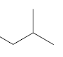 b. 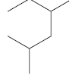 c. 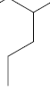
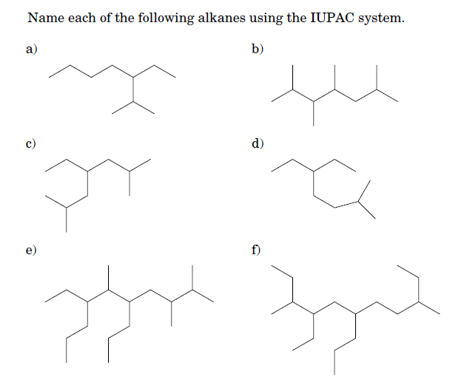

- Name each of the following molecules:
  - 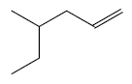 b. 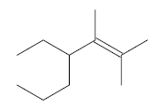 c. 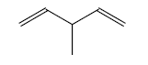
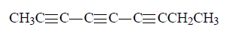
d.
e. 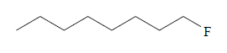 f. 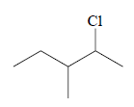

g. 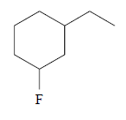 h. 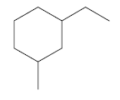 i.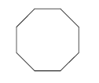

- Name the following molecules that contain functional groups:
  - 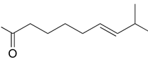 b. 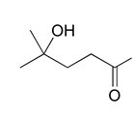

- 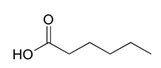 d. 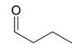

- 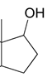 f. 