Physics Honors: Electrostatics Test

1. In which way(s) can objects be charged?
- Conduction
- Induction
- Polarization
- All answers are correct

2. An acetate rod is rubbed with cotton fabric and becomes positively charged. Which statement best explains why the acetate rod becomes positively charged?
- Protons were created as a result of the charging process
- The acetate rod acquired extra protons during the charging process
- The acetate rod acquired extra protons from the cotton
- The acetate rod lost electrons to the cotton fabric during the charging process

3. When are electrical forces between charges normally strongest?
- When objects are close together
- When objects are far apart
- When the electrical force is constant everywhere
- Distance is not a factor in determining force

4. An electrostatic force F, exists between two charges. If the distance between the charges is doubled, what is the force between the charges?
- 4F
- 2F
- 0.5F
- 0.25F

5. During an investigation of methods of charge transfer, students are asked to make an electroscope using an old peanut butter jar. They insert a metal coat hanger through the lid and bend a hook on the end that will be inside the jar. They hang a bent piece of foil on the hook. Once the lid has been screwed into place, they attach a ball of tinfoil to the end of the coat hanger outside the jar.
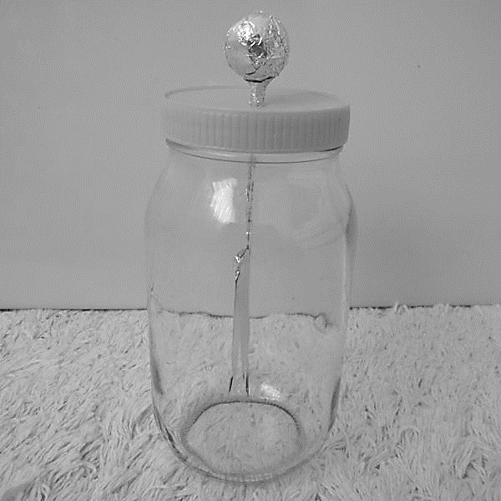
The students are asked to use an acrylic rod to charge the electroscope by conduction. They begin to develop the following procedure:
Step 1 | Touch the rod to the foil ball
Step 2 | Observe any movement of the foil inside the jar
Step 3 | Charge the rod
Step 4 | Ground the electroscope by touching a conductive material to the foil ball
The students agree that these steps would allow them to observe charging by conduction but they disagree on the order in which they should be completed. What is the correct order?
- 1,2,3,4
- 2,3,4,1
- 1,3,2,4
- 4,3,1,2

6. Two uncharged metal spheres, L and M, are in contact. A negatively charged rod is brought close to L, but not touching it, as shown below. The two spheres are then slightly separated and the rod is then withdrawn.
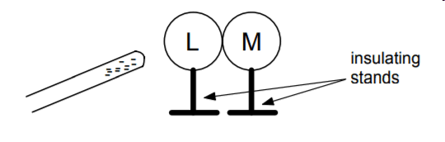
- Both spheres are neutral
- Both spheres are positive
- L is positive and M is negative
- L is negative and M is positive

7. Which type of charging is shown in the diagram above?
- Conduction
- Induction
- Polarization
- Radiation

8. Two pieces of tape are pulled off of a table and brought near each other. The same pieces of tape are then placed near each other and pulled apart. What results would you see and why?
- The pieces of tape pulled off of the table repel because each piece receives the same charge, because the same action was performed on each piece of tape.
- The pieces of tape pulled off of the table attract because each piece receives the same charge, because the same action was performed on each piece of tape.
- The pieces of tape pulled apart from each other repel because each piece received different charges.
- The pieces of tape pulled apart from each other attract because each piece received the same charge, because the same action was performed on each piece of tape.

9. A force of 50N exists between 2 charges placed a certain distance apart. If each charge is doubled, what amount of force would now exist between the charges.
- 12.5 N
- 100 N
- 200 N
- 800 N

10. A load of laundry consisting of cotton socks is placed in the dryer. An acrylic sock was accidently left in the dryer from the previous load. During the drying cycle, the acrylic sock is constantly in contact with the other socks. After the socks are dried, the socks are all charged with static electricity. What method of charging happened in the dryer?

- Conduction
- Friction
- Polarization
- Induction

11. In which material is electricity transferred the best?
  - Insulator
  - Conductor
  - Radiator
  - No difference between above

12. When you draw electric field lines around a positive charge, which direction do the arrows point?
  - To the right
  - To the left
  - Towards the particle
  - Away from the particle

Free Response Questions:
- A particle with a charge of +2.4*$10^{-6}$C is separated from another charged particle with a charge of –4.6*$10^{-6}$ C by a distance of 1.8 m. Find the direction (towards or away from each other) and the magnitude of electrostatic force between the particles.

Givens
Unknown
Equation
Substitution
Solve

