AP Physics – Newton’s Law Lab

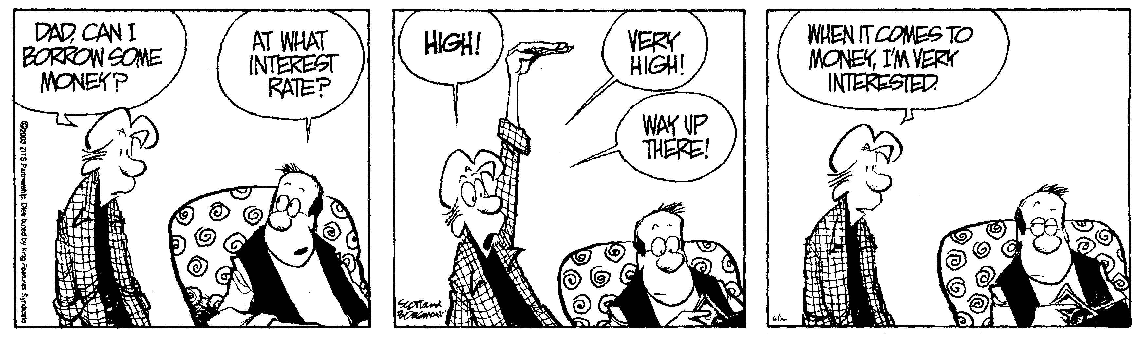
One day Alice came to a fork in the road and saw a Cheshire cat in a tree.
“'Which road do I take?” She asked.
“Where do you want to go?” Was his response.
”I don't know.” Alice answered.
“Then,” said the cat, “it doesn't matter.” -- Lewis Carroll

Okay, you’ve been learning all about Newton’s laws. So now you are going to devise a lab that will prove or show something about one (or, what the heck, more) of Newton’s laws.

Several pieces of your basic physics laboratory equipment will be situated out so that you can make use of it

May the force be with you.

