Newton’s Hovercraft
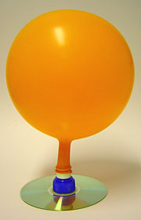
Objectives:
- to create a balloon powered hovercraft for maximum speed and distance
- to learn how to use the formula Speed= Distance / Time
- to understand Newton’s 3rd Law: Every action has an equal and opposite reaction

Materials
- Old CD
- Pop-top lid from a drink bottle
- Glue
- 1 Large Balloon and several small, long balloons
- Tape

What to do
- Close the pop-top lid and glue the base so the lid covers the hole in the center of the CD.
- Blow up a balloon and pinch the neck so that no air can escape.
- Stretch the neck of the balloon over the pop-top.
- Blow up the long balloons and tape them on the CD.
- Open the pop top lid and release the air from the long balloons. Measure the distance and time.

Data:

Team Member Names Distance Time Speed = distance/time

Conclusion:
- Who had the fastest hovercraft? Why do you think theirs was the fastest?

- Who had the slowest hovercraft? Why do you think it was the slowest?

- If you could begin this project again, what would you do different?

- How does the movement of the car show Newton’s 3rd Law? Explain thoroughly.

