Naming Alkanes Name: _____________
Chemistry/Bly Hour:_______
Naming alkanes with the IUPAC rules.
Step 1. Find the longest continuous chain of carbons (it doesn’t have to be straight). (Draw a line through these carbons if it’s helpful.) Assign an “alkane” name according to the number of carbons in this chain (such as “butane,” “pentane”).

Step 2. All carbons not in this main chain are “branches” connected to the main chain. Name each branch using the corresponding prefix with a “–yl” ending.
1 carbon - “methyl” 2 carbons - “ethyl” 3 carbons - “propyl”

Step 3. Number the carbons in the main chain so that the branch(es) have the lowest possible numbers assigned to them. Assign each branch a number corresponding to where it attaches to the main chain.
Step 4 If there is more than one of a type of branch, add a prefix:
2 = di 3 = tri 4 = tetra 5 = …don’t worry about five groups.
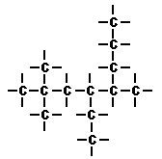

Name: .

Drawing Alkanes

Step 1. Draw the main chain (the last word on the right side of the name).

Step 2. Number the carbons from left to right.

Step 3. Attach branches according to the number of carbons in each branch (“___yl” words) and their position on the main chain.

*** it might be helpful to ignore any “di” or “tri” type prefixes in the branch names. “n-“ means normal and is representing the straight chain. ***

Example: 4-ethyl 2-methyl octane
Name the following alkanes

1. ________________________ 2. ___________________________
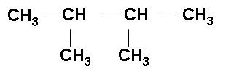
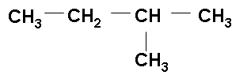

3. ________________________ 4. ___________________________

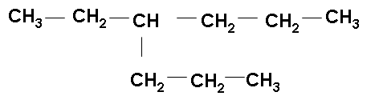
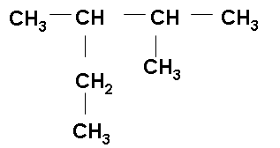

5. ________________________ 6. __________________________
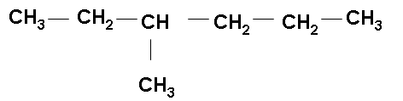
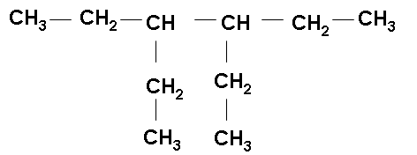

Draw these molecules:

7. 2, 2, 4-trimethyl pentane 8. 2, 3-diethyl 4-propyl octane

9. 3, 4-diethyl 2,2-dimethyl 3-propyl decane

