Quiz for Mythbusters: Young Scientists Video
(Scientific Method—Electric Vehicles)

Name: _______________________________ Period: _________ Date: _______________
Electric Cars


1. What problem are the Mythbusters trying to solve?
A. Which is better for the environment, electric cars or gas cars?
B. How big can an electric car be?
C. How fast can electric cars go?
D. Can batteries be used to make cars electric?

2. Even though they didn’t actually say it, the Mythbusters hinted at a hypothesis. Which would be the correct
hypothesis?

A. Wearing headphones and blindfolds can affect how you drive a car.
B. An electric car has to be a strange shape in order for it to work properly.
C. The way you drive a car affects how much electricity or gas the car uses.
D. An electric car is more sluggish (slower) than a gas-powered car.

3. What’s the procedure in Experiment 1 with the two cars?
A. Use two electric cars, drive them wearing headphones, and see which one is better.
B. Use an electric car and a gas car, ride in them blindfolded or wearing headphones, and later, tell which you
feel is going faster.
C. Use two cars, everybody ride in them blindfolded, and guess which one is electric and which one is gas.
D. Use an electric car and a gas car, ride in them blindfolded or wearing headphones, and watch the
speedometer to see which car is going faster.

4. Which variable below is a controlled variable?
A. One car uses electricity; the other, gas.
B. The headphones were used to block out the radio.
C. The cars are different colors.
D. The cars are the same type of car.

5. What is the manipulated (independent) variable?
A. One car uses electricity; the other, gas.
B. They used a blindfold on both rides.
C. The cars are different colors.
D. The cars are the same type of car.

6. What variable wasn’t controlled, that helped “give away” which car was electric and which was gas?

A. One car was more sluggish and didn’t speed up as fast.
B. Being able to see through the blindfold.
C. One car was heavier than the other.
D. How bumpy the road was.

7. In preparing for Experiment 2, what variable was manipulated in the newly built go-cart to make it run better?
A. the boy Brandon was no longer a passenger B. the tires smoke, not the wiring
C. 26 new lithium iron phosphate batteries D. 4 new tires

8. How did they decide to collect data in the go-cart experiment?

A. Going four laps and averaging the speed to find the best value.
B. Going four laps and the fastest one will count.
C. Counting how many spin-outs happened and subtract that from the go-cart’s speed.
D. Going all-out in one lap and counting it.

9. What unexpected variable could they not control on the electric go-cart, which might affect the experiment?

A. the horsepower of the engines
B. the stiffness of the steering wheel
C. how low the go-cart sat near the ground
D. the heavy weight of the batteries

10. What did the Mythbusters conclude?
A. Electric cars really are slower than gas cars.
B. The electric car “held its own” and both kinds of cars can go about the same speed.
C. Gas cars are “outdated” and are slower than electric ones.
D. Due to the unexpected variable (mentioned above) causing problems, they couldn’t make a conclusion.

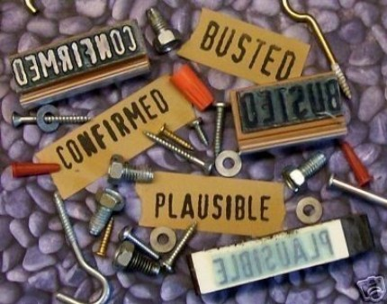

ANSWERS:
Mythbusters: Electric Cars
1. C
2. D
3. B
4. D
5. A
6. A
7. C
8. B
9. D
10. B

