AP Physics – My First AP Lab

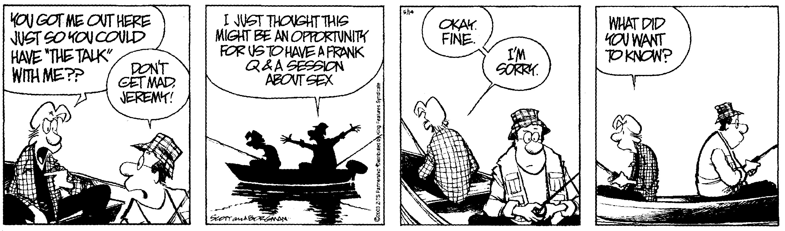
A Pessimist sees the difficulty in every opportunity. An Optimist sees the
opportunity in every difficulty. -- Winston Churchill

This is your first lab.

You’ve never done a lab for the Physics Kahuna before (maybe, okay, if you took physics last year you have, but pretend you didn’t).

AP Physics labs are a lot different than the ones you’ve done in your other science classes.

You’ve been given the format for lab reports. This will tell you what you have to do when you write the lab up. Read through the thing and comply with it.

In this lab you will find a whole bunch of circular stuff. Cans, bottles, flower pots, buckets, caps, &tc. You are going to pick out ten objects. Measure the diameter and circumference of each object. Use appropriate metric units. When you record your measurements ensure that you utilize proper significant figures. (See the handout on significant figures.)

Construct a graph (graph paper is available). Plot diameter on the x axis and circumference on the y axis.

The important part – why you are doing this. Make sense of the numbers and the graph. Analyze the thing. Use what you already know about math and science to look at the graph and make some determinations about the values and information that it displays.

This is your first opportunity to impress the Physics Kahuna with the power of your intellect.

Don’t blow it.

May the force be with you.

