Motor Skills
(You know the fun stuff!)

The following are a list of all the PE type games that I play with my kids. Most of us will be very familiar with them. The games work on various physical motor skills such as working with large groups, moving safely in large groups, locomotor skills, ball skills, teamwork, etc.
- Locomotoring around
- Movement songs
- Partner Games
- Scooters
- Balloons
- Jump Rope
- Parachute
- Beach Balls
- Beanbags
- Target Toss
- Scarves (juggling)
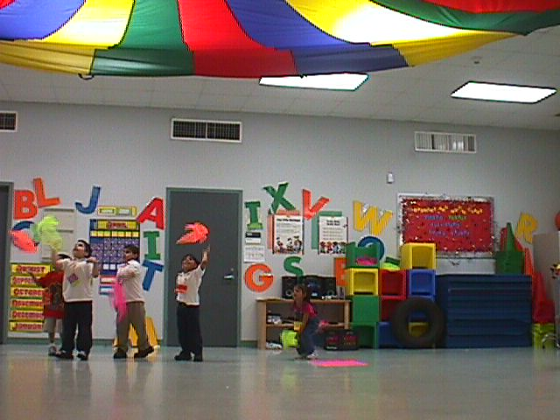
- Ice Skate (sliding around on white wash cloths)

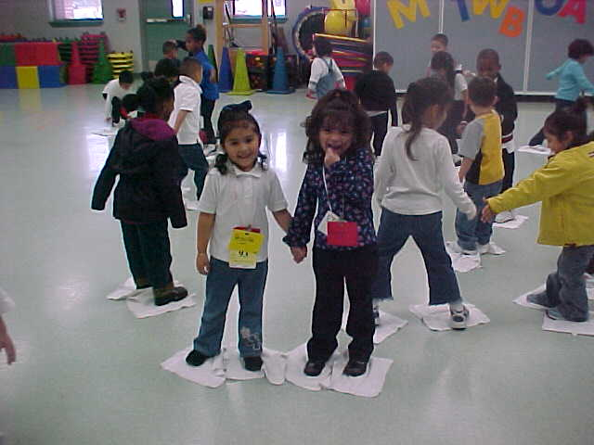
- Tunnel Fun

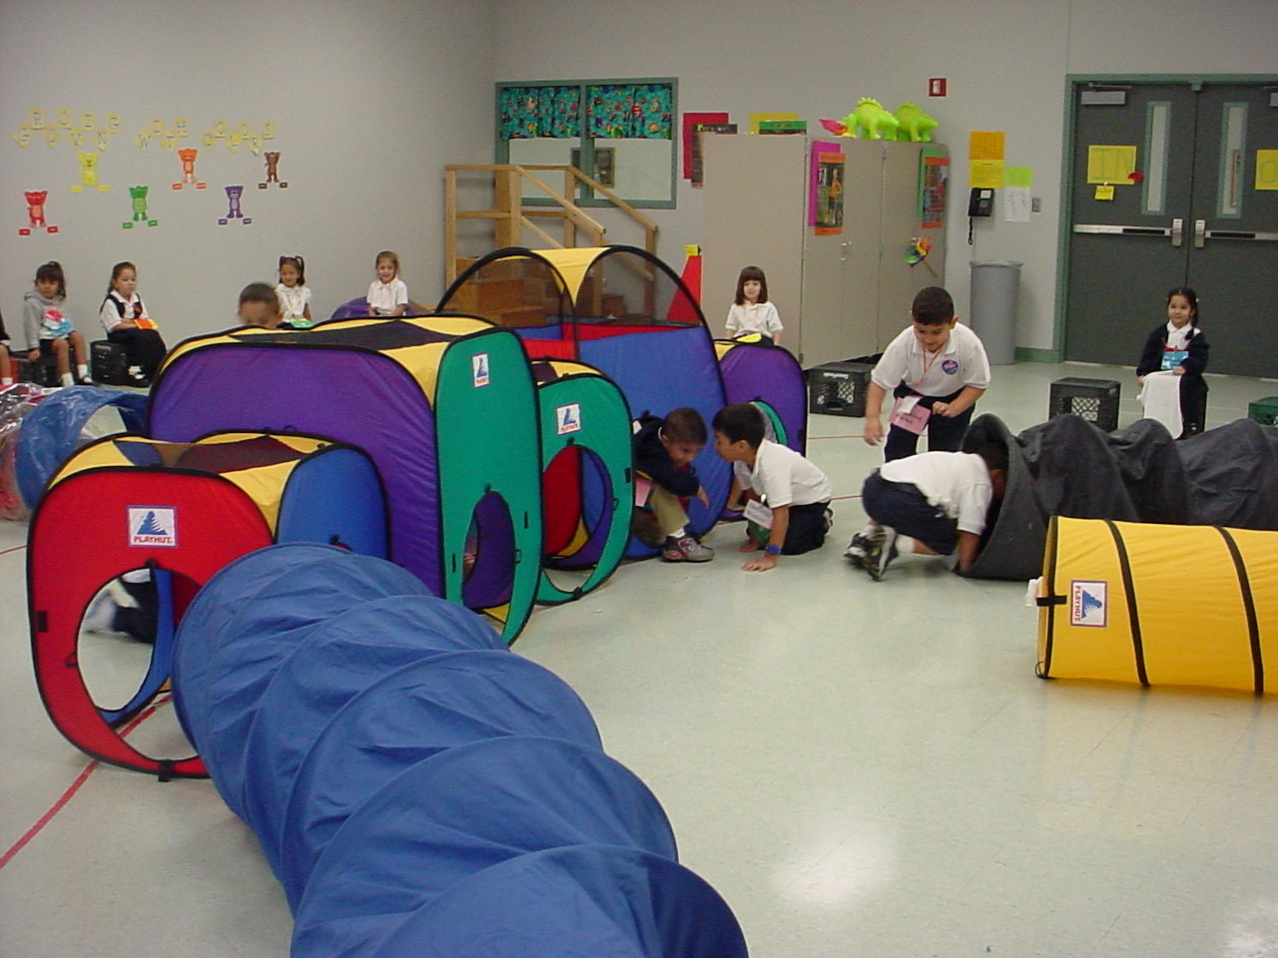
- Basketball
- Soccer
- Fun noodle Games

The above is also in the same order that I teach the activities.

