/50
Modeling Transcription Activity

Introduction

Transcription, or RNA synthesis, is the process of creating an equivalent RNA copy of a sequence of DNA Both RNA and DNA are nucleic acids, which use base pairs of nucleotides (nts) as a complementary language that can be converted back and forth from DNA to RNA in the presence of the correct enzymes. During transcription, a DNA sequence is read by RNA polymerase, which produces a complementary, anti-parallel RNA strand. As opposed to DNA replication, transcription results in an RNA complement that includes uracil (U) in all instances where thymine (T) would have occurred in a DNA complement.

Method
Apparatus per Group (4 +/-)

1 Bag of Miniature Marshmallows (deoxyribose/ribose and/or bases)
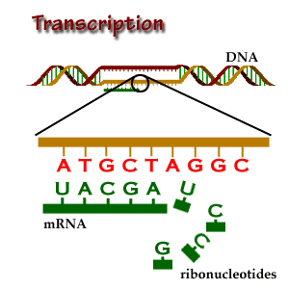
Cheerios (phosphate groups)
Toothpicks (bonds)
(3) Note Cards
(2) Post-it Notes
Fine Tipped Marker
Wide/Chisel Tip Markers (ie. pen + GEAR; 8 count):
Blue, Red, Green, Yellow, and Orange
References

Procedure

Create a DNA Segment:

1. Using toothpicks and white marshmallows (deoxyribose), create (2) DNA “backbones” that
are each (40) marshmallows long. However, between each “deoxyribose” place a Cheerio
“phosphate group” on the toothpick. Note: On one of the ends of each of your backbones, you
will have a toothpick with just a single Cheerio on it (no “deoxyribose” attached); thus, you
should have (40) “phosphate groups” per backbone, too.

2. Using toothpicks and white marshmallows (bases), create bases along the “backbones” by
placing the toothpick marshmallow combination into each “deoxyribose” marshmallow along
the backbones.

3. Check to see if each backbone has a 3’ (no phosphate group) and a 5’ (with a phosphate
group) end. Also, make sure that the backbones are “anti-parallel”; if not turn them around.

4. Select which strand/backbone of DNA you wish to be the “Sense Strand/Template” that will
create a pre-mRNA in a 5’ → 3’ direction.

* When completed, ask to be checked

Create a Gene: Be sure to read each step completely through before performing the step.

Use the colored marker key to create the bases by placing a large corresponding colored dot on the marshmallow for that base: A, T, G, C, or U

Adenine = Blue  Thymine = Red  Uracil = Orange (to be used later) | Guanine = Green  Cytosine = Yellow

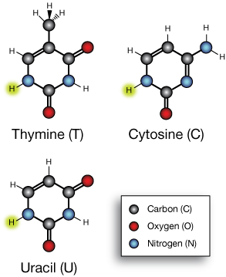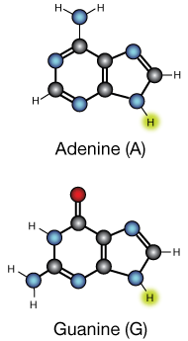

5. Starting on the 3’ end of your chosen Sense Strand DNA backbone, create a Promoter starting
with (4) TATA bases (aka Box) followed by (6) bases of your choice. However, with your
choices do not use any of the following combinations: TAC, ATT, ATC, or ACT. In reality the
Promoter may be between ~15-300 bases (nts) long and that not all Promoters start with a
TATA Box). Note: The Non-Sense Template is assumed to have complementary bases (which
will not be created/represented here)

6. After your last base choice, create a Coding Sequence starting with the (3) bases TAC followed
by (9) more bases of your choice. However, with your choices do not use any of the following
combinations: TAC, ATT, ATC, or ACT. Once you have added your Coding Sequence, now
you may add any of the following (3) base sequences: ATT, ATC, or ACT. In reality a Coding
Sequence can be 100’s – 1,000’s of nts long.

7. After your last base choice, create a Polyadenylation Signal Sequence (PSS) by adding any of
the following (6) base sequences in order to end the gene segment: TTA TTT or TAA TTT

At this point you should a “total” of 31 labeled bases representing a hypothetical gene.

* When completed, ask to be checked

Create a Transcription Fork and RNA Pol (w/ BTFs):

8. Show unzipping by creating a “fork” at the beginning with the promoter.

9. On a notecard, write out RNA Pol and on (2) Post-it notes, write BTF. Place the RNA Pol at
the “fork” and the Basal Transcription Factors alongside of each DNA strand.

* When completed, ask to be checked

Create a pre-mRNA:

10. Using toothpicks, white marshmallows (ribose), and Cheerios, create a “pre-mRNA” strand
from the Sense Strand DNA backbone by creating an RNA “backbone” with complementary
paired bases in a 5’ → 3’ direction. Start “after” the Promoter; thus, with TAC and continue
until you have reached the end of your PSS; thus, include the PSS. Do not forget to use
Uracil (U) in order to replace Thymine (T) for this entire process.

11. Restore the DNA by placing the complementary DNA bases close together (no hydrogen
bonding / toothpicks)

* When completed, ask to be checked

Creating a Refined Code:

12. Create a “refined mRNA” by removing any (3) bases (nts) sequences that are close together
within the middle of the pre-mRNA. These (3) bases (nts) are referred to as “intron”.

13. Reconnect the remaining bases which are now referred to as “exon”; RNA that is now free to
be used to code for a protein.

14. Label a note card, “spliceosome” and bend it in half. Place the enzyme in the place where
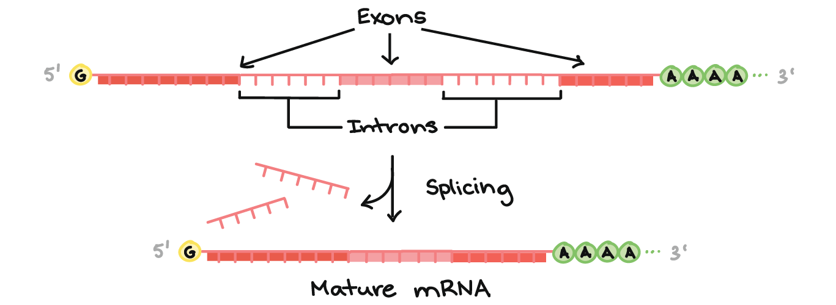
you removed the intron.

* When completed, ask to be checked

Creating an mRNA:

Methylated Guanosine Cap:
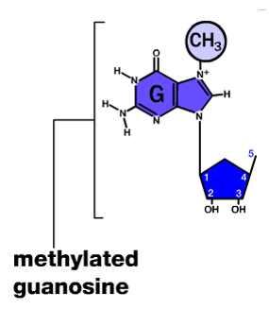
15. Create a “Guanosine” nucleotide; but, also bond a marshmallow
with the formula, “CH₃” written on it with a fine tipped black
marker, to the base of your nucleotide in order to make a
“methylated guanosine”.

16. Bond the “methylated guanosine” to the 5’ end of your RNA
molecule to create the “cap”. Note: Other CH3’s may bond
with other nucleotides at the end to ensure that a “cap” has
been created.

Poly A Tail:

17. Create (5) “Adenine” nucleotides and using a toothpick and Cheerios, bond them to each
other and then bond the last one to the 3’ end of your RNA molecule to create the “tail”. In
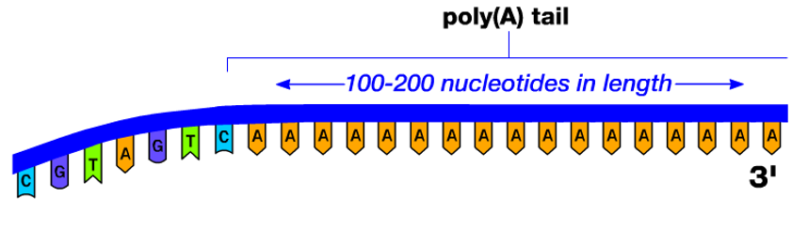
reality, the tail can be 100-200 nts long.

* When completed, ask to be checked *

