Modeling Protein Synthesis Activity

Introduction

Traits are passed on from one generation to the next and are based on the types of proteins that are made by the cell. All organisms carry an elaborate blueprint containing the information necessary to develop and maintain life. This genetic instruction manual is located in a chemical molecule called DNA, which is found within a person’s genes (sections of a DNA molecule). The instructions are passed to mRNA, which provides a sequence of bases (code) for tRNA to bring amino acids to a ribosome where the two molecules meet. As a result, a “protein” is made.

Apparatus

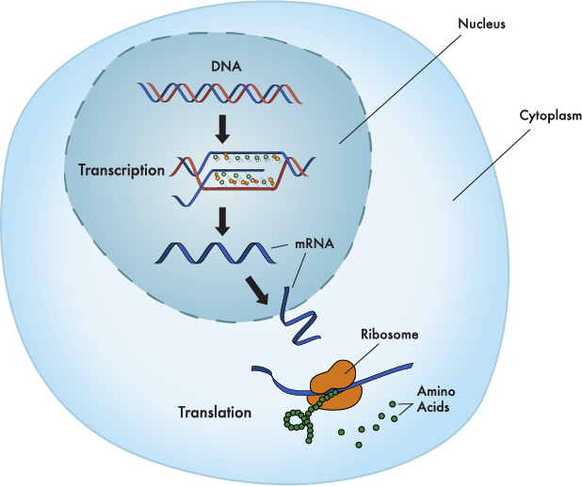
Stock Table:

barrel pony beads (royal blue) = deoxyribose sugars
barrel pony beads (light blue) = ribose sugars
tri-beads (crystal) = phosphate groups

blue chenille stems (pipe cleaner) = adenine
red chenille stems (pipe cleaner) = thymine
green chenille stems (pipe cleaner) = guanine
yellow chenille stems (pipe cleaner) = cytosine
orange chenille stems (pipe cleaners) = uracil

* Note for teacher: chenille multi- package “Fibre-Craft”:3228-10 (100 pc) has
all necessary colors for DNA & RNA / pkg. per Class

Group:

(2) Dixie-cup (to hold beads)
craft-wire (spool) = for DNA “and” mRNA backbone (showing phosphodiester bonds)
ruler
needle-nose pliers w/ wire cutters
(5) large paper clips = for tRNA backbone (showing phosphodiester bonds)
note card (large, standard / best w/ no lines) = for amino acids
scissors
tape = for peptide bonds
fine black marker
plastic box (to hold models for next in the series)
references

DNA Construction Activity: Part 1

Procedure

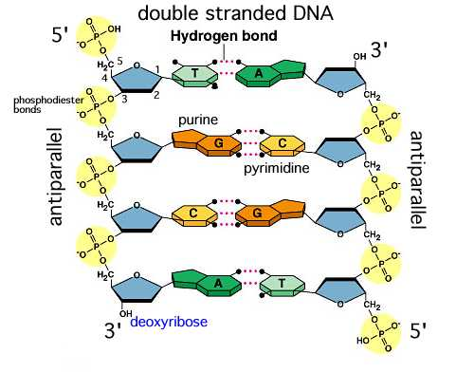
1. Measure 60 cm craft wire and cut it in half so that you have two
(2) 30 cm pieces.

2. Gather two (2) of each “chenille stem” (pipe cleaner) color [not
for Uracil]. Using a ruler and wire cutter carefully and exactly cut
the “chenille” stems (pipe cleaners) into (6) 5 cm “base” pieces.
(note: using the black marker to measure the chenille stems prior
to cutting may help)

3. Gather (36) royal blue Barrel Pony Beads and (36) clear Tri-Beads (Note: best to use a Dixie-
cup for each to scoop them from the stock table and count them at your table – return extra or
gather extra if needed). Construct one strand or side of the DNA molecule by first threading
and then tying/twisting a Tri-Bead to the end of the wire first as an anchor to prevent other
beads from sliding off the wire. Then string a Barrel Pony-Bead. Continue to alternate
between each bead until you have strung eighteen (18) of each. Thread and then tie/twist the
last bead, a Barrel Pony-Bead, to the end of the wire only. This is your 5' → 3' strand.

4. Construct the other strand of the DNA molecule by first threading and then tying/twisting a
Barrel Pony-Bead to the end of the wire first as an anchor to prevent other beads from sliding
off the wire. Then string a Tri-Bead. Continue to alternate between each bead until you have
strung eighteen (18) of each. Thread and then tie/twist the last bead, a Tri-Bead, to the end of
the wire only. This is your 3' → 5' strand.

5. Lay both strands anti-parallel to each other by having a different ending bead facing each
other on opposite ends. (note: the 5’ ends show a “phosphate group” or Tri-Bead).

6. Choose the 5’→3’ strand and begin attaching the 5 cm “chenille” bases in the following order
using the following key and sequence below:

- Only thread and bend just around once, one end of a “chenille” base through the “Barrel-Bead” sugar; the other end (~4 cm) of the “chenille” base will be used later.
- The 5’→3’ strand that you chose will be considered the “anti-sense strand/template”
- START ON THE 5’ END (THE TRI-BEAD (PHOSPHATE GROUP) END)!!!
- You may have extra “back-up” bases.

DNA Base Key and Sequence

* Note: Phosphate group or “tri-bead” = always attaches to the 5’ carbon end

Adenine = blue  Thymine = red | Guanine = green  Cytosine = yellow

Tri-Bead → 5’- A T G , C T C , A T A , G C T , A G C , T A G -3’ ← Barrel-Bead
7. Using the other strand, begin attaching the other 5 cm “chenille” bases in the following
order using the previously mentioned key and the following sequence below:

- The sequence should be a complementary pairing to the “sense strand”. (ie. A=T; C = G)
- The strand that you are going to construct will be considered the 3’→5’ or “sense strand/template”
- The blank bases “__” are ones that you have to figure out from the base code of the “anti-sense” strand/template on top. (i.e. the first __ below on the “sense strand/template” would be a C from the G on the “anti-sense” strand/template above that you just constructed)
- START ON THE 3’ END (THE BARREL-BEAD (SUGAR) END)!!!
- Do not try to create this strand by matching “bases” from the strand you just made.
- You may have extra “back-up” bases.

Barrel-Bead → 3’- T A __ , G __ G , T A __ , __ G A , T __ G , __ T __ -5’ ← Tri-Bead

8. Hook and bend a small yet exposed end of the “bases” together to form the “rungs” of the
ladder neatly. (note: these will have to be easily unattached later). If you did the model
correctly, blue bases will bond with red; green bases will bond with yellow.

9. When complete, ask to be evaluated: (see questions below)

- Where is the DNA found in eukaryotes?
- Name 8 parts of the DNA molecule?
- What does it mean to have DNA anti-parallel?
- Check KEY

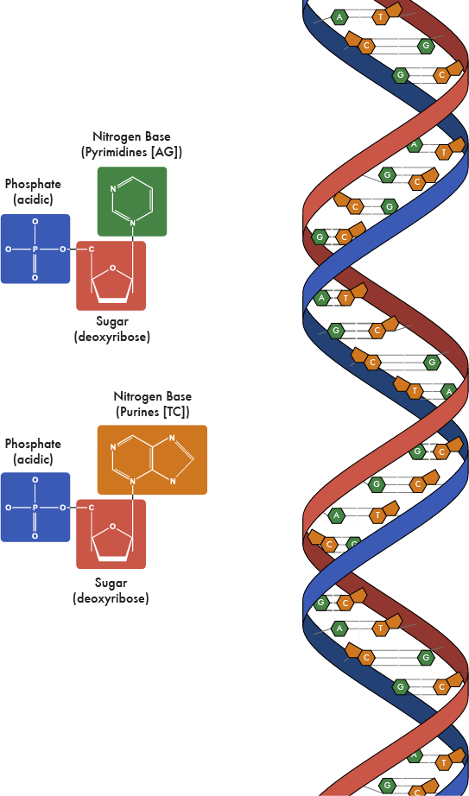

General RNA (mRNA) Construction: “Transcription” Part 2

Transcription occurs in the nucleus of a cell. Transcription is the process through which a DNA sequence is enzymatically copied by RNA polymerase II to produce a complementary RNA. Or, in other words, the transfer of genetic information from DNA into RNA. In the case of protein-encoding DNA, transcription is the beginning of the process that ultimately leads to the translation of the genetic code (via the mRNA) into a functional protein(s). The coding mRNA sequence can be described as a unit of three nucleotides called a codon. Note: prior to mRNA, pre-mRNA must first be made.
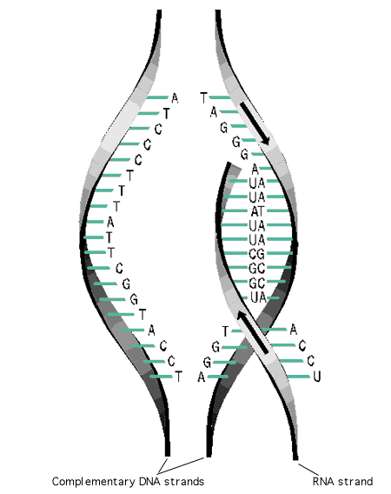
Procedure

1. Gather one (1) of each “chenille stem” (pipe cleaner) color [not
for Thymine]. Using a ruler and wire cutter carefully cut the
“chenille” stems into (6) 5 cm “base” pieces. (note: using a black
marker to measure the stems prior to cutting may help)

2. Gather (18) light blue Barrel Pony Beads and (18) Tri-Beads.
Using the Barrel Pony-Beads and the Tri-Beads, construct 18
pre-mRNA nucleosides (base + sugar): 5 w/ A, 5 w/ U, 4 w/ G,
and 4 w/ C by using the following key and directions: (steps 3-10)

RNA Base Key and Sequence

Adenine = blue  Uracil = orange | Guanine = green  Cytosine = yellow

3. Thread and bend around one end of the “chenille” base through a “Barrel Pony-Bead” sugar;
the other end of the “chenille” base will be used later.
- Note that uracil (U) “orange” will be replacing thymine (T) red on the mRNA.
- You may have extra “back-up” bases.

4. Demonstrate how a DNA separates to expose its bases for transcription by “unzipping”
your previously made DNA between the bases.

5. Using the 3’ → 5’ DNA “sense” strand (side with the Thymine (red) base on the 3’ end),
match (line-up) each RNA nucleoside’s base you just made with its complementary base on
the DNA “sense” strand on the table in a 5’ to 3’ order like RNA Pol would.

6. Measure and cut off 30 cm craft wire.

7. Construct a pre-mRNA backbone by first threading and then tying/twisting a Tri-Bead
(phosphate group) to create a 5’ end of the wire first as an anchor to prevent other beads from
sliding off the wire.

8. String your first nucleoside that was laid down (one with Adenine (blue) base) through the
sugar (Barrel Pony-Bead).

9. Continue with the rest of the sugars (Barrel Pony-Beads); however, add a Tri-bead
(phosphate group) between each of the sugars (Barrel Pony-Beads) that were laid down
with their colored Chenille (base) until you have strung eighteen (18) of beads.

Note: An enzyme called “RNA Polymerase” helps make pre- mRNA by adding/proofreading the
pre-mRNA nucleotides together based on the 3’ → 5’ DNA “sense” strand.

10. Tie/twist the last bead, a Barrel Pony-Bead, to the end of the wire.

11. As with “transcription”, finish by reattaching your DNA.

12. It will be assumed that the pre-mRNA will have been refined (ie 5’ methylated guanine cap,
exons (in) / introns (out), poly-A tail) prior to leaving the nucleus into becoming mRNA at
this point.

13. When complete, ask to be evaluated and checked: (see questions below)

- What is the name of the process you just completed called?
- How many sets of “codons” did you create on your pre-mRNA?
- You made a pre-mRNA. After it’s been processed (Poly (A) tail) added and after “introns” have been removed, what is the new RNA molecule now called?
- Check KEY

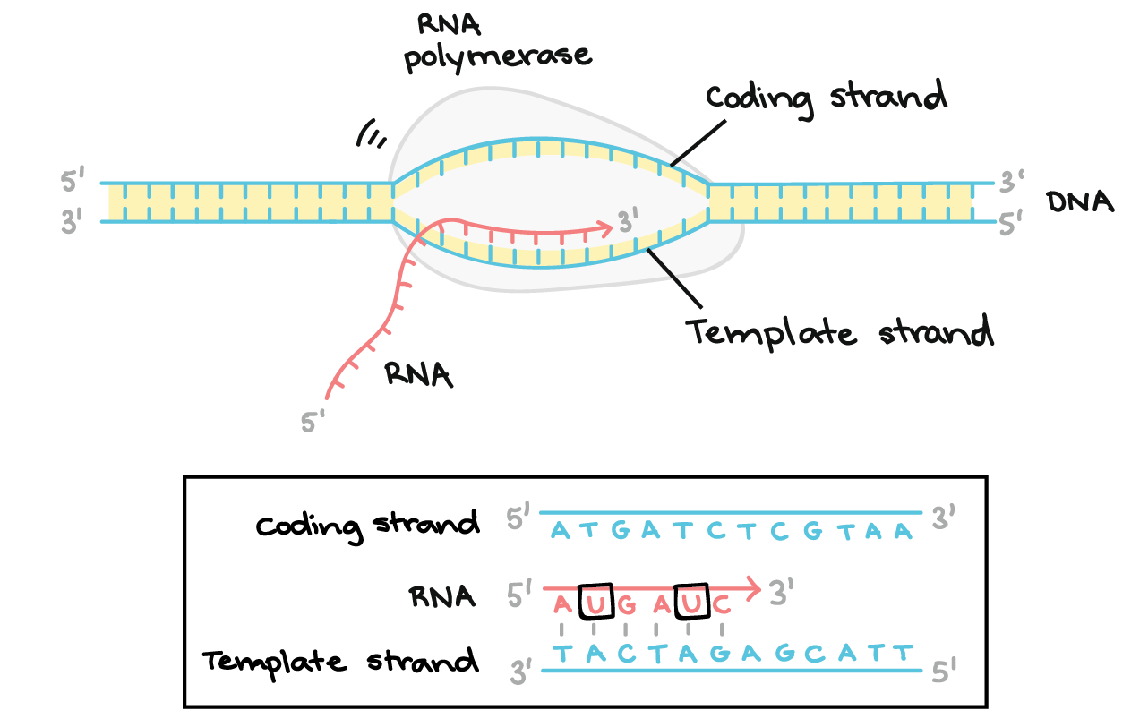

General Protein Synthesis Simulation: “Translation” Part 3

The ribosome in the cytoplasm is where Translation takes place. The ribosome binds to the mRNA at the start codon (AUG). The ribosome then goes along the mRNA strand. While the ribosome is moving, amino acids, linked to tRNA, bind to their appropriate codon on the mRNA; thus, forming complementary base pairs within the ribosome. As the ribosome continues to move from codon to codon along the mRNA, amino acids are added one by one by means of peptide bonds. At the end, the nonsense codon “stop codon” terminates translation and a protein is released.

Procedure
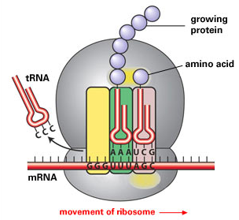
1. Gather one (1) of each “chenille stem” (pipe cleaner)
color [not for Thymine]. Using a ruler and wire cutter
carefully and exactly cut the “chenille” stems into (6)
5 cm “base” pieces. (note: using a black marker to
measure the stems prior to cutting may help)

2. With the “large” paper clips, bend down only one outer
wire into a “right angle” leaving the rest of the clip alone
to be able to hold a piece of paper.

3. Gather (15) light blue Barrel Pony Beads and (10) Tri-Beads. Using your under-
standing of RNA and/or references, construct a single tRNA molecule by stringing first
a Barrel Pony Bead to the wire and then stringing a Tri-Bead until you have strung
three (3) Barrel Pony Beads and (2) Tri-Beads. Note that the rest of the paper clip wire
is to simulate the continuation of the “sugar-phosphate backbone” of an RNA
molecule; about 80 nucleotides long.

4. Using pliers, slightly bend the one end of each paper clip that was placed into a “right
angle” upwards/around to prevent the beads from falling off. Complete 2-4, 4x’s in
order to have a total of 5 tRNA’s

5. Using the just created tRNA molecules, attach the 5 cm “chenille” bases using the
following key:

tRNA “anti-codon” Base Key

* Note: each tRNA molecule will only have three (3) bases attached to their sugars; collectively these bases are called “anti-codons”

Adenine = blue  Uracil = orange | Guanine = green  Cytosine = yellow

tRNA #1: U C G | tRNA #3: U A U | tRNA #5: C G A
tRNA #2: G A G | tRNA #4: U A C

- Only thread and bend around one end of the “chenille” base threw the “Barrel-Bead” sugar; the other end of the “chenille” base will be used later.
- Be sure to place the sequence from left-to-right for every tRNA molecule.
- The bases on the tRNA molecule are called, “anti-codons” and will be used to bond with complementary bases on the mRNA called, “codons”.

6. Using the note card, bend it into 6 equal squares (bend 1x horizontally and then 2x
vertically). Using scissors, cut out the squares that you outlined by bending the card.

7. Using the table below, write the following names of these amino acids or function and
letter(s) in quotes (“”) on each “side” of each card:

for tRNA #1: Serine “N” | for tRNA #3: Isoleucine “OT” | tRNA #5: Alanine “EI”
for tRNA #2: Leucine “R” | for tRNA #4: Methionine “P” | Non-Sense (stop) “!”

8. Match each amino acid (card) with the correct tRNA by placing the amino acid (card)
in the paper clip. For example, tRNA #1 needs to have “Serine” attached.

9. Create a “polypeptide” by using the anti-codon bases on the tRNA molecules and the
codon bases on the mRNA molecule. Match up each tRNA’s anticodon with its
complementary codon on the mRNA molecule. You may want to use the chart below
to confirm your amino acid -to- mRNA codon match. It is not necessary to attach the
bases.

10.As you match the “complementary bases”, create a “peptide bond” between the
amino acids by taping the cards (amino acids/functions) together AND releasing the
“polypeptide” card from the tRNA (paper clip) molecule(s). Remember, the
“Nonsense” card has no amino acid or tRNA associated with it; thus, it’s not part of the
protein and no peptide bond is created between it and the last amino acid.
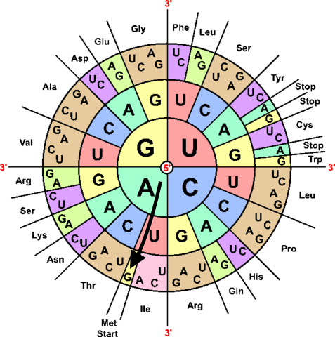
When completed, ask to be evaluated: (see questions below)

- What do the tRNA’s bring to the
mRNA’s?
- Where does this process of
translation occur?
- Do you think that more than
one “codon” could stand for
the same amino acid?
- What is the “hidden word”
when you placed the amino
acids in correct order and
what is its definition?

Modeling Protein Synthesis Activity
Key

Adenine = blue  Thymine = red  Uracil = orange | Guanine = green  Cytosine = yellow

DNA: Color Code

NON-SENSE: (5’) Tri-Bead End → B R G, Y R Y, B R B, G Y R, B G Y, R B G → Barrel Bead End (3’)

SENSE: (3’) Barrel Bead End → R B Y, G B G, R B R, Y G B, R Y G, B R Y → Tri-Bead End (5’)

mRNA (pre-mRNA): Color Code; Based off “SENSE” DNA

(5’) Tri-Bead End → B O G, Y O Y, B O B, G Y O, B G Y, O B G → Barrel Bead End (3’)

Protein: mRNA Codons and AA Sequence

A U G C U C A U A G C U A G C U A G

MET LEU ILC ALA SER (stop)

P R OT EI N !

