Naming Hydrocarbons Review
Part 1: (36 pts) Name each of these.

 | 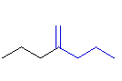 | 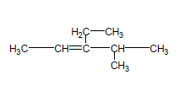
 | 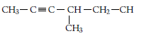
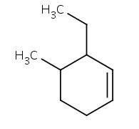 | 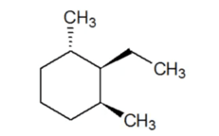 | 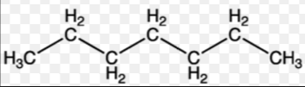
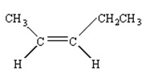  cis or trans? | 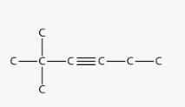
2. (16pts) Draw the skeleton structures (carbons) for the following: Please do not draw line structures. If the structure is labeled cis- or trans-, please add the two hydrogens to the carbons that are double bonded in the appropriate location.

(a) 3-methyl-2-hexene

(b) 2-ethyl-3-methyloctane

(c) 3,5-diethyl-2,4-dimethyl-5-propyldecane

(d) 4-ethyl-1,1-dimethlycyclohexane

( e ) cis-2,6-dimethyl-3-heptene

(f) 1-ethyl-3-propyl-cyclohexene

(g) trans-6,6-dimethyl-3-nonene

(h) 3-chloro-1-pentyne

