Mitosis – Meiosis Tutorial

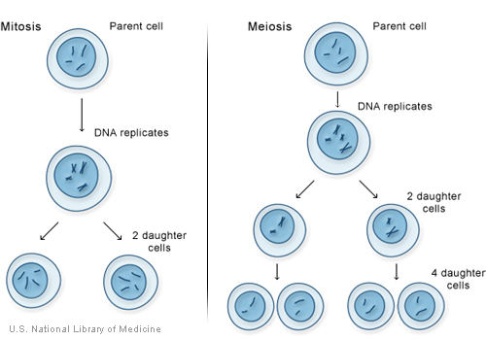

Mitosis Tutorial:

http://www.sumanasinc.com/webcontent/animations/content/mitosis.html

Meiosis Tutorial:

http://www.sumanasinc.com/webcontent/animations/content/meiosis.html

A side by side comparison of mitosis & meiosis:

http://www.pbs.org/wgbh/nova/baby/media/divi.swf

Another excellent tutorial with excellent practice questions:

http://www.biology.arizona.edu/CELL_BIO/tutorials/cell_cycle/main.html

http://www.biology.arizona.edu/CELL_BIO/tutorials/meiosis/main.html

Here’s a great game: http://www.quia.com/rr/195724.html

and another: http://www.studystack.com/matching-13355

