Name: Date:
Mrs. Tennant Science 7 per:

Punnett Square Minion Genetics Lab
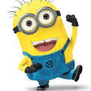
Bello!! Genetics Rocks!!

Objective: For students to learn and understand how to read a word problem, create Punnett Squares and solve a Punnett Square. For students to learn and understand how to determine phenotype and genotype.

Directions: For each problem, create a key and then fill in the Punnett Square accordingly. Write the genotype and phenotype for each offspring.

1. In Minions, the trait for two eyes is dominant to one eye. Show the cross between a homozygous one eye female with a heterozygous two eye male. What are the expected genotypes and phenotypes of the offspring?
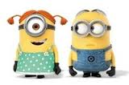

Key: = Parents: _______ x__________
=

Phenotype: %
%

Genotype: %
%
%

2. In Minions, the trait for wolverine is recessive!! The trait for non-wolverine is dominant. Show the cross between a homozygous non-wolverine female with a homozygous wolverine male. What are the expected genotypes and phenotypes of the offspring?
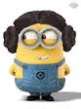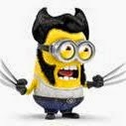

Key: = Parents: _______ x__________
=

Phenotype: %
%

Genotype: %
%
%

3. In Minions, having an elephant nose is recessive to non-elephant nose. Show the cross between a homozygous elephant nose male with a heterozygous non-elephant nose female. What are the expected genotypes and phenotypes of the offspring?
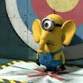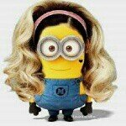

Key: = Parents: _______ x__________
=

Phenotype: %
%

Genotype: %
%
%
4. In Minions, having spiky hair is dominant to non-spiky hair. Show the cross between a homozygous spiky-hair male with a homozygous non-spiky hair female. What are the expected genotypes and phenotypes of the offspring?
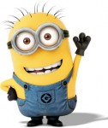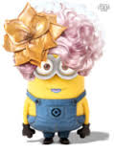

Key: = Parents: _______ x__________
=

Phenotype: %
%

Genotype: %
%
%

Conclusion Questions:
- In a Punnett Square, what percentage does each individual box represent?
- What is the difference between phenotype and genotype?
- Reflect on today’s lab activity and write 2-3 full sentences on what you learned.
