What kind of boundary is located at C? _______________________ at B? _______________________

Use the following terms to correctly identify the following features/processes:
Subduction, convection current, mid ocean ridge, deep sea trench, island arc volcanoes

A. ___________________ B. ________________________ C. ___________________
D. ________________________ E. ___________________
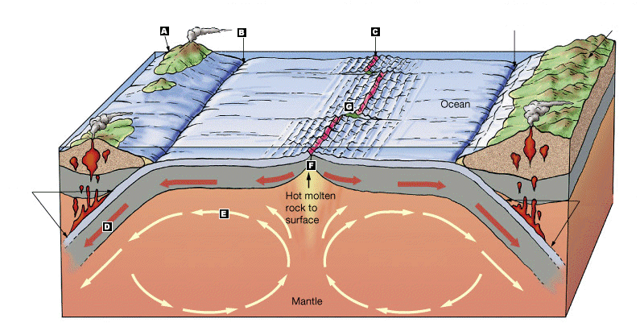

What kind of boundary is located at C? _______________________ at B? _______________________

Use the following terms to correctly identify the following features/processes:
Subduction, convection current, mid ocean ridge, deep sea trench, island arc volcanoes

A. ___________________ B. ________________________ C. ___________________
D. ________________________ E. ___________________

