Mendel’s Peas
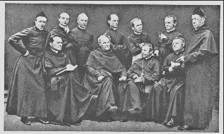
A bunch of guys with a lot of time on their hands…

Mendel is standing (second from the right) looking at a pea-plant while the photo is being taken.

It is not too difficult to understand why his work was not appreciated until rediscovered 50 years later! Try reading his original http://www.mendelweb.org/CollText/homepage.html

A quick review:

http://www.quia.com/cb/286828.html

Here is a nice Tutorial – check out the first four links:

http://www.mhhe.com/biosci/genbio/espv2/data/genetics/002/index.html

Try Problems 1,2,3 & 4 at the bottom of this link:

http://www.execulink.com/~ekimmel/mendel1a.htm

Here is another good tutorial: Focus on the monohybrid and the dihybrid crosses for now.

http://www.biology.arizona.edu/mendelian_genetics/mendelian_genetics.html

