Name:_____________________________________________ Class:___________
Intro to Medical Terminology Test
Write the correct answer in the blank to the left of the number
_____ 1. The _____ plane divides the body into dorsal and ventral.
A) Sagittal B) Transverse C) Coronal D) Midsagittal
_____ 2. Dorsal is to posterior as _____ is to anterior.
A) Ventral B) Lateral C) Superior D) Distal
_____ 3. ______ is to cephalic as inferior is to caudal.
A) Proximal B) Superior C) Anterior D) Radial
_____4. Your toes are _____ to your knee.
A) Proximal B) Superior C) Cephalic D) Distal
_____ 5. The outside of the knee is _____ to the midline.
A) Lateral B) Inferior C) Medial D) Posterior
_____ 6. The spine is on the _____ side of the body.
A) Anterior B) Ventral C) Posterior D) Distal
_____ 7. The lungs are _____ to the intestines.
A) Inferior B) Ventral C) Superior D) Proximal
_____ 8. Your shoulder is _____ to your elbow.
A) Distal B) Proximal C) Posterior D) Inferior
Matching: Write the letter from the picture in the correct blank in the list
A
_____ 9. Posterior
_____ 10. Inferior
_____ 11. Coronal
_____ 12. Anterior
_____13. Transverse
_____ 14. Superior
_____ 15. Midsagittal
** D/E are on either side of plane C
** F/G are on either side of plane B
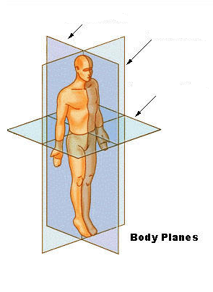
F
E
D
G
C
B

Write the correct answer in the blank by the number
_____ 16. A/an _____ is a sign
A) Headache B) Fever C) Upset Stomach D) Chill
_____ 17. A collection of signs and symptoms is a _____
A) Diagnosis B) Prognosis C) Disease D) Syndrome
_____ 18. Histology is the study of ______
A) History B) Cells C) Tissues D) Histamines
_____ 19. Cytology is the study of _____
A) Cells B) Cytoplasm C) Muscles D) Eyes
_____ 20. Anatomy is the study of _____
A) Structures of the body B) functions of living systems C) cells D) Animals
_____ 21. Physiology is the study of_____
A) structures of the body B) emotional stress C) physical activity D) functions of the structures of the body
_____ 22. The rapid onset of a disease or a condition is a/an _____ disease.
A) Syndromatic B) Acute C) Chronic D) Lateral
_____ 23. Nausea is a/an _____
A) symptom B) Disease C) Eponym D) Sign
_____ 24. An example of an eponym is _____
A) Hepatitis B) Muscle weakness C) Edward’s Syndrome D) Colonoscopy
Matching: Write the letter from the picture in the correct blank in the lis

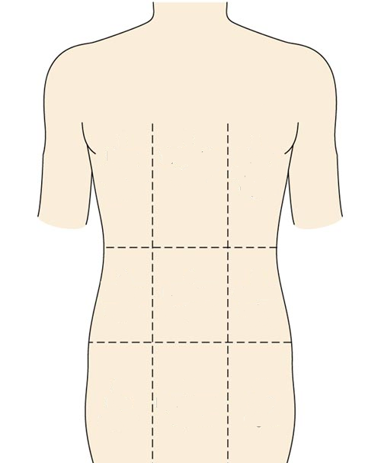
B
A
D
E
F
I
H
G
C
______ 25. Right Hypochondriac
_____ 26. Hypogastric
_____ 27. Left Lumbar
_____ 28. Umbilical
_____ 29. Epigastric
_____ 30. Right Iliac
_____31. Left Hypochondriac
_____32. Right Lumbar
_____33. Left Iliac

Define the term.
Mark an X over the prefix, circle the root, and underline the suffix
Prefix root suffix
34. Hepatology:______________________________________________________

35. Hypogastric:_____________________________________________________

36. Myelitis:_________________________________________________________

37. Tachycardia:_____________________________________________________

38. Osteocyte:________________________________________________________

Bonus: Write your own medical term, define it, and mark is like above

_______________________:______________________________________________

