Match Stick Rocket – Safety Lab
A small solid propellant rocket is made from a match and a piece of aluminum foil. The exhaust of the fire produced from the burning match (smoke and gas) causes the movement of the rocket. Pressure builds up and eventually escapes as a rapid stream of smoke and gas.

MATERIALS: Paper stick matches, aluminum foil, Paper clip, lighter, scissors

PROCEDURE:
- Take one match and wrap a small piece (size of your thumbnail) of aluminum foil around the matchhead. Wrap the foil tightly.
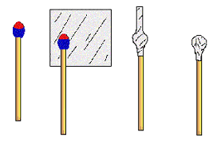
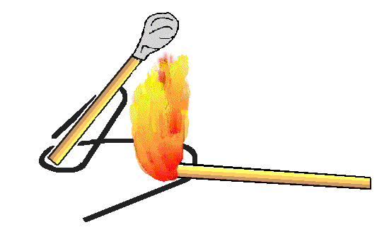
- Bend the paper clip to form a launch pad as shown in the picture. Put the matchstick rocket on the pad.

- Light the match by holding a lighter flame under the foil until it combusts.
Caution: Be sure the match rocket is pointed away from people or burnable materials. The foil head of the rocket will be very hot! Wait before throwing it in the trashcan.
EXPERIMENTING:
- Control – 1 piece of aluminum foil and one match only. How far did it go?
- Wrap 2 pieces of aluminum foil instead of 1. How far did it go?
- Wrap 3 pieces of aluminum foil? How far did it go?
- Put 2 matches side by side and wrap both tips with 1 layer of aluminum foil. How far did it go?
- 2 matches are too heavy….Cut off 1 match tip and place it next another match tip. Use 1 layer of aluminum foil. How far did it go?
- 2 matches are too heavy….Cut off 1 match tip and place it next another match tip. Use 2 layers of aluminum foil. How far did it go?
- Dip a match in alcohol. Wrap it in 1 layer of aluminum foil. Even if it lights right away, keep the lighter flame on the aluminum foil until you see smoke. How far did it go?
- Try any mixture of multiple matches, scraping the chemical of match tips, dipping in alcohol, multiple layers of aluminum foil, etc. to find what makes the rocket go the farthest.
Lab Safety!
Answer each question by putting the correct Lab Rule:
Example: A student handled equipment without being instructed to. Which lab rule did this student break? Answer: Do not touch or handle equipment, chemicals, or other materials until you are instructed to.
- A student with long hair catches his/her hair on fire on accident and then did not report it to the teacher. Which 2 lab rules did this student break?

- A student goes into the storage room to get more matches without permission and then begins the lab without completely reading the directions. Which 2 rules did this student break?

- A student grabbed the hot end of the aluminum foil with his/her bare hand and then did not report it to the teacher. Which 2 rules did this student break?

- A student that was wearing baggy clothes, was being distracting to the other students. Which 2 rules did this student break?

- A student left his lit lighter unattended during the lab and then did not clean his lab area. Which 2 rules did he break?

- After the experiment, a student did not wash her hands and was also eating a piece of pizza. What 2 rules did this student break?

- A student threw his partially lit matchstick rocket in the trashcan, caught the trashcan on fire, didn’t know where the fire extinguisher was, almost burned down the building, and was scared of getting suspended so did not tell the teacher. Which 2 rules did this student break?

- A student got a matchstick rocket lodged in his eye, ran around screaming in pain, and had no idea where the eyewash was. Later the eye had to be removed! What 2 rules did this student break?

- A student took his matchstick and soaked it in bleach then ammonia. What 1 rule did he break?

- A student placed the aluminum foil on the wrong end of his/her matchstick and did not know why the rocket wouldn’t work. What 1 rule would have helped him?

