Match Stick Rocket – Safety Lab
A small solid propellant rocket is made from a match and a piece of aluminum foil.
The match stick rocket demonstrates Isaac Newton's Laws of Motion as they relate to rocketry. Newton's third law states that for every action, there is an opposite and equal reaction. The exhaust of the fire products from the burning match (smoke and gas) is the "action" and the movement of the rocket in the other direction is the 'reaction.' The action thrust is produced when the match burns in an enclosed environment. The aluminum foil acts as a rocket combustion chamber. Because the opening in the foil is small, pressure builds up in the chamber that eventually escapes as a rapid stream of smoke and gas.
In an interesting variation of the experiment, try making holes of different diameters to let the combustion products out at different rates. A larger opening permits the smoke and gas to escape before it has time to build up much pressure. The escape of the products will be slower than produced by a match stick rocket with a smaller opening. Isaac Newton's second law states that the force or thrust of a rocket is equal to the mass of the smoke and gas escaping the rocket times how fast it escapes. In this experiment, the mass of the smoke and gas is the same for both cases. The difference is in how fast it escapes. Compare the distance traveled with the two match stick rockets.

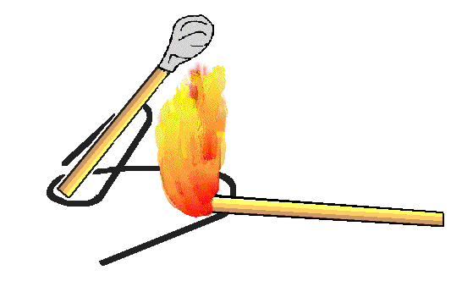
MATERIALS:
- Wooden stick matches
- Small square of aluminum foil
- Paper clip

PROCEDURE:
- Take one match and wrap a small piece of aluminum foil around the match-head. Wrap the foil tightly. Repeat this so that you have 2 pieces of aluminum foil wrapped tightly around the match stick head.
- Bend the paper clip to form a launch pad as shown in the diagrams. Erect the match stick rocket on the pad. Make sure the pad is set up on a surface that will not be damaged by the rocket's exhaust such as a lab table. Several layers of foil on the lab table work well.
- Ignite the match by holding a second lighted match under the foil until its combustion temperature is reached.
Caution: Be sure the match rocket is pointed away from people or burnable materials. it is recommended to have water or some other fire extinguisher available. The foil head of the rocket will be very hot!
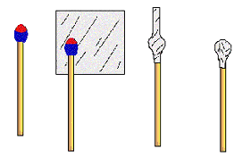
Lab Safety!
Answer each question by putting the correct Lab Rule:
Example: A student handled equipment without being instructed to. Which lab rule did this student break? Answer: Do not touch or handle equipment, chemicals, or other materials until you are instructed to.
- A student with long hair catches his/her hair on fire on accident and then did not report it to the teacher. Which 2 lab rules did this student break?

- A student goes into the storage room to get more matches without permission and then begins the lab without completely reading the directions. Which 2 rules did this student break?

- A student grabbed the hot end of the aluminum foil and burned his/her hand and then did not report it to the teacher. Which 2 rules did this student break?

- A student that was wearing baggy clothes, was being distracting to the other students. Which 2 rules did this student break?

- A student left his lit candle unattended during the lab and then did not clean his lab area. Which 2 rules did he break?

- After the experiment, a student did not wash her hands and was also eating a piece of pizza. What 2 rules did this student break?

- A student threw his partially lit matchstick rocket in the trashcan, caught the trashcan on fire, didn’t know where the fire extinguisher was, almost burned down the building, and was scared of getting suspended so did not tell the teacher. Which 2 rules did this student break?

- A student got a matchstick rocket lodged in his eye, ran around screaming in pain, and had no idea where the eyewash was. Later the eye had to be removed! What 2 rules did this student break?

- A student took his match stick and soaked it in alcohol before creating a match stick rocket. Although he made a rocket that went really far, what 1 rule did he break?

- A student placed the aluminum foil on the wrong end of his/her matchstick and did not know why the rocket wouldn’t work. What 1 rule would have helped him?

