Name Date Per

Ring of Fire

Plot the points for the Earthquakes and Volcanoes. Earthquakes should be in blue and Volcanoes should be in red. Plot them in order from top to bottom. Connect the points in the correct color as you go.
West
East
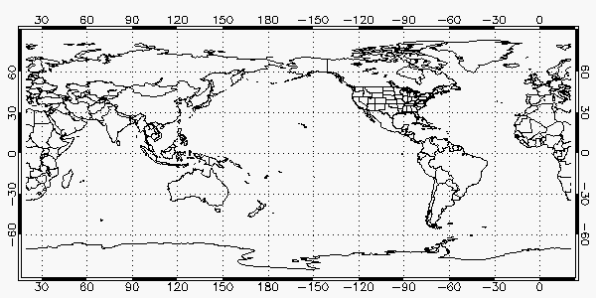
Plot the following coordinates one at a time and connect the dots as you go. Use a blue colored pencil for the Earthquake coordinates and a red colored pencil for the Volcano coordinates.

Earthquakes |  |  | Volcanoes
Longitude | Latitude |  | Longitude | Latitude
Ring of Fire |  |  | Ring of Fire
122 W | 37 N |  | 150 W | 60 N
110 W | 25 N |  | 120 W | 45 N
75 W | 15 S |  | 122W | 40 N
75 W | 45 S |  | 105 W | 20 N
175 W | 35 S |  | 75 W | 0
175 E | 0 |  | 70 W | 30 S
135 E | 5 S |  | 70 W | 35 S
120 E | 22 N |  | 180 | 30 S
140 E | 35 N |  | 127 E | 10N
160 E | 52 N |  | 140 E | 40 N
175 W | 50 N |  | 160 E | 55 N
142 W | 60 N |  | 170 E | 50 N
Mid Atlantic Ridge |  |  | Mid Atlantic Ridge
5 E | 82 N |  | 0 | 75 N
15 W | 65 N |  | 20 W | 65 N
30 W | 55 N |  | 55 W | 15 N
45 W | 30 N |  | 15 W | 15 S
35 W | 0 |  | 30 W | 60 S
15 W | 30 S
25 W | 60 S
Mediterranean Zone |  |  | Mediterranean Zone
35 W | 45 N |  | 15 W | 35 N
5 W | 35 N |  | 15 E | 40 N
30 E | 35 N |  | 30 E | 40 N
60 E | 30 N |  | 35 E | 15 N
90 E | 30 N |  | 60 E | 30 N
105 E | 5 S |  | 120 E | 10 S
135 E | 5 S

