AP Physics – Magnetic Quiz Time

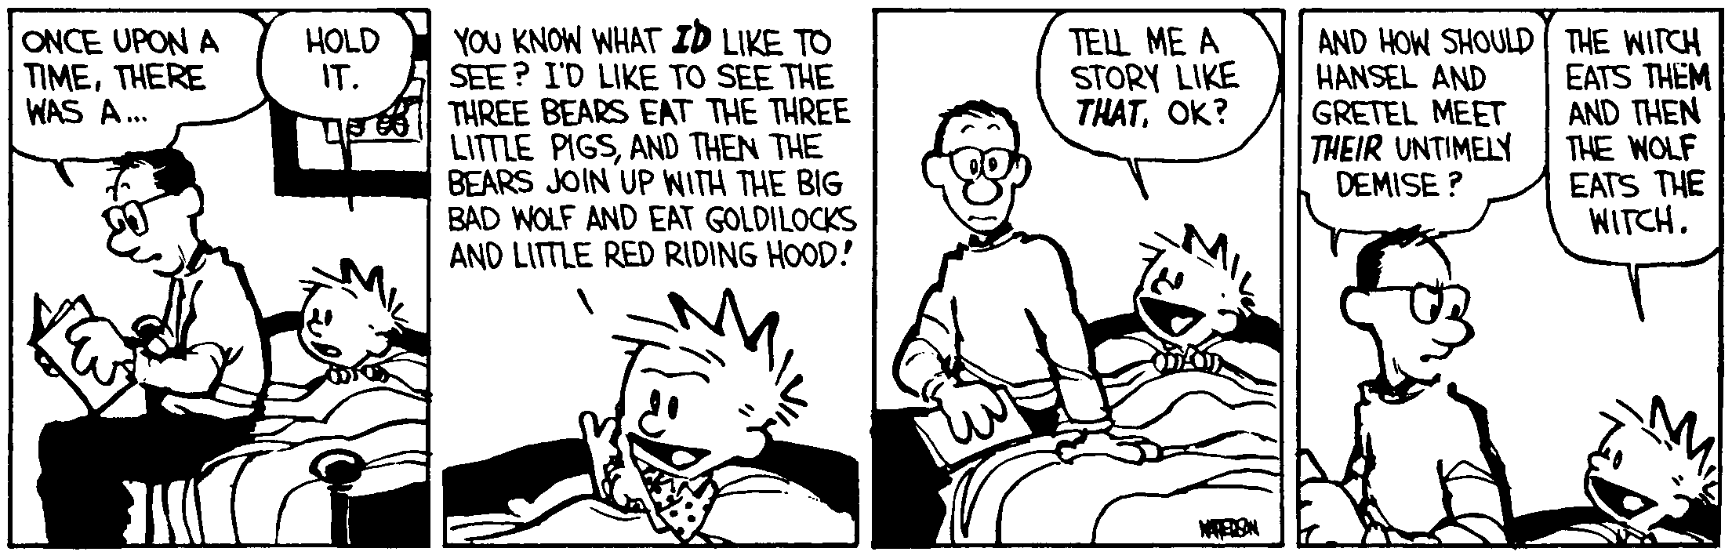
Huh thee?_________________________________________________________________Per__
Physics is very muddled again at the moment; it is much too hard for me anyway, and I wish I were a movie comedian or something like that and had never heard anything about physics! -- Wolfgang Pauli
- Here is your basic lovely circuit. What is (a) the total resistance, (b) the total current, (c) the heat dissipated by the 75 Ohm resistor in 5.0 minutes, and (d) the charge stored on the 125 μF capacitor, C₁ .

- Two wires run parallel to each other. They are both 28.0 cm in length. They are separated by 4.30 cm. The first wire has a current of 1.60 A and the other wire has a current of 2.25 A. The currents travel in the same direction. (a) What is the force that is acting between them? (b) Is the force attractive or repulsive?

- In a linear accelerator, protons are accelerated from rest in a uniform electric field, E = 8.65 x 10⁶ V/m. It is directed along the y axis. Its displacement is 0.385 m in the direction of the field.

- Determine the velocity of the protons after they are accelerated.

The proton beam enters a region of uniform magnetic field B, as shown above, that causes the beam to follow a semicircular path.

- Determine the magnitude of the magnetic field that is required to cause an arc of radius 0.10 meter.
- How much work is done on the proton by the magnetic field?

- A metal rod is pulled into a magnetic field, B = 17.8 T, at a constant velocity while it is in contact with two conducting rails. The rails are separated by a distance of 5.00 cm. A resistor has been placed between the rails at the edge of the field as shown. It has a resistance of 4.50 Ω. The power output of the resistor is 15.0 W. Find (a) the emf induced into the rod by its motion through the field. (b) The velocity of the rod through the field. (c) The direction of the current through R. (d) The Force, F_{a}, applied to the rod to make it move through the magnetic field.

