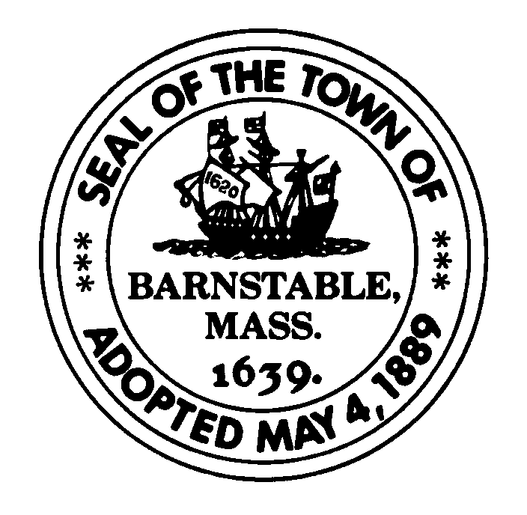
Town of Barnstable
Administrative Services
Treasurer’s Office
230 South Street
Hyannis MA 02601

Debra Blanchette, Treasurer Tel: (508) 862-4661
Joanna Callahan, Assistant Treasurer Tel: (508) 862-4656
Fax: (508) 862-4779

To: Treasurer, Town of Barnstable

Date: 04/13/2020

Subject: 2020 Lump Sum Request Form

I request that my summer salary be paid to me in a lump sum at the end of the present school year.

Employee Number:
Employee Name:
Location:

The deadline for the lump sum payment request is May 15, 2020
Please note that this is mandatory for all June 2020 retirees.

***Please Note***
THIS IS MANDATORY FOR ALL RETIREES

All requests must be received by May 15th,2020

Lump sum payments will be paid in the payroll of June 25th, 2020

Please contact the Treasurer’s Office if a receipt is not received prior to May 22nd, 2020

If you do not wish to have the lump sum payment in June, please disregard this memo and do not respond to it.

**RETURN TO THE TREASURER’S OFFICE – SCHOOL ADMINISTRATION BUILDING**

For Payroll Office Use Only

Name |  | Signature (payroll dept.) Date
School Location |  | Lump Sum Receipt

