Light Independent Reaction Photosynthesis Lab

Do plants produce sugar in the form of starch during photosynthesis? Autotrophs are also called producers because they can use the energy in sunlight or chemicals to produce food. Now we are going to explore how autotrophs use the energy in sunlight to produce food. In the process of photosynthesis plants use the energy in sunlight to convert water and carbon dioxide into oxygen and high-energy carbohydrates. Photosynthesis occurs inside a cell organelle called the chloroplast. The chloroplast contains green pigments called chlorophyll, which capture the energy in sunlight. The equation for photosynthesis can be as follows:

6 CO₂ + 12 H₂O + Light à C₆H₁₂O₆ + 6 O₂ + 6 H₂0

One of the products of photosynthesis is C₆H₁₂O₆, which represents a molecule of glucose. As the plant receives sunlight it is constantly producing glucose and then transporting it outside of the chloroplast. However, the plant cannot transport glucose out of the chloroplast as fast as it is produced. To solve this problem, the plant combines the glucose molecules into a larger molecule called starch. The glucose molecule is a monosaccharide that through the process of dehydration synthesis, can form a larger molecule called a polysaccharide. This polysaccharide, starch, is stored inside the chloroplast until it can be transported. Iodine is a specific stain for starch, producing a black color (actually a very dark blue) where starch is present. The hypothesis is that a pattern will be revealed by using starch as an indicator when a prepared plant leaf is exposed to a light source for a significant amount of time.

Method

Materials:

Geranium (Pelargonium) Plant (exposed to no light (~3 days)) [making it starch-free]

Ethel Ethanol: (50 mL / group)
Iodine Reagent-Grade Solution (not Lugol’s Solution)
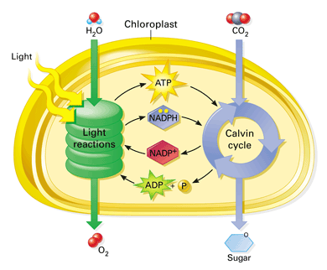
Aluminum Foil (pre-cut: ~ 10 x 10 cm)
400 mL Beaker
100 mL Beaker
Razor Scalpel
Cutting Board
Masking Tape
Forceps
Hot Plate
Large Petri Dish
Goggles

Procedure:

Part I:

- Place a pre-cut piece of aluminum foil on a cutting board and careful use a razor scalpel to cut out a familiar; yet, basic shape (ie triangle, star, circle, square, etc…but nothing too advanced) about the size of a nickel in the middle of the foil.

- Carefully wrap the foil around an attached fairly large leaf (redo foil to accommodate leaf size if necessary) so that the shape is facing upwards. Note: If necessary, place one staple through the foil and leaf to keep it on the leaf (see instructor).

- Using of a piece of masking tape, place your initials or name on the tape and affix the tape carefully and around your petiole (leaf stem) for identification.

The plant will then be exposed to light for several days in preparation for Part II.

Part II:

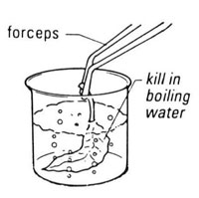
- With googles and using the 400-mL beaker, measure about 250 mL of tap water and place the beaker on a hot plate in order to get the water boiling.

- After carefully removing the foil “and” petiole (leaf blade), place
the leaf in the water for about 2 minutes to kill the cells and dis-
rupt their structures. Remove from heat.

- Add about 50 mL of ethanol to the 100-mL beaker.

- Using forceps, immerse the leaf in the ethanol for about 2 minutes to remove the chlorophyll; should start to look white (or least, less green).

- Replace the warmed water in the 400-mL beaker with tap water and carefully immerse/ and rinse the leaf in the water to remove any remaining alcohol for about 2 minutes.

- Carefully place the leaf in a Petri dish (top facing upward) and using iodine, cover the leaf with the “starch” indicating solution. Note: The blue-grey-black areas represent starch where your symbol should be noticed; may want to look under the dish too.

- Refer to the data/result sheet to answer questions about the lab then clean and return all materials when finished.

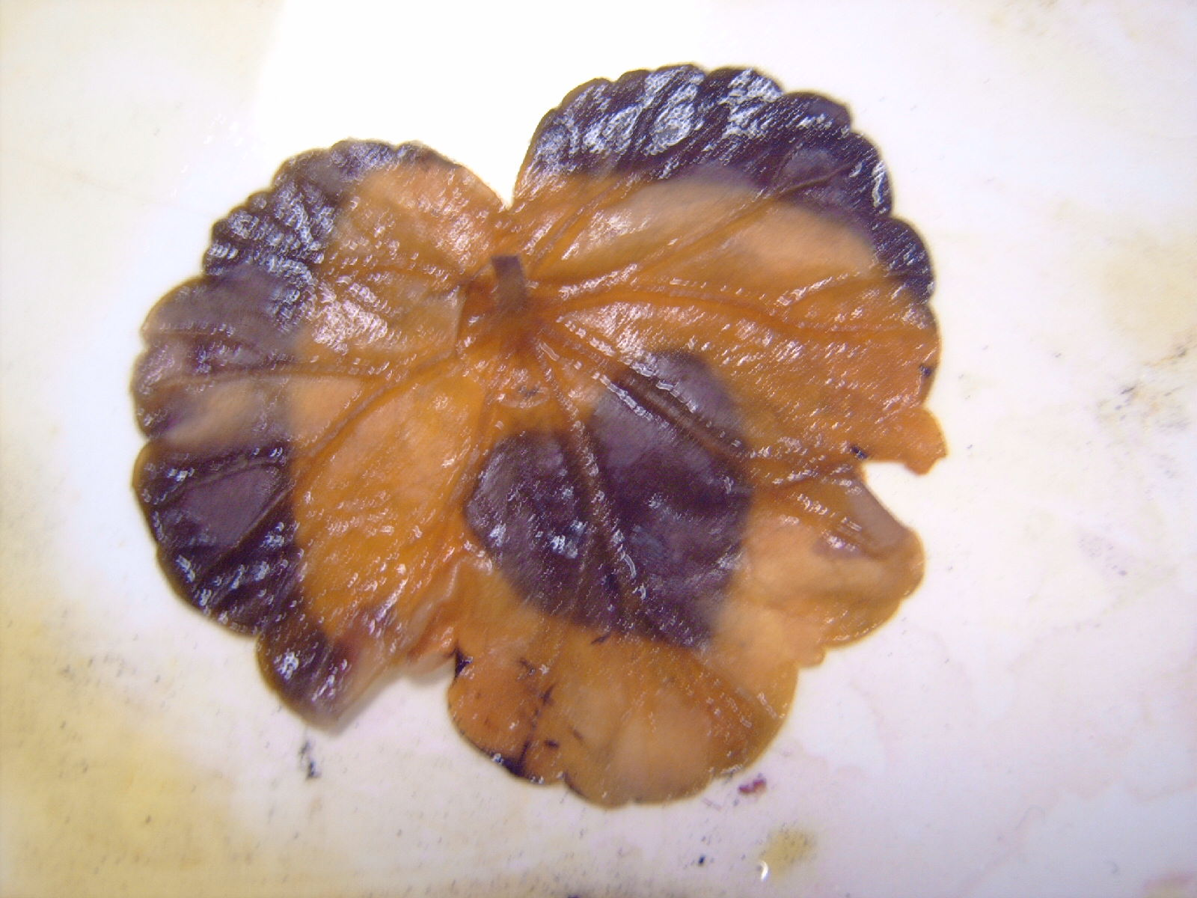
Dark Areas Represent the Production of
Results Questions: Light Independent Reaction Photosynthesis Lab
/50
Place All Answers on a Separate Sheet of Paper

Drawing: 5 points

Sketch Your Leaf with its Pattern

Short Answers: 2 points each

- What was the reason for placing the leaf in boiling water first?

- What was the function of the ethanol/IMS?

- What was the purpose of using the iodine solution?

- Name the cycle involved with the light independent reaction of photosynthesis:

- What two nucleic acids for the light reaction are necessary for the light independent reaction?

- Despite shading off areas of the leaf, did the light independent reaction still take place?

- What molecular gas is needed to supply carbon in order to make starch (sugar)?

- Does the light independent reaction depend on the light dependent reaction in order to make starch?

- To store the large amounts of glucose made what does the plant convert the monosaccharides into?

- What is the general formula of photosynthesis?

Conclusion Paragraph: 10 pts

Write a proper conclusion paragraph by “restating” the problem question and hypothesis below and then answer the remaining questions (see bullets below). You may need to review the beginning of the lab; such as, the background information paragraph. When you are done, you should have “one” indented paragraph summarizing the activity.

Do not include use any personal pronouns: “I, we, our, etc…” in the paragraph
Do not include any proper names “ie Jack or Jill, etc…” in the paragraph
Do not include the word “it” anywhere in the paragraph.
Do not have fragmented sentences in the paragraph.
State the following in your paragraph:
- What was the problem question? (see background paragraph)
- ie Start off by writing… The problem question was ….
- What was the hypothesis? (see background paragraph)
- ie Start off by writing… The hypothesis was that …
- Was the hypothesis supported or refuted? If refuted, tell why?
- ie Start off by writing… The hypothesis was …
- What unforeseen event(s) happened during the lab? (never say none)
- ie Start off by writing… An unforeseen event was …
- What improvement(s) could have been made in the activity? (never say none)
- ie Start off by writing… An improvement that could be made for this lab would be …
- State a “springboard question” (followed by a question mark) *

* A springboard question is a “question” that you make up based on the problem question or this
activity. Do not answer this question; but simply state it as the last sentence in your conclusion
paragraph with a question mark (?) at the end. The question is meant to “springboard” other
thoughts that the reader could investigate having done this lab which is an inventive yet
effective way to end a lab activity.)

Name: KEY /50

Results Questions: Light Independent Reaction Photosynthesis Lab

5 points

“Leaf Sketch with Your Pattern”

2 points each:

- What was the reason for placing the leaf in boiling water first?
TO KILL THE LEAF CELLS

- What was the function of the ethanol/IMS?
TO REMOVE CHLOROPHYLL PIGMENTS (OTHER ACCESSORY PIGMENTS)

- What was the purpose of using the iodine solution?
TO IDENTIFY STARCH (SUGAR)

- Name the cycle involved with the light independent reaction of photosynthesis:
CALVIN CYCLE

- What two nucleic acids for the light reaction are necessary for the light independent reaction?
ATP AND NADPH (NOT ADP AND NADP+)

- Despite shading off areas of the leaf, did the light independent reaction still take place?
YES

- What molecular gas is needed to supply carbon in order to make starch (sugar)?
CARBON DIOXIDE

- Does the light independent reaction depend on the light dependent reaction in order to make starch?
YES

- To store the large amounts of glucose made what does the plant convert the monosaccharides into?
STARCH

- What is the general formula of photosynthesis?
6 CO₂ + 12 H₂O + Light à C₆H₁₂O₆ + 6 O₂ + 6 H₂0

Conclusion Paragraph: 10 pts

