AP Physics – Light

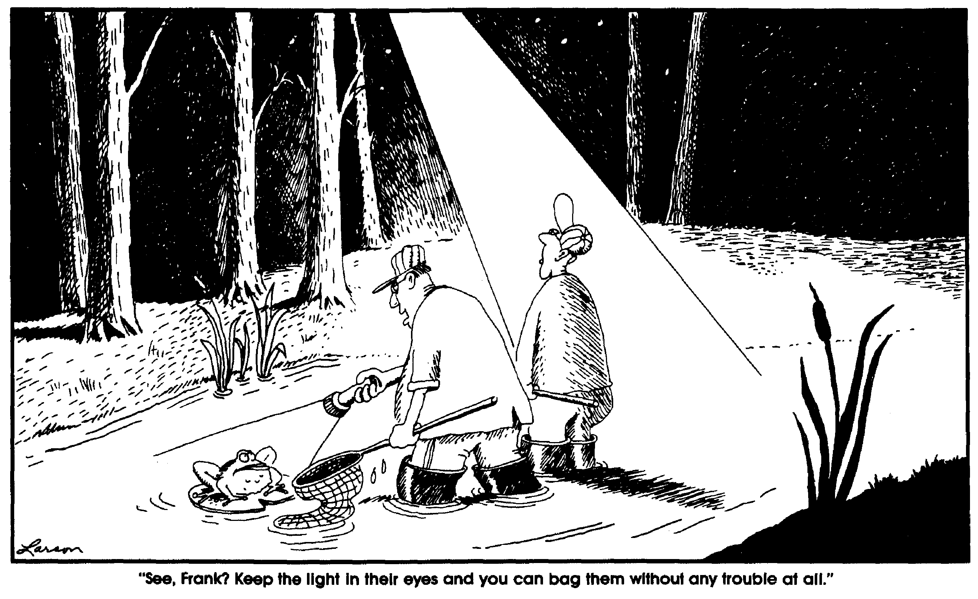Let there be light.

Huh? Where’s that from?

Well, it’s from the Bible and it leads off the Book of Genesis, which relates how the world began. According to the good book, it began with light. What is interesting about that is that it is consistent with the Big Bang Theory for the origin of the universe.

Anyway, this unit is called “Light” but really it should be called “electromagnetic waves”. Light (by this the Physics Kahuna means visible light) is a type of electromagnetic wave – it’s just the one that we are most familiar with.

Until the 18th century light was the only electromagnetic wave that was known. Even at that, it was poorly understood. The first really good scientific treatment of light was done by the good Sir Isaac Newton (well, we say that, but in truth he wasn’t so good, i.e., he wasn’t a very nice man, but, we hasten to point out, a terrific physicist). Newton believed that light was a stream of particles that traveled through space. This nicely explained how light could reach the earth from the sun through the vacuum of space. Little teeny fast particles could easily travel through space, couldn’t they?

This was Newton’s corpuscular theory of light – he called the little particles corpuscles. (“Corpuscles” is one of those words that were immensely popular in the old timey days, but which have gone out of favor in these modern times. Corpuscles is still the name used for blood cells. It was also the name the J.J. Thompson gave to electrons when he initially discovered them, but that name, obviously, is no longer used.)

A competing theory was also in vogue at about the same time. This theory viewed light as a wave rather than as a stream of particles. Christian Huygens, a Dutch astronomer, was the leader of this faction. The wave idea had, unfortunately, a big problem -- what was the medium for this wave? At that time, it was a well-established fact that all waves had to have a medium that they propagated through. So light needed to have one as well. But what was the medium? There wasn’t one! At least one that anybody could discover.

Eventually physicists, resourceful devils that they were, invented an invisible, undetectable substance that would provide just such a medium for the propagation of light. They called the stuff luminiferous ether (which turned out to not exist, but that’s another story best told later in the course).
Both theories were able to explain the behavior of light, at least as it was known at the time. But in 1801 a British physicist and physician named Thomas Young conclusively demonstrated that light was a wave. This was accomplished in a very famous experiment - Young’s double slit experiment. What Young did was to show that light exhibited interference patterns (interference patterns result from constructive and destructive interference, which, the Physics Kahuna is sure, you will recall is a result of the superposition law of waves). It was well known at the time that waves could interfere with each other causing interference patterns. In fact, at the time, it was believed that only waves could do this (This turns out not to be true – but this discovery came about much later). This put the particle theory to rest and it was gracefully retired. Throughout the 19th century physicists were cheered by the certain knowledge that light was a wave and not a particle. They were, however, stuck with the ether business.
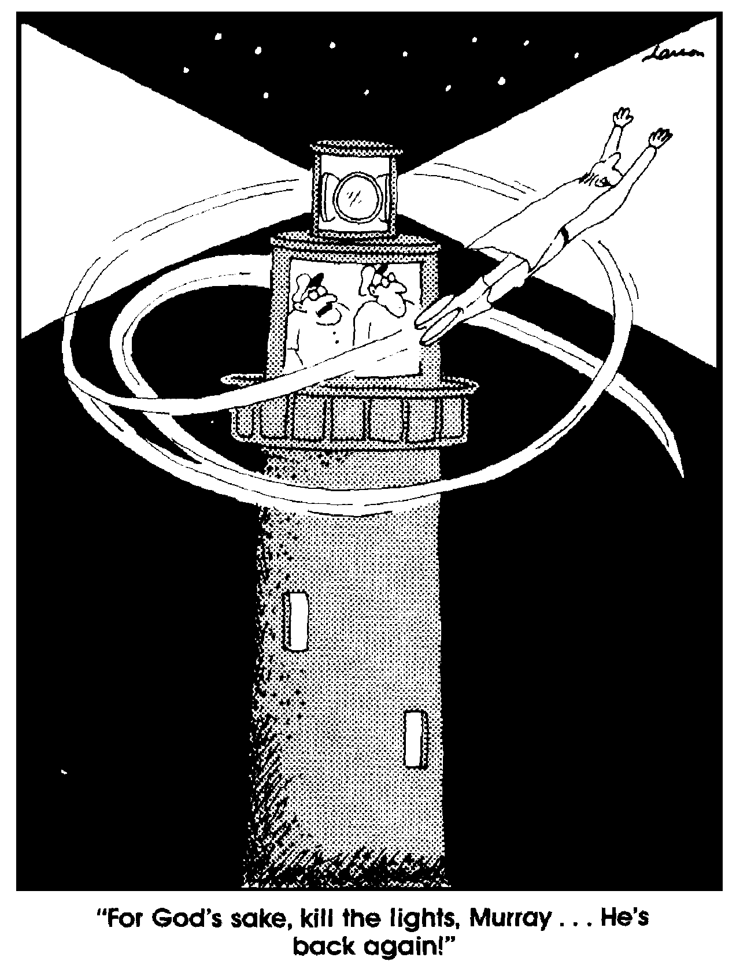
In 1865 James Clerk Maxwell, considered by many (including the Physics Kahuna) to be the greatest physicist in the 19th century, unified electricity and magnetism and was able to show that a moving charge would produce a changing electric and magnetic field. Said fields would then propagate through space. He was able to calculate the speed of these waves using his equations (collectively known as Maxwell’s laws) and came up with a number that was equal to the speed of light. He boldly stated that light had to be one of his electromagnetic waves. He also predicted that different ones would be discovered in the fullness of time.

In 1900 Max Planck was trying to explain a thing called the black body problem (more on that later when we study quantum mechanics). This had to do with the energy of light as a function of its frequency. Experiments had yielded results that classical physics could not explain. In order to come up with something that would match up with the experimental results, Planck had to imagine that a beam of light was somehow arriving as a stream of energy bits. He called the energy bundles “quanta” (this led to the quantum theory of light, which later led to the quantum atomic theory). Max came up with a formula that would calculate the energy of one of these quanta.

This is one of the most famous equations in all of physics. Physics before Planck’s equation is called classical physics. All physics after the equation is called modern physics. Here is the equation.

E is the energy of a quanta of light, h is called Planck’s constant, and f is the frequency of the light.

Planck’s constant is: h = 6.63 x 10⁻³⁴ J s or 4.14 x 10⁻¹⁵ eV⋅s
It should be pointed out that Planck did not believe these quanta were real. He thought of the equation as being a sort of mathematical artificiality that allowed him to closely approximate the energy provided by light as a function of its frequency, but that it was not a true description of the nature of light. We won’t do much with this equation . . . . . yet.
Color Film: A Public Radio Commentary by Bill Hammack
I know of no better illustration of science being a creative process, and not just a list of facts, than the invention of color film by two friends who loved first and foremost, not photography, or chemistry, but music.

It all began when they saw a color movie. Dissatisfied with the blurry image they decided, with the hubris of youth, to make a better color film.

At that time color photographs and movies were made by using three pieces of film, one for each primary color. These separate pieces were combined in a projector to create a full color image, yet always blurry because the three pieces of film never aligned correctly.

Godowsky and Mannes, realized that to get sharp color images they needed all three layers to be part of the same piece of film. In their lab they found it very tricky to create a thin layer for each color, called an emulsion, then to separate these with an even thinner layer of clear gelatin. Although dedicated to making color film, their nineteen year quest was often interrupted by their love for music. At one point Godowsky studied violin at the University of California, and Mannes studied piano at Harvard. Then Mannes won Pulitzer and Guggenheim scholarships to study music composition in Italy.

By 1930 they found their experiments so complex that they could no longer fund them from their musical performance fees. Luckily, the Research Director for Kodak had learned of their work. He hired Godowsky and Mannes to work in the Kodak laboratories. This arrangement fit them ideally: They could spent days in the lab, then evenings performing at the nearby Eastman School of Music, although the music wasn't completely separate from their lab work.

Godowky and Mannes would sing as they worked in their labs, not for fun, but as an essential part of developing their color film. In their darkened lab they were unable to see a watch, so they timed the reactions by singing passages from their favorite musical pieces, whose length they knew by heart.
By 1935 they perfected their color film. In an odd press conference, the inventors announced their discovery, showed sample photos, then played a violin and piano sonata for the reporters. After this they developed no more film, but instead returned full time to musical careers.

Now to some it seems odd that these two would return to music, but to me there is no discontinuity. Creating color film, or playing a sonata are both creative acts. So, to continue playing music for them, was one and the same, at a fundamental level, with developing another type of film.

In 1887 Heinrich Hertz (a Deutsche physicist) discovered the photoelectric effect. This was a very mysterious deal. What happened (what he found) was that light shining on certain metals would cause electrons to leave the surface of the metal. Why? How?

It remained a mystery until 1905 when a 3rd class technical inspector for the Swiss Patent Office published a paper that explained the effect. This was Albert Einstein before he became famous. Actually the paper helped make him famous – at least within the world of physics. Einstein won the Noble prize for his discovery. The main thing about this was that Einstein explained the photoelectric effect by assuming that the light was made up of a stream of actual, physical particles that were banging into the metals physically knocking electrons loose from the atoms.

According to Einstein light wasn’t a wave at all, it was a stream of particles just like Newton had said. The light particles are now called photons. So we end up coming back to Newton after all the trouble with the waves and particles.

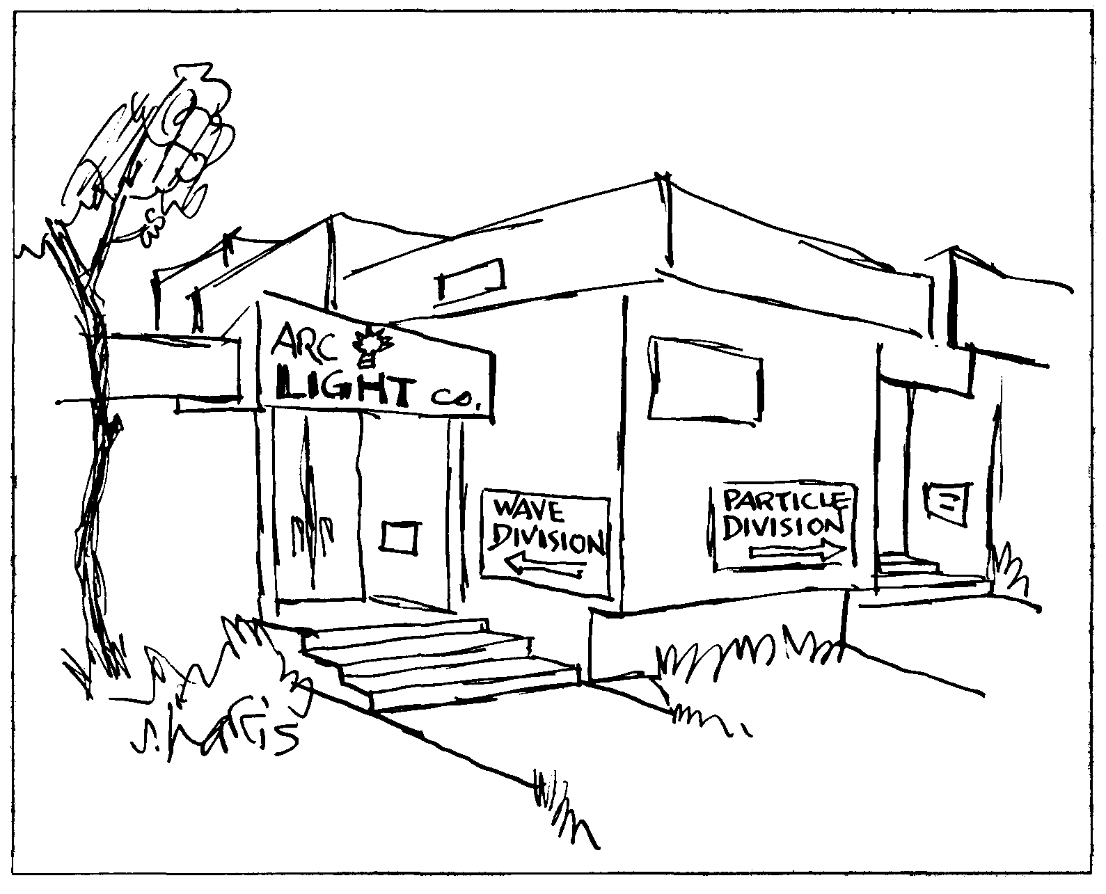
So who is right? Is light a particle or is it a wave?

Well, this is where physics gets a little sticky. Many people are very unhappy with what follows, but it is the best physics we have for now. Hopefully someone will make a few odd discoveries and come up with a theory that is more elegant.

But don’t hold your breath.

Here it is. Light acts a both particle and wave. This is called wave/particle duality.
How simple! How elegant! How confusing! How can light be a particle and a wave both? The two are very different things. But that is the way it is. Electromagnetic waves are particles and waves at the same time and there is nothing we can do about it.

It is obvious that we do not properly understand the nature of light (or matter as well). We have a theory that works, but it is a clumsy thing and no one is happy with it.

It turns out for some things, it is easier to imagine that light is a wave – optics and interference for example. For other concepts it is better to think of it as a particle – the photoelectric effect comes to mind.

Electromagnetic waves are transverse waves (when we think of light as a wave). We have a changing electric field that has a spatial orientation that is ninety degrees from a changing magnetic wave. Here is a rough drawing of the thing.

And yet another drawing.

Speed of Light: Light speed, that is the speed of light in a vacuum, is a universal constant. It has been given its very own symbol, c – this is a true measure of how important it is.

c ≡ speed of light

The latest and greatest value for the speed of light (at least the last time the Physics Kahuna checked on the thing) is 2.997 924 574 x 10⁸ m/s. Note, this is the speed of light in a vacuum. When light travels through other mediums it slows down.

For our humble purposes, we will use:

c = 3.00 x 10⁸ m/s

All electromagnetic waves travel at c.

In astronomy a common unit of distance is the light year, which is defined as the distance that light will travel in one year (which to us is a heck of a lot of distance, but to the universe is pathetically small).

- What is a light year in meters?

The Electromagnetic Spectrum: The electromagnetic spectrum encompasses all the various types of electromagnetic waves. The sorting of these waves into specific groupings is, with the exception of visible light, arbitrary. Anyhow, the specturm is the width and breadth of all the electromagnetic waves. These waves are all the same – a changing magnetic and electric field, but as the frequency varies, the energy changes and this changes the way that they interact with the universe. The spectrum has been arbitrarily chopped up into named groups of waves that have similar characteristics.
Above is a representation showing the various types of electromagnetic waves in the spectrum.

Note that there are no numbers on the graphic. You will not be expected to remember frequencies or wavelengths for these waves. What you will be expected to know is the relative positions of the different types of waves. You should also be cognizant of the fact that the greater the frequency, the greater the energy carried by a light photon (remember E = hf). Thus the greatest energy photons are gamma rays. Also notice that as the frequency gets bigger, the wavelength gets smaller. You do need to remember the wavelength minimum and maximum for visible light; 400 nm to 700 nm.

Gamma rays have the smallest wavelengths and radio waves have the longest.

Since light is a wave, we know that its speed must be equal to its frequency multiplied by its wavelength. In other words:

Here are the different types of waves with a general description of their uses and characteristics.

Radio Waves: Radio waves were discovered in 1888 by Hertz. It didn’t take long to come up with a practical use for them – radio! Today radio waves are used for, well, radio – AM radio and short-wave radio both use radio waves. Other communication systems use them as well - cordless telephones, radio controlled toys, cab radios, &tc.

Microwaves: Microwaves were discovered in the early 1900’s. Microwaves are used for FM radio, broadcast TV, radar, cooking food, telephone communication systems, and numerous other communications systems (different types of radio). The cooking food thing is interesting. It turns out that microwaves excite molecules that are about the size of the ones that make up water. Thus, anything that contains a significant amount of water can be heated by microwaves.

Infrared: Infrared electromagnetic waves are radiant heat. They are often times referred to as IR. We get a great deal of energy from the sun in the form of infrared waves. When you go out on the first warm spring day and bask in the sun, absorbing all that wonderful heat, you are taking in infrared electromagnetic waves. The wavelength of IR is just right to penetrate your outer skin and excite the molecules in your epidermis, thus heating you up.

Visible Light: Visible light is important to we humans because we make great use of it to create mind pictures of our surroundings. We arbitrarily arrange light into colors. The main colors, when we think of colors, are red, orange, yellow, green, blue, and violet. The colors are listed in increasing order of frequency. So red light photons have less energy than blue light photons. Commit to memory the energy order of visible light. So in order of increasing energy: red, orange, yellow, green, blue, and violet. But these are arbitrary names and the number of colors the human eye can see is vast. There are a wide range of colors that we call “red” for example. Don’t believe the Physics Kahuna? Okay, go to the makeup section of a store and look at all the shades of lipstick. There are thousands to chose from.

The wavelength of red photons begins at 700 nm (700 x 10⁻⁹ m or 7 x 10⁻⁷ m). The highest energy violet light photons have a wavelength of 400 nm (4 x 10⁻⁷ m).

Ultraviolet Light: Ultraviolet light or UV is the general group of electromagnetic waves that follows directly after visible light. We can’t see UV, but other critters can. Insect eyes can pick up UV. It turns out that many plain looking flowers reflect lovely patterns when viewed in the UV – no doubt to attract the esthetic senses of discriminating insects.

UV represents the point on the spectrum where the photons have enough energy to be harmful to earthling hominid types. Besides the IR and visible light the sun radiates, it also radiates UV. Fortunately for us, most of this UV is absorbed high in the atmosphere by the ozone layer (ozone is a fancy oxygen molecule that has three oxygen atoms bonded together, O₃). But some of it gets through. When you go out and expose your outer surface to the sunlight, the UV, especially the shorter wavelengths, has enough energy to damage skin cells. We call this damage sunburn. Have you ever gotten a bad case of sunburn?

Sunburn is damaging. The skin ages and gets premature wrinkles. Even worse, too much sun has been linked to skin cancer. People can die from skin cancer.

X-Rays: x-rays are very high-energy waves that are produced by the decay of unstable radioactive elements or by exciting elements with high voltages. x-rays have a lot more energy than UV. They have so much energy that they can pass right through a person’s soft tissue, but the bones and denser organs absorb them. This is how x-rays at the doctor's office work. A large piece of unexposed photographic film in a protective wrapper is placed on a table. Then the part of the body the doctor is interested in examining is placed on top of the film. x -rays are then zapped into the area. They travel through the soft tissue and expose the film (they affect it just as visible light would). The bones absorb the x-rays so that the film under the bones is not exposed. The film is developed and a picture of the interior of the body is revealed - shadows where the bones blocked the x-rays.

x-rays have a great deal of energy, so doctors are very careful to prescribe them only when they are really needed. Over exposure to x-rays is very dangerous. The x-rays penetrate the body and have collisions with atoms in the various tissues. They can knock atoms loose and break chemical bonds. When they mess up DNA molecules a body can end up with mutations. One can also get a really bad form of skin cancer called melanoma.

Gamma Rays: Above the x -rays are the gamma rays (γ-rays). γ-rays are also produced by the decay of radioactive elements. They are the most energetic of all the electromagnetic waves and can be enormously destructive. They have tremendous penetrating power. Gammas are produced naturally in the earth and atmosphere by the decay of radioactive elements. We also get a lot of them from space – they are one of the constituents of what we call “cosmic rays”. So we are exposed to them all the time - they are part of what is called the earth’s background radiation. It is a most fortunate fact that our bodies can deal with the damage caused by this form of radiation. Exposure to artificial γ-rays above the natural background, however, is extremely dangerous. People whose work could expose them to such radioactivity have strict limits on the amount of exposure they are allowed. Their exposure is monitored with personal film badges as well as installed radiation detectors.
Vision: We see things because light rays have somehow traveled from the things we see into our eyes. This can happen in several ways. Many objects give off their own light rays – candles, light bulbs, LED’s, &tc. We say that these objects are luminous. The other way we can see things is when the object reflects light rays. For example, light rays from the sun reflect off the leaves of a tree and then come into our eye. So we see the tree.

Red objects appear red because they reflect red light. The other wavelengths are absorbed.

A green object is green because it reflects green light. And so on.

When we see all the colors at once, we see “white”. “Black” is the absence of light. Black objects absorb all wavelengths of light. White objects reflect all wavelengths of light.

What happens to the light that is absorbed? Well, it basically heats the object up a slight amount.

Light travels in straight line path until it reaches a boundary. Once it reaches a boundary it can be reflected, absorbed, or transmitted.

Transparency: Transparent objects allow light to travel through them. The way this happens is kind of interesting. Photons enter the transparent medium and are absorbed by atoms. The photon is absorbed by an electron within the atom. This increases its energy and it jumps to a higher energy level. This is called a quantum leap (did you ever see the TV program of the same name?). The electron is not stable at the higher energy level and falls back down to a lower energy state. The energy lost by the electron is converted into a photon of the same energy as the one that was absorbed. So light travels through a transparent medium in a series of photon absorptions and emissions. These absorptions and emissions take time, so light is effectively slowed down as it travels through the new medium. Thus light travels as a slower speed when it enters a medium from a vacuum.

Reflection: There are two types of reflection that light can undergo. Oh, by the way, when we are looking at the path of light, we talk about light rays. A light ray is the path that a single photon will follow – in general, a straight line. (At least on earth. Einstein found that light follows curved paths in space. This curvature is caused by the bending of spacetime by objects with a great deal of gravity.)

Here are the two types of reflection:

Diffuse reflection - the rays are reflected in random directions.

Specular reflection - parallel rays are reflected parallel to each other.

Objects that exhibit diffuse reflection are said to be opaque. Most things are opaque – clothing (usually), paper, wood, leaves, concrete, people, hair, dirt, rugs, etc. are all examples of opaque objects.

Specular reflection is often called mirror or regular reflection. Mirrors, polished metal surfaces, the surface of calm water, and other really smooth surfaces exhibit mirror reflection.

Specular Reflection: Light rays obey the law of reflection during specular reflection. In the rest of the course, when we discuss the reflection of light we will be talking about specular reflection.

The reflection of light must obey the law of reflection, this means that the angle of reflection is equal to the angle of incidence.

Angle i is the angle of incidence – this is the angle made by an incoming light ray to a normal to the surface. A normal to the surface is a line that is perpendicular to the surface. Angle r is the angle of reflection. This is the angle the reflected ray makes with a normal to the surface.

Refraction: Refraction occurs when a wave travels from one medium to another. The light rays are said to be “bent”. You can see this in a glass of water. Place a pencil in the glass – the pencil looks like it is broken, shifted to the side, and larger in the water.

This occurs because light rays from the pencil are bent as they travel through the water.

Refraction of light ≡ change in the path direction in a different medium.

The refraction happens because of the velocity difference for light in the two mediums.

This brings us to a very important concept. The index of refraction. This is the ratio of the speed of light in a vacuum to the speed of light in the new medium.

The index of refraction ≡ ratio of the speed of light in a vacuum to the speed of light in a different medium.

n is the index of refraction, c is the speed of light in a vacuum, and v is the speed of light in the medium.

You will be provided with this equation on the AP Physics Test.
Directly to the right, the Physics Kahuna has placed a table of values for the index of refraction for different substances. Using this table, one can easily calculate the speed of light in any of the listed substances.
Substance | Index of Refraction
Diamond | 2.419
Fused quartz | 1.458
Crown glass | 1.52
Flint glass | 1.66
Ice | 1.309
Polystyrene | 1.49
Zircon
Benzene | 1.501
Ethyl alcohol | 1.361
Water | 1.333
Air | 1.000 293
Carbon dioxide | 1.000 45

- What is the speed of light in ice?

We use the index of refraction equation to find the speed in the ice.
Important Thingee: Observe the table for the index of refraction for air. It is essentially one. So on all problems, let the index of refraction be one for all calculations.

Snell’s Law: The amount of refraction is of great interest to we physicists – you are interested are you not?

If the light rays travel from one medium into another, they will be bent. The bigger the difference in the light speed in the two media, the bigger the refraction. If the speed of light is the same in both media then there will be no refraction.

You should remind the Physics Kahuna to show you some of his nifty refraction demonstrations.

In the drawing to the right, the angle of incidence is θ_{I}, the angle of refraction is θ₂. These angles are measured relative to a normal to the surface of the boundary between the two substances.

Another important point is that the frequency of light does not change as it goes from one medium to another. The wavelength can change and the speed of light can change, but the frequency does not. must hold true.
The amount of refraction, that is, the angle of refraction, is related to the angle of incidence by Snell’s law. The drawing to the right shows a ray of light passing from one medium into another. In the first medium it has an index of refraction of n₁ in the second medium its index of refraction is n₂. Here is Snell’s law:

n₁ is the index of refraction in the first medium, n₂ is the index of refraction in the second medium, θ₁ is the angle of incidence, and θ₂ is the angle of refraction.

You will be provided with Snell’s law on the AP Physics Test.

- A beam of light that has a wavelength of 651 nm traveling in air is incident on a slab of transparent material. The angle of incidence is 35.0°. The angle of refraction is 23.4°. Find index of refraction for slab.

For all practical purposes, the index of refraction in air is 1.

Wavelength and Frequency: What happens to the wavelength and frequency as light travels from one medium to another? We could, actually you could, develop any number of equations relating wavelength and frequency or index of refraction. Unfortunately, you won’t have access to any of those equations. So Physics Kahuna is going to introduce you to solving the

various problems using brute force and the equations that you are given. It’s not very elegant, but it works. Feel free, however, to derive relationships if you like.

Let’s look at a typical problem.

- A Beam of light with a wavelength of 565 nm is traveling in air and is incident on slab of transparent material. The angle of incidence is 32.0°. The refracted beam makes an angle of 20.5°. (a) Find the index of refraction for the slab and (b) find the wavelength of the light in the second medium.

(a)
- We know the index of refraction in the second medium. We can use this to find the speed of light in this medium:

Using this and the equation relating wavelength and velocity, we can find the wavelength in the new medium

But what is the frequency? Well we can solve for the frequency of the light in air (recall that the frequency of the light will be the same in both mediums):

Okay, we can plug this into the velocity equation, which we solve for wavelength.

- A beam of laser light, wavelength 633.8 nm in air is incident on a block of polystyrene at an angle of 32.0°. Its wavelength in the new medium is 345 nm. Find (a) the index of refraction of the light in the polystyrene and (b) the angle of refraction in the polystyrene.
- We can find the frequency of the light in air and that’s the same as it is in the polystyrene.

Next we find the speed of the light in the new medium:

Now we can find the index of refraction:

- This is simple, just use Snell’s law.

Dear Doctor Science,
Before electric lighting, did we have acoustic lighting?
-- Joe Futrelle from Urbana, IL

Dr. Science responds:
We did, but it was so loud that it strained the ears, as well as the eyes so it was quickly prohibited by law, causing people to use dim but quiet forms of illumination such as candles and the oil lamps. Acoustic lighting was even more orange than sodium vapor lights, and anything red appeared black under its garish glow. For some reason, a certain portion of the populace suffered from seizures when exposed to this light, and it's thought that the Cleveland Nonsense Riots of 1889 were
caused by the Cleveland Indians using acoustic lighting to illuminate the first night game.

Total Internal Reflection: When a light ray encounters a new medium, some of the wave is reflected and some of the energy is transmitted. So at a boundary when the incident wave is not perpendicular to the surface we would see both reflection and refraction.

As the angle of incidence increases, the angle of refraction also increases. Eventually the angle of refraction is big enough so that it is bent into the surface of the boundary. This means that none of the energy goes into the second medium, all of it is trapped in the first medium. We call this total internal reflection. This is really big in the field of fiber optics.
Total internal reflection will occur at the angle where the refracted ray stays in the boundary. This is called the critical angle. The critical angle is given by the formula:

The nice thing is that you will be given this equation on the AP Physics Test.
- What is the critical angle for water and air?

Polarization:
We have already learned that light is a transverse wave. It is created by electrons when they change energy levels in atoms. As they do this, the energy that they give up is converted into photons of light. This happens in all directions and orientations – there is no “up” or “down” to an atom, electron, or photon. So the electromagnetic waves that are formed are oriented in all possible planes.

Light can undergo processes that orient all the waves so that they are in the same plane. Such light is said to be polarized.

Please note that just about all sources of light – the sun, a candle, lightbulbs, etc. produce light that is unpolarized. In fact the idea of polarization was not even dreamed of until the 1940’s when a brilliant inventor, Edmund Land, discovered it. He also learned how to make a filter that would produce polarized light. These are called polarizing filters. When normal light passes through a polarizing filter, only light in one plane gets through, the rest is absorbed by the filter.

What happens to the filter when it absorbs this light? (It heats up, right?)

Here is a poor drawing that the Physics Kahuna made to try to give you an idea of this polarizing filter thing. Does the drawing make any sense at all?

The other way that light can get polarized is during reflection off planer surfaces (i.e., flat surfaces).
This is called polarization by reflection and is quite common.

Edmund Land invented polarizing filters in the 1940's. One of their first applications - and still popular today - is in sunglasses. Most of the surfaces that cause glare (reflected sunlight) are horizontal: bumpers, car windows, water puddles, the polished hood of a car, etc. Land made sunglasses that had the filters vertically polarized. Normal light which contains light oriented in all planes can come through the lenses, but only the light that is vertically polarized gets through. So the light reaching the eyes is diminished (just what you want in sunglasses). Light reflected off horizontal surfaces is polarized horizontally. Normally this reflected light causes glare. But the vertically oriented polarized filters won’t let this light come through. So they do a bang up job of reducing glare.

Polarized light is also used in 3D movies. We see in three dimensions (3D stands for three dimensions). This is because we have two eyes that are set slightly apart. Because of this, we have parallax, each eye sees a slightly different picture. The brain receives two slightly different images. Objects that are very close are situated very differently in the two images. Objects that are very far away look about the same. Hold a finger a few inches from you nose and look at it with one eye closed. Then close the other eye. The finger will look very different. Next look at something farther away in the same manner. You will see that there isn’t much of a change between what the right and left eye sees when the object is distant. Anyway, your brain puts the two images from each eye together and gives you a sense of depth. You can tell just by looking if a thing is close or distant. In a 3D movie, the film that is projected on the screen is made up of two such images. One image is polarized horizontally, the other is polarized vertically. Each member of the audience is given special glasses. One of the lenses is polarized horizontally and the other vertically. Only one of the pictures is allowed through each of the filters so the brain has two images to put together, just as in real life. So you see a 3D image.

Dear Doctor Science,
When I wake up in the morning and open my closet door, I'm afraid that instead of the light from my room shining into my closet, the darkness from the closet will fill up my room. Could this ever really happen?
-- Clair J., Age 7 from Portland OR

Dr Science responds:
Of course, it could. If you've been bad. When bad little children open their closet doors, they're often engulfed by great impenetrable waves of darkness. This is just nature's way of testing you to make sure you're mature enough to watch prime time television. Remember, there's nothing to be afraid of. It's just a shadow. Small wonder we're so afraid of shadows when most of humanity forms their conception of reality by staring at colored shadows dancing around inside a box! It's not your fault you were born in the television age. You have a right to be neurotic.

Dear Cecil:
I'm sitting here placing cold compresses on my eyes after being suckered into another 3-D movie. After being tortured as a child with those ridiculous candy-wrapper glasses, you'd think I'd learn, but nooooo. Though the movie, Space Hunter, was the most natural, i.e., it wasn't hitting you in the face at every turn with special effects, it still fell victim to the low state of 3-D technology. Is there a reason, save Foster Grant's special interest, that we must suffer through the present form of projection? Why can't a coherent 3-D image just appear on the screen?
--John F., Evanston, Illinois
Cecil replies:
John, you knucklehead, think about it. The movie screen is flat! Reality is 3-D! There is a basic problem trying to get a 3-D image to "just appear" on a 2-D surface. What you have to do is fool the eye by presenting each eyeball with a slightly different image, which the brain then fuses into the illusion of 3-D. (Remember those old Viewmaster 3-D image viewers? They worked the same way.)

To create a 3-D movie, two images are projected simultaneously, one for each eye. You wear special glasses with different-colored lenses so that one eye sees one image, the other eye sees the other. Voila, 3-D action--plus untold misery as the glasses dig into your nose. But hey, what's your complaint? Haven't you heard of suffering for your art?

For years one heard rumors of an experimental 3-D screen that made glasses unnecessary. (Supposedly it worked along the lines of those novelty photos where the image changed as you looked at the thing from different angles.) However, as far as I can tell, this process is
never became commercially practical.

The main problem with Space Hunter, in any event, was not the glasses but the print. Years ago 3-D required two separate projectors, which were hard to keep properly aligned and in sync. To eliminate such problems, Space Hunter used a new process in which both images were printed on the same piece of film. Unfortunately, since you were still using the same old 35mm stock, each image got to be only half as big as before, and consequently was a lot fuzzier when it got enlarged to big-screen size. In addition, since you only had one light source (as opposed to two with the old 3-D system), the screen image was a lot dimmer. The result was eyestrain and migraine headaches for viewing audiences around the country.
--CECIL ADAMS

Dear Doctor Science,
What is polarized light?
-- Melissa Kitchen from Emporia, VA

Dr. Science responds,
Polarized light is light that has passed over both the North and South poles. Thanks to the atmosphere's refractive nature, light from the sun bends when it hits the stratosphere, and begins to circle the planet. Heavy light, an oxymoron, sinks quickly into the oceans where it forms algae and plankton. Zippy, peppy, vivacious light, or lite light, zooms around the earth, sometimes passing over the entire planet in less than a few minutes. This is the rare and exotic "polarized light" which you can only see with special glasses. Sure, they're more expensive than ordinary sunglasses, but they're worth it. Sometimes you'll see and angry polar bear or a lovesick penguin, but those are virtual images, remnants from polarized light's amazing journey.

Dear Dr. Science,
How come whenever you look at a house where they're watching TV with the lights off, the television glow is always blue?
------------- Teresa Fullinwider, Pittsburgh, PA

Dr. Science responds:
Anything black and white shows up as blue on a TV screen. People are mostly watching re-runs at the time of night you're out there prowling around their homes. Plus, the bushes you're looking through may filter the light, favoring the blue end of the spectrum. Could be you're wearing dark glasses, to avoid being recognized the next day. As if they can't see the freak behind those foster grants, hunkered down, a lonely voyeur at his rounds. To you, the Mexican cable channel Ultravision would seem monochromatic, a study in blue.

Dear Doctor Science,
What colors attract a child's attention most? Do some colors encourage learning better than others?
-- Annie O'Keefe, Webster Groves, MO

Dr. Science responds:
Color attraction is the key to personality type. The happy, extroverted child will naturally be attracted to joyous, primary colors. Children who prefer mauve and burnt umber are suffering from some malady, usually a biochemical imbalance that can be cured with exposure to loud rock music and a steady diet of chewing gum. Learning is best stimulated by an effective reward system. Money works very well, as does candy and access to cute animals. Punishing children by making them watch so-called educational television rarely accomplishes anything.

Dear Doctor Science,
No matter whether I put white, blue, red or green clothing in my dryer, the lint always comes out gray. Why?
-- Marsha Wegman from Minneapolis, MN

Dr. Science responds,
You know that one black sock the dryer keeps eating? Well, it stays deep within the bowels of the drier, providing a necessary service. Not only does its reluctant fluff lubricate the spinning drum, but it allows you to know that your dryer is indeed, working. Sure, your clothes are dry when they come out, but they were dry when you put them into your washing machine. Dryer lint is the only absolute indicator that something has happened. Gray lint was found to be the most reassuring, providing this tangible gauge of progress, without signifying destruction of your clothing. Very few clothes are gray.

Dear Doctor Science,
I have noticed while driving around the country, that the best radio reception always seems to be on religious radio stations. Does God have anything to do with this?
-- Rick Urban from Urbandale, Iowa

Dr. Science responds:
Oddly enough, no. God tends to favor stations that play early rhythm and blues recordings, and maintains a limited interest in hip hop, or rap music. By the way, Solomon was the first rapper, and if read in the original language, the Song of Solomon is very close to something Snoop Doggy Dog or Puff Daddy might intone into the microphone. Last time I checked, God's favorite song was "At Last" by the young Etta James. God finds most religious music to be a crashing bore and given his soulful musical leanings, it's not hard to see why.

Dear Cecil:
Sometimes when I'm lying on my back looking at the sky or the ceiling or some other light-colored background, I swear I can see specks and what looks like little threads floating by. They seem to move when I move my eyes, leading me to believe they're actually on my eyes. Is there some optical phenomenon that allows us to focus that close? Is there a name for this effect?
--Mike P., Dallas
Cecil replies:
Those little specks and threads aren't on your eyes, you silly, they're IN your eyes. Doctors call them floaters, muscae volitantes (Latin for "fluttering flies"), or, if they're in a prosaic mood, spots. The specks are variously described as particles, soot, spiders, cobwebs, worms, dark streaks, or rings. Just about everybody experiences them, although they're most common in people who are nearsighted. Usually--but not always--they're harmless.
The little threads are believed to be the sad remnants of the hyaloid artery, which nourishes the lens and other parts of the eye during fetal development and then withers away. During its brief life the artery floats in the vitreous humor, the goo that fills the eyeball behind the lens. Running from the lens to the back of the eye where the optic nerve comes in, it reaches the high point of its existence around the third month of development, then starts to atrophy. By the seventh month blood stops flowing through the artery and it gradually disintegrates. Most of the debris disappears by the time you're born, but some of it remains on the scene indefinitely.
As you get older, the number of floaters in your eyes tends to increase due to the formation of fibrous clumps and membranes in the vitreous fluid. If things really start to slide, the vitreous material may even pull away from the inside of the eyeball, in which case what you're seeing may be crudniks stuck to the back side of your eyeball jelly. Disgusting, sure, but more or less normal, they tell me. Your vision remains unimpaired.

But floaters aren't always benign. Sometimes they're errant blood cells resulting from hemorrhage of the delicate vessels inside the eye. This can be caused by a good whack to the head or by a variety of ailments. A sudden shower of spots, for instance, often accompanied by flashes of light, can signal that you're about to suffer a detached retina.
Floaters can also be debris resulting from an eye infection--or worse. I note here in my ophthalmology handbook, which needless to say I keep with me always, that sometimes floaters can be "intraocular parasites"--meaning that what look like flies may actually be flies, after a manner of speaking. Fortunately, these are rare.
Assuming your floaters aren't caused by some ongoing disease or other problem, they'll generally go away or at least settle out of your line of vision eventually. If not, and if your sight is seriously impaired as a result, the vitreous fluid can be surgically drained and replaced with an inert substitute. This is called a vitrectomy, and it's a bit delicate. If you're checking out surgeons and the guy says, "Sure, I'll take a stab," he is not, in my book, the ideal candidate for the job.
--CECIL ADAMS

Dear Cecil:
I can hardly believe my Genus Edition ears. My boyfriend has the audacity to claim that his geography professor knows more than I do. In a game of Trivial Pursuit not long ago I correctly answered that the only man-made structure on earth visible from outer space was the Great Wall of China. He has the nerve to tell me that his teacher said this is not true, and worse, he is taking the prof's word over mine. Who's right, the geek from college or the trivia buff?
--M.K.M., Los Angeles
Cecil responds:
Prepare to eat crow, babycakes--those wankers at Trivial Pursuit have screwed up again. Any number of man-made structures can be seen from space, provided we construe "structure" to mean "anything built." Many of these are things that look like long, straight lines when seen from afar, such as highways, railroads, canals, and of course walls. If the orbit is low enough you can see even more. I have here a photo of Cape Canaveral taken during the Gemini V flight in which the big Launch Complex 39, used for the Apollo missions, is clearly visible. Another photo of the Nile delta, taken from a height of 100 miles, shows an extensive road network. Gemini V astronauts Gordon Cooper and Charles Conrad were able to spot, among other things, a special checkerboard pattern that had been laid out in Texas, a rocket-sled test in New Mexico, and the aircraft carrier that would later pick them up in the Atlantic, along with a destroyer trailing in its wake. Take it from me, honey--Trivial Pursuit is one game I never lose.

THE TEEMING MILLIONS HIT THE WALL, PART ONE
Dear Cecil:
Recently a reader incorrectly stated that the only man-made object visible from Earth orbit was the Great Wall of China. You set him straight--but you may be interested to know the Wall is the only man-made object visible with the unaided human eye from the surface of the moon. The quarter-million miles does make a perceptible difference.
--Kenneth L., Chicago

Cecil replies:
Nice try, Ken, but you whiffed too. According to NASA, the earth as seen from the moon takes up less than one degree of arc in the sky. Basically it looks like a big blue marble. No man-made detail can be seen at all; sometimes even the continents are barely distinguishable.
The NASA folks, I gather, are getting a little tired of hearing about the Great Wall of China. Nobody knows exactly where the story got started, although some think it was speculation by some bigshot during an after-dinner speech in the early days of the space program. The Teeming Millions are humbly requested to give it a rest.
THE TEEMING MILLIONS HIT THE WALL, PART TWO

Dear Cecil:
I was greatly disturbed by your blindly taking the word of some NASA goofball who is unable to perform even simple math correctly. Given an earth-moon distance of 239,000 miles and the
diameter of the earth as 7,920 miles, the angle subtended by the earth from the surface of the moon is almost two degrees, not "less than one degree." Furthermore, how can you even, consider that the earth looks "basically ... like a big blue marble"? The earth is 3.7 times as large in the lunar sky as the moon is from earth, and I can easily see a large amount of detail on the lunar surface, even through earth's polluted atmosphere. The moon, of course, has no atmosphere or city lights to obscure the view.
In fact, the data on visual acuity do not seem to indicate that "no man-made detail can be seen at all." Hugh Davson, in Physiology of the Eye, 4th edition, states that in the common eyechart-type measure, a monocular resolving power of approximately 20 seconds of arc is observed, and when visual acuity is measured by the power to detect a single line on a uniform background, the normal eye can resolve 0.5 seconds of arc. Davson gives an increase in acuity of the square root of two for binocular vision, thus indicating a potential resolution from the moon of objects 0.4 miles across. While the earth may not be a perfect test surface, neither are all eyes "normal." And I can name several man-made details many times larger than 0.4 miles across--the average city, for one. Admittedly, the Great Wall at 12-40 feet in width is much smaller than 0.4 miles, but I think in magnitude of error, it was you, not Mr. L., who really "whiffed on this one."
--Rick A., Chicago

Cecil replies:
Think so? Tom Burnam, author of More Misinformation (1980), quotes a letter from astronaut Alan Bean on the subject:
"The only thing you can see from the moon is a beautiful sphere, mostly white (clouds), some blue (ocean), patches of yellow (deserts), and every once in a while some green vegetation. No man-made object is visible on this scale. In fact, when first leaving earth's orbit and only a few thousand miles away, no man-made object is visible at that point either."
You're right about one thing, though. The earth takes up two degrees of arc in the lunar sky, not one.
--CECIL ADAMS

Dear Cecil:
When I was a little kid my mother always warned me not to sit too close to the TV because it would "ruin your eyes." Now I am saying the same thing to my two sons. Is this really true? Exactly what eye damage can occur? Is there an optimal distance from which to view a television screen? I am aware of the mental damage that children can incur from watching television but have never been clear about the adverse physical effects of this pastime.
--David Horowitz, Los Angeles, California

Dear David:
First the good news: according to most eye specialists, claims that you'll ruin your eyes by sitting too close to the TV, reading in bed, using inadequate light, etc., are old wives' tales. The bad news is that the old wives may have been right.
First let's dispose of the TV threat. Virtually no one believes that under ordinary circumstances television watching poses any special danger, at least physically. Prior to 1968 or so some sets emitted excessive X-rays, but that problem has now been eliminated. More recently concern has arisen about computer video display terminals (VDTs), which typically are viewed at much closer range than televisions; research is inconclusive so far but continuing. To be on the safe side some eye doctors say you shouldn't let your kids get closer than five feet from the TV screen, the room shouldn't be pitch black, etc. But the intention is to prevent eye fatigue, not eye damage.
The more general (and more interesting) question you raise is this: is it possible to ruin your eyesight through overuse, close work, inadequate light, and so on? The usual answer from the MDs is no. But don't be too sure. It is tempting to conclude that some eye problems, notably myopia (nearsightedness), are a "product of civilization," as one researcher puts it.

The most striking demonstration of this was a study in the late 60s of eyesight among Eskimos in Barrow, Alaska. These people had been introduced to the joys of civilization around World War II. The incidence of myopia in those age 56 and up was zero percent; in parents age 30 and up, 8 percent; in their children, 59 percent.
The same phenomenon has turned up in studies of other newly-civilized peoples, suggesting that modern life somehow causes nearsightedness. But how? Nobody knows. The shift among the Eskimos was too sudden to be explained by genetics alone (although there is little question that a predisposition to nearsightedness is inherited). On the theory that too much close focusing while young permanently distorts the eyeball, some experts gave kids regular doses of atropine, which relaxes the eye muscles. (Eye doctors use it to dilate your pupils prior to an exam.) A few claimed this halted myopia but failed to convince many of their peers, and there was the obvious practical problem that with your eyes dilated you couldn't see for beans.

Other researchers blame dietary deficiencies, e.g., not enough copper or chromium; excessive exposure to pesticides; and so on. But nothing has yet been proven.
Animal studies tend to support the idea that myopia is caused by eyestrain. Normal monkeys are not myopic; neither are monkeys whose eyes are kept completely sealed off from light. But monkeys whose eyes were sutured so they could see only dimly (I realize this is the kind of thing that outrages animal rights activists) did become myopic, presumably because they could see something and strained their eyes trying to see more.
So what's a father to do? Search me, pard. You could feed the kids whale blubber and chuck the books, TV, and needlepoint lessons, but the tradeoff may not be worth it. Having to wear eyeglasses is hardly a major handicap these days whereas being an illiterate mope is. Till such time as the myopia-inducing component of civilization is isolated, you're probably best off chalking up a little nearsightedness as a small price to pay for indoor plumbing.
--CECIL ADAMS

Dear Cecil:
I remember hearing somewhere about being able to tell from the static on your television set whether a tornado is coming. Is this true, Cecil? If so, how and why?
--Auntie Em, Kansas
Cecil replies:
Tornados create an electrical disturbance somewhere in the 55 megahertz range, close to the frequency band assigned to channel 2. With this phenomenon in mind, Newton Weller, an electronics technician, has devised the following method for using your TV set as a tornado warning device.
Tune to channel 13 and turn the brightness control down to the point where the image is nearly -- not completely -- black. Then turn to channel 2. Lightning will register as horizontal streaks on the screen. When the picture becomes bright enough to be seen, or when the screen glows with an even light, there's a tornado within 20 miles, and it's time to find Toto and head for the basement.
--CECIL ADAMS

The Ballad of Gum-Boot Ben
He was an old prospector with a vision bleared and dim.
He asked me for a grubstake, and the same I gave to him.
He hinted of a hidden trove, and when I made so bold
To question his veracity, this is the tale he told.

"I do not seek the copper streak, nor yet the yellow dust;
I am not fain for sake of gain to irk the frozen crust;
Let fellows gross find gilded dross, far other is my mark;
Oh, gentle youth, this is the truth -- I go to seek the Ark.
"I prospected the Pelly bed, I prospected the White;
The Nordenscold for love of gold I piked from morn till night;
Afar and near for many a year I led the wild stampede,
Until I guessed that all my quest was vanity and greed.

"Then came I to a land I knew no man had ever seen,
A haggard land, forlornly spanned by mountains lank and lean;
The nitchies said 'twas full of dread, of smoke and fiery breath,
And no man dare put foot in there for fear of pain and death.
"But I was made all unafraid, so, careless and alone,
Day after day I made my way into that land unknown;
Night after night by camp-fire light I crouched in lonely thought;
Oh, gentle youth, this is the truth -- I knew not what I sought.

"I rose at dawn; I wandered on. 'Tis somewhat fine and grand
To be alone and hold your own in God's vast awesome land;
Come woe or weal, 'tis fine to feel a hundred miles between
The trails you dare and pathways where the feet of men have been.
"And so it fell on me a spell of wander-lust was cast.
The land was still and strange and chill, and cavernous and vast;
And sad and dead, and dull as lead, the valleys sought the snows;
And far and wide on every side the ashen peaks arose.

"The moon was like a silent spike that pierced the sky right through;
The small stars popped and winked and hopped in vastitudes of blue;
And unto me for company came creatures of the shade,
And formed in rings and whispered things that made me half afraid.
"And strange though be, 'twas borne on me that land had lived of old,
And men had crept and slain and slept where now they toiled for gold;
Through jungles dim the mammoth grim had sought the oozy fen,
And on his track, all bent of back, had crawled the hairy men.

"And furthermore, strange deeds of yore in this dead place were done.
They haunted me, as wild and free I roamed from sun to sun;
Until I came where sudden flame uplit a terraced height,
A regnant peak that seemed to seek the coronal of night.
"I scaled the peak; my heart was weak, yet on and on I pressed.
Skyward I strained until I gained its dazzling silver crest;
And there I found, with all around a world supine and stark,
Swept clean of snow, a flat plateau, and on it lay -- the Ark.

"Yes, there, I knew, by two and two the beasts did disembark,
And so in haste I ran and traced in letters on the Ark
My human name -- Ben Smith's the same. And now I want to float
A syndicate to haul and freight to town that noble boat."
I met him later in a bar and made a gay remark
Anent an ancient miner and an option on the Ark.
He gazed at me reproachfully, as only topers can;
But what he said I can't repeat -- he was a bad old man.

------- Robert Service

