Unit 2 Physics Essentials: Forces Around Us

Monday | Tuesday | Wednesday | Thursday | Friday
 |  | Oct 16 | Oct 17  Forces Content  Early dismissal | Oct 18  Force Body/Net Forces Diagrams Practice
Oct 21  Forces Stations | Oct 22  Forces phET Lab | Oct 23  Net Force Practice | Oct 24  Newton article  Data Day - Sub | Oct 25  Catch up day
Oct 28  Review, Newton’s laws mini-lecture | Oct 29  Newton’s Laws Stations | Oct 30  Newton’s Laws Stations  Organize Binder | Oct 31  FBD, again  Halloween | Nov 1  Newton’s Laws  Challenges
Nov 4  Review | Nov 5  catch up day  Half-day Election Day | Nov 6  Unit 2 Test  Unit 2 Binder check
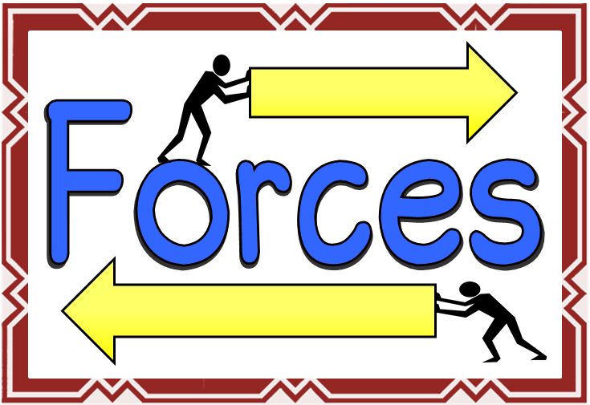

Unit Choices- If work is not finished in class it is HOMEWORK! Binder Check Grading

Name___________________________________________ _______/210

Forces | Newton’s Laws
___/20: Content  - In Class Mini Lecture (notes)  - Tutorial (Google Classroom)  ___/20: Forces Stations  ___/20: FBD Practice (Choose 2 out of 3)  - Challenge 1  - Challenge 2  - Challenge 3  ___/20: Forces PhET Lab  ___/20: Net Force Practice (Choose 2 out of 3)  - Challenge 1  - Challenge 2  - Challenge 3  ____/20: Mass vs. Weight Lab | ___/20: Content (Choose 2 out of 3)  - In Class Mini Lecture  - Tutorial  - Video Notes  ___/20: Newton’s First and Second Law Stations  ___/20: Second Law Practice  ___/20: Newton’s Third Law Stations  ___/20: Newton's Laws Challenges  ____/10: Binder Order Correct

