Language and Movement Games

Letter Search- post letters of the alphabet around the room. Use about three sets of letters for small groups and up to 10 sets for large groups.
- Ask the students to perform a movement skill in the center of the play area. Remind students to use their bumpers so they will not run into each other. When you call out a letter or give a letter sound the students will find the letter, move close to it and point to it with out touching the letter. I usually only do 3-5 letters per game.

Letter Songs- I am blessed to have a computer that will burn music CD’s and I have purchased lots of various CD’s to do this activity. I work on the same letters that the teachers are working on in the classroom. I will search my music for songs that have subjects the start with the week’s letters, burn them to one CD and in the order I wish to play them. Below are examples of some of my Letter CD’s that I use. If the song is about an animal I check out the animal puppet from our library to use as a visual☺
- A and M songs
  - “Aerobic Armadillo” A to Z, The Animals and Me
  - “A-The Sound of The Letter ‘A’” Sing the Alphabet, Sesame Street
  - “Magical Monkey” A to Z, The Animals and Me
  - “M-MMM Monster Meal” Sing the Alphabet, Sesame Street
  - “The Monster In the Mirror” Platinum All-Time Favorites, Sesame Street

- I and W songs
  - “Isabella Inchworm” The Alphabet from A to Z, Sing and Read
  - “Itchy Iguana” A to Z, The Animals and Me
  - “Weight Lifting Walrus” A to Z, The Animals and Me
  - “Wiggle Wobble” Greg and Steve We All Live Together, volume 1

Days of the Week
- After the students enter the room and do the warm up I play the songs “Days of the Week” in English and Spanish. This song is on the Greg and Steve We All Live Together, Volume 4 CD.
- I do this every time the students come in up until around Christmas.

Feelings- Using sound clips off the computer I ask the students to move the way the music makes them feel. I will call out various feelings to help them pick one that works for them.
Positional words- to help my students understand next to, over, under, on, off, etc. I set up a large obstacle course in my room.
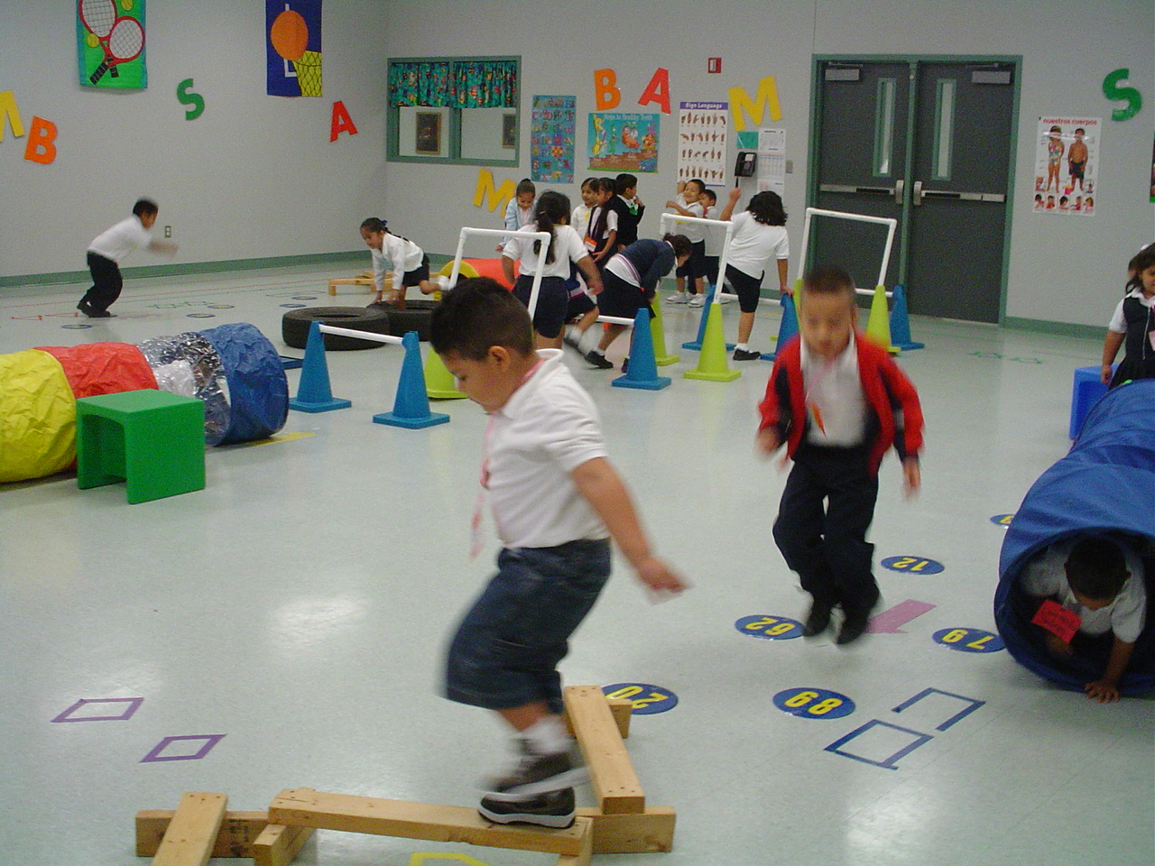
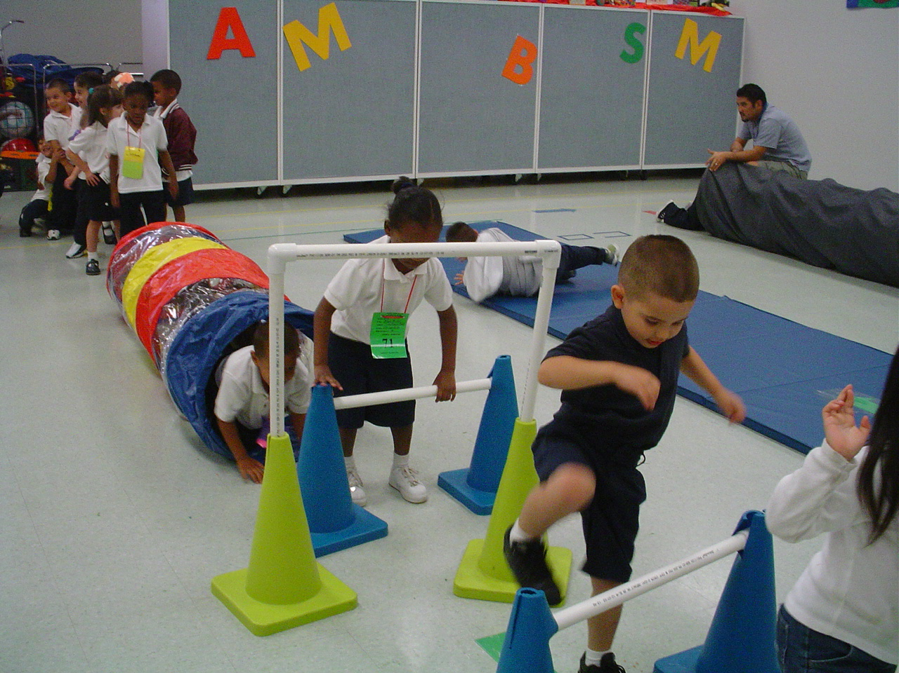

Picture/Letter search- Pair up students and have them sit with their partner around the perimeter of the play area. Give one student a magic clip. The magic clip will help the students remember whose turn it is and help you see who should be taking a turn☺. Scatter die cut laminated pictures of things that start with the two letter sounds that you wish to work on. Make sure you have one picture for every two students.
- Call out the initial letter sound or letter name that you want the students to find.
- On your go signal, the student that has the clip will run around the outside of the circle. Once the student reaches the space where their partner is sitting they will enter the circle and find a picture that starts with the given sound or letter.
- I also use this game to work on letter recognition. Instead of pictures I will place laminated letters in the center. I would then give the students a letter name or sound and they would have to find the correct letter.

- Alpha Egg Hunt- use lots of plastic Easter eggs and permanent markers mark the largest part of the eggs with an uppercase letter and the smallest with a matching lowercase letter.
  - The students find the matching halves.
  - The letters and the colors have to match.

Pre-K TEKS- Physical Development 1A, 1B, 1c, 1D, 1F, 1G; Mathematics 1B, 3B; Language 1A, 1B, 1C, 5B, 7A, 7B, 7C, 7D
Kindergarten TEKS- Physical Education 1A, 1B, 3D, 5A, 6A, 6B, 7A, 7b, 7C

