Lab Safety Test Review
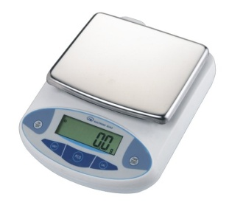
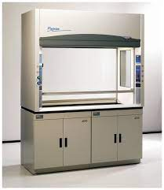
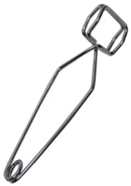
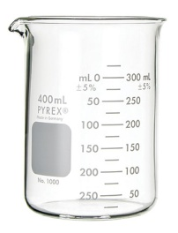

Fume Hood Digital Scale Beaker Test Tube Clamp
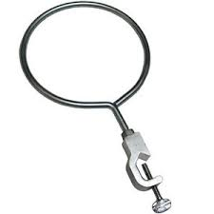
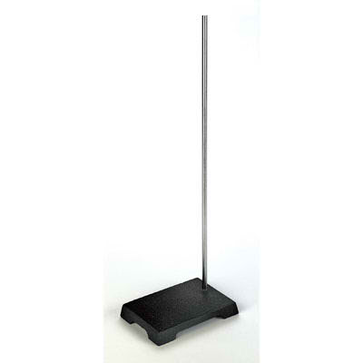
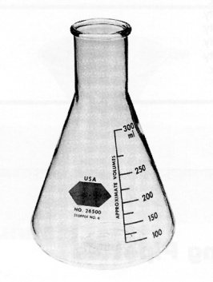
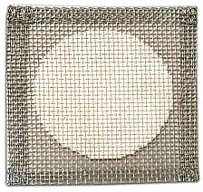

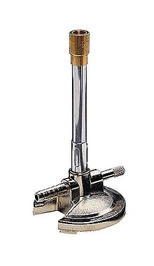
Ring Stand Ring Wire Gauze Flask
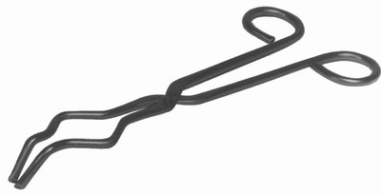
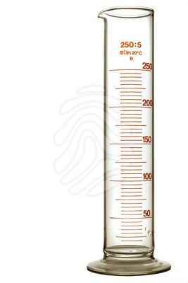
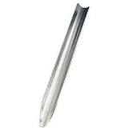

Graduated Cylinder Scoopula Tongs Bunsen Burner
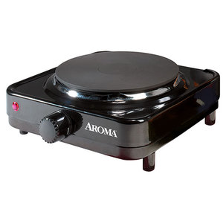
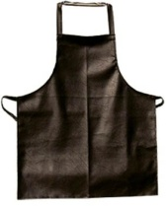
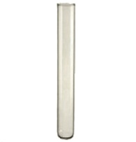
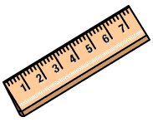

Test Tue Hot Plate Apron Ruler
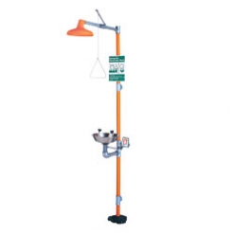
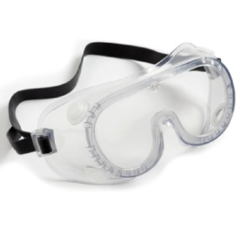
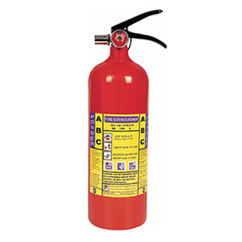
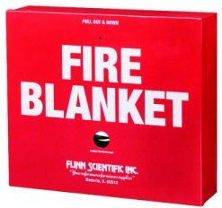

Fire Extinguisher Goggles Fire Blanket Safety Shower

Lab Safety Rules
- Conduct yourself in a responsible manner at all times in the laboratory. No Horseplay.
- Follow all instructions. If you do not understand a direction, ask the instructor before proceeding.
- Never work alone. No student may work in the laboratory without an instructor present.
- When first entering, do not touch equipment, chemicals, or other materials until you are instructed to do so.
- Do not eat food, drink beverages, or chew gum in the laboratory.
- Perform only those experiments authorized by the instructor. Unauthorized experiments are prohibited.
- Be prepared for your work in the laboratory. Read all procedures thoroughly before entering the laboratory.
- Work areas should be kept clean and tidy at all times. Keep aisles clear.
- Know the locations for all safety equipment including first aid kit, eye-wash station, safety shower, fire extinguisher, and fire blanket. Know where the fire alarm and exits are located.
- Use the fume hood when working with vapors. Never place your head into the fume hood.
- Notify the instructor immediately of any unsafe conditions you observe.
- Dispose of all chemical waste properly. Sinks are to be used only for liquids. Solid chemicals, metals, matches, filter paper, and all other solids are to be disposed of in waste containers, not in the sink.
- Wash your hands with soap and water after performing all experiments. Clean all work surfaces and apparatus at the end of the experiment. Return all equipment clean to the proper area.
- Experiments must be monitored at all times. Do not leave open flames unattended.
- Do not wander around the room, distract other students, or interfere with the laboratory experiments of others.
- Students are never permitted in the science storage room unless given specific permission by their instructor.
- When using knives and other sharp instruments, always carry with tips and points pointing down and away. Always cut away from your body. Never try to catch falling sharp instruments.
- If you have a medical condition (e.g., allergies, etc.), notify the instructor prior to working in lab.
- Any time chemicals, heat, or glassware are used, students will wear laboratory goggles. No exceptions!
- Contact lenses may be worn provided eye protection is provided by safety goggles. The instructor should know which students are wearing contact lenses in the event of eye exposure to hazardous chemicals.
- Dress properly for lab activities. Long hair, dangling jewelry, and loose or baggy clothing are hazardous. Long hair must be tied back and dangling jewelry and loose or baggy clothing must be secured.
- Lab aprons have been provided for your use and should be worn during select laboratory activities.
- Report any accident (spill, breakage, etc.) or injury (cut, burn, etc.) to the instructor immediately.
- If a chemical splashes in your eye(s) or on your skin Notify the instructor immediately. Then flush with running water from the eyewash station or safety shower for at least 20 minutes.
- All chemicals in the laboratory are to be considered dangerous. Do not touch, taste, or smell any chemicals unless specifically instructed to do so. The proper technique for smelling chemicals is called wafting.
- Take only as much chemical as you need. Never return unused chemicals to their original containers.
- Never use mouth suction to fill a pipet. Use a rubber bulb or pipet pump.
- Acids must be handled with extreme care. When cleaning a container that held acid or another dangerous chemical, turn the water on first in the sink and then place the glassware in the running water. Never place glassware in the sink and then turn on the water. This will cause the chemical to splash up and on your skin.
- Never dispense flammable liquids anywhere near an open flame or source of heat.
- Never remove chemicals or other materials from the laboratory area.
- Take great care when transporting acids and other chemicals from one part of the laboratory to another.
- Tell instructor first if glassware is broken. Never handle broken glass with your bare hands. Use a brush and dustpan to clean up broken glass. Place broken or waste glassware in the designated glass disposal container.
- When removing an electrical plug from its socket, grasp the plug, not the electrical cord.
- Examine glassware before each use. Never use chipped or cracked glassware. Never use dirty glassware.
- If you do not understand how to use a piece of equipment, ask the instructor for help.
- Do not immerse hot glassware in cold water; it may shatter.
- Exercise extreme caution when using a gas burner. Take care that hair, clothing and hands are a safe distance from the flame at all times. Do not put any substance into the flame unless specifically instructed to do so. Never reach over an exposed flame. To light a Bunsen burner, first connect the hose to the outlet. Then turn the handle so that it is parallel to the outlet. Use only a striker to light the flame. Adjust the flame using the knobs on the base of the Bunsen burner until you get a flame with an inner blue cone.
- Never leave a lit burner unattended. Never leave anything that is being heated unattended.
- Always turn the burner or hot plate off when not in use.
- Do not point the open end of a test tube being heated at yourself or anyone else.
- Heated metals and glass remain very hot for a long time. They should be set aside to cool and picked up with caution. Use tongs or heat-protective gloves if necessary.
- Never look into a container that is being heated.
- Hot and cold glass have the same appearance. To see if an object is hot bring the back of your hand close to it.
- When using a digital scale to weigh a chemical, you must first place a paper towel or weighing paper on the scale. Then turn on the scale. Press the “zero” or “tare” button to make sure the reading says “0”. Then use a scoopula to place the chemical on the paper tower.

