A kite consists of these basic parts:
The Spine. The up-and-down, or vertical stick that you build your kite around.
The Spar. The support stick(s), that are placed crossways over the spine.
The Frame. The joined spine and spars that form the shape of the kite and make a support for the cover.
The Cover. The paper, plastic, or cloth, that covers the frame to make a kite.
The Flying Line. The string running from the kites’ bridle, where you hold to fly the kite.
The Tail. A long strip of paper or plastic that helps to balance the kite in flight.
The Reel. The object you use to wind your flying line, to keep it form getting tangled or flying away.

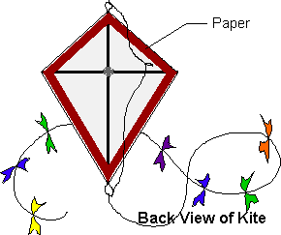

DIAMOND KITE
Materials:
• string
• scotch tape or glue
• trash bag
• Straws

1. Make a cross (the spine and spar) with the straws by forcing each straw into the other straw.
2. Tie the two straw pieces together with the string in such a way as to make sure that they are at right angles to each other. A good way to ensure that the joint is strong to put a dab of glue to stick it in place.
3. Lay the sail material flat and place the straw frame face down on top. Cut around it, leaving about 2-3cm for a margin. Tape or glue it down so that the material is tight.
5. Cut a piece of string about 122 cm long and tie one end to the loop at the other end of the string to the loop at the bottom. Tie another small loop in the string just above the intersection of the two cross pieces. This will be the kite's bridle, the string to which the flying line is attached.
6. Make a tail by tying a material roughly every 10cm along the length of string. Attach the tail to the loop at the bottom of the kite.

