A kite consists of these basic parts:
The Spine. The up-and-down, or vertical stick that you build your kite around.
The Spar. The support stick(s), that are placed crossways over the spine.
The Frame. The joined spine and spars that form the shape of the kite and make a support for the cover.
The Cover. The paper, plastic, or cloth, that covers the frame to make a kite.
The Flying Line. The string running from the kites’ bridle, where you hold to fly the kite.
The Tail. A long strip of paper or plastic that helps to balance the kite in flight.
The Reel. The object you use to wind your flying line, to keep it form getting tangled or flying away.

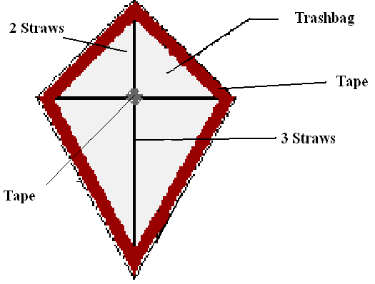
Materials:
-String
- Scotch tape and Duct Tape
- Trash bag
- Straws
- Glue

1. Make a cross (the spine and spar) with the straws by forcing each straw into the other straw. Make the straws stronger by pushing as many toothpicks as possible in the straws. Then squeeze glue into the straws. Once the glue dries, the straws will become strong.
2. Lay the long (5 straws) piece on the trash bag. Lay the 4 straw piece about 1/3rd of the way down the 5 straw piece. Duct tape both pieces onto the trash bag. Do not use too much duct tape – it will be too heavy to fly! Place duct tape in the center and on all 4 tips of the straws. Also, make sure the trash bag is pulled tight before taping down the straws.
3. Cut out a diamond shape.
4. Make a tail out of excess trash bag and tape it to the bottom of the kite.
5. Tie string to the kite however you choose.

