Kinetic Energy
Materials:
Marble
½ cut foam tubing
Meter stick
2 Ring Stands
Tape

Procedure:
- Place the tubing on the ring stand similar to the drawing below. Make sure the heights are both about 1 meter above the floor.
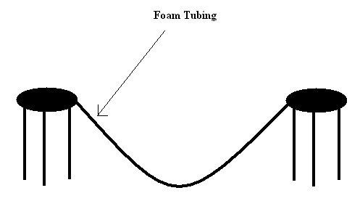
- Mark the 1 meter spot with a piece of tape – not on the track part of the foam but under it.
- Place the marble at this starting point and release the marble. Record this spot as height 1.
- Follow the marble and mark where it stops on the up hill. Measure this height and record it as height 2.
- The ratio of the starting point to the ending point is the efficiency of the marble. Find the efficiency and record in the data table. Efficiency = height 2 / height 1
- Now, disconnect the foam and make a loop like the drawing below. Have the radius of the loop to be 6 cm or a diameter of 12 cm. Convert cm to meters for use in the equation. Be sure and leave a lot of foam tubing at the start of the loop as in the picture.
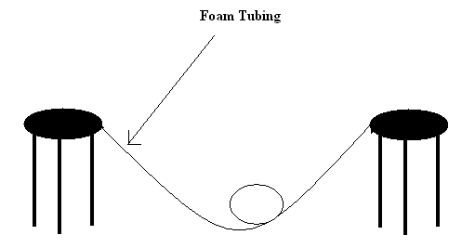
- Using this equation, calculate the velocity needed for the marble to make it around the loop; mg = mv²/r, measure the mass of your marble using the triple beam balance. Record the velocity in the data table.
- Now to find the height needed to create this velocity, use this equation;
½ mv² +mg²r = mgh; Use the calculated velocity and measured mass to find the height. Record the needed height.
9. Try dropping your marble from the required height and answer the questions below.

Data Table:

Height 1 Height 2 Efficiency = Height 2 / Height 1 V2 Height Needed

_______ _______ _________________________ ____ ________
Conclusion:
1. Does the marble make it through the hoop from the calculated required height? Why or why not?

2. If you used a lower height would the marble make it? Why or why not?

3. If you used a higher height, would the marble make it? Why or why not?

4. The marble is losing energy; this is why it slows down. Where is the energy going? (What is causing this loss of energy?)

