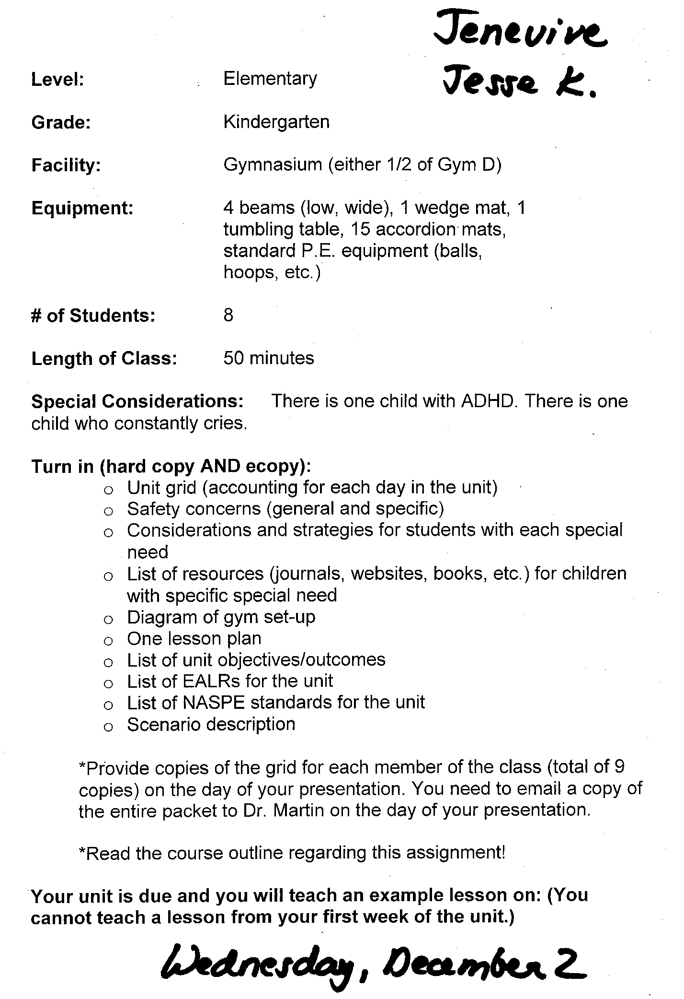

Day 1: Intro to Gymnastics/Balance
Gym Diagram A
Equipment: 15 AM, 1-2 children/mat
Safety Basics: see safety list
Make sure everyone is following dress code
Dynamic stretching progression:
- neck stretches (side, up & down, half circles) - arm circles, shoulder & tricep stretches
- windmills, soldier
- downward dog, cobra
4pt. balance: Table position
3pt. balance: alternating arms/legs, L/R
2pt. balance: asymmetrical, symmetrical L/R
4pt. balance: plank
3pt. balance: alternating arms/legs, L/R
2pt. balance: asymmetrical, symmetrical L/R

Day 2: Upright Balance
Gym Diagram A
Equipment: 15 AM, 1-2 children/mat
Safety Basics: only move in range of comfort
Dynamic Stretching
Progression:
- Review table & plank (4, 3, 2pt.)
- 1 foot balance, knee lifter
- Bent-hip scale (shoulders extended & abducted)
- Extended-hip scale (shoulders ext. & abducted)
*Practicing all on L & R
Independent Practice - 2 students opp. ends 1 mat:
- Alternate leader, partner mirror upright balance
Day 3: Falling & Landing
Gym Diagram A
Equipment: 15 AM, 1-2 children per mat
Dynamic Stretching
Safety Basics: all practice on mat, only one
student on mat practicing falling at a time
Progression:
-Back rockers (start from seated, squat, standing)
- Seat roll, both directions
- Puppy dog roll, both directions
- Dog roll, both directions
- Squat beside mat – dog roll
- Stand to squat to back shoulder roll
- Paratrooper roll (introduce only if back
shoulder roll shows general proficiency)
Independent Practice

Gymnastics Unit Grid - Kindergarten
Day 4: Falling/Landing/Upright Agility
Gym Diagram A
Equipment: 15 AM, 1-2 children/mat
Dynamic Stretching
Safety Basics: all practice on mat, students take turns on mat to practice falling 1 at a time
Review: back rockers, dog roll, back shoulder
Review or teach: paratrooper roll
Safety: all jumping controlled and on mat
Progression:
- Vertical jump for height, cushioned landing
- Knee slapper
- Seat kicker
- Ankle slapper
Independent Practice
- Alternate leaders, put 3 jumps together,
partner mirrors

Day 5: Upright Agility
Gym Diagram A
Equipment: 15 AM, 1-2 children/mat
Dynamic Stretching
Safety Basics: all practice on mat
Review: Falling & landing
Review: vertical jump/landing, knee slapper, seat
kicker & ankle slapper
Progression:
- Star jump
- Straddle jump
- Pike jump
- Rotations: 90°, 180°, both directions
Independent Practice
- Alternate leaders, put 3 jumps together,
partner mirrors

Day 6: Upright Agility/Inverted Balance
Gym Diagram A
Equipment: 15 AM, 1-2 children/mat
Dynamic Stretching
Safety Basics: all practice on mat
Review: Falling & landing
Review: Star, straddle, pike jumps & rotations
Progression:
- Hand position
- Head touch (to form triangle w/ hands)
- Knee meets elbow, L/R alternate
- Tripod
Independent Practice – only after all show
appropriate head/hand placement
*Safety - safe self space, raise hand for
help/spot

Day 7: Intro Forward Rolling
Diagram
Equipment: 14 AM,1 WM,1 TT, 8 bean bags
Safety:
- Don’t go airborne
Progressions:
- Stretch necks
- Look behind with bean bags
- Weight bearing look behind
- Log roll
- Puppy dog roll
Stations:
- 4 total
- 1 WM
- 1 TT
- 2 AM
Day 8: Forward Rolling
Diagram
Equipment: 8 AM, 1 WM, 1 TT
Safety:
- Don’t go airborne
Progressions:
- Stretch necks especially light run warm up
- Seat balance
- Weight bearing look behind
- Tip-over*
- Forward roll
Stations:
- 4 total
- 1 WM
- 1 TT
- 2 AM

Day 9: Introduce Back Rolling
Diagram
Equipment: 8 AM
Safety:
- Always tuck neck to chest
Progressions:
- Warm up and stretch necks
- Sit back
- Back balance
- Back rocker
- Sit back to back rocker
- Back rocker to puppy dog position
Stations:
- With partner, attach 2 mats together
Day 10: Backward Rolling
Diagram
Equipment: 8 AM
Safety:
- Tuck chin to chest
Progressions:
- Back balance
- Squat to back rocker
- Hand position
- Toe touch
- Back shoulder roll*
- Standing to squat back shoulder roll
Stations:
- With partner, attach 2 mats

Day 11: Introduce LWB
Diagram
Equipment: 4 LWB, 14 AM, 1 bean bag
Safety:
- Mats against LWB, away from wall
- No jumping off
Progressions:
- Review upright stationary balance
- Balance on LWB and step off
- Side step
- Walk down beam
- Dismounting
Stations:
- 4 total
- LWB side step and dismount
- LWB walk down and dismount
- LWB step on, balance, dismount
- LWB walk or side step with bean bag on head

Day 12: LWB and Circuit
Diagram
Equipment: 15 AM, 2 LWB, 1 WM, 1 TT
Safety:
- Be near most dangerous stations
Progressions:
- Stretch
- Review upright balance, agility, falling/landing,
forward/backward rolling
Stations: Change activities at each station 2nd
time around
- 8 total
- 4 LWB stations (every other station)
- 1 WM
- 1 TT
- 1 upright agility
- 1 falling/landing

Gym Diagram A: Gym Diagram B:
Stereo Wall

Stereo Wall

Gym Diagram C: Gym Diagram D:
Stereo Wall

Stereo Wall

Key:

= Accordion Mat = Tumbling Table

= Wedge Mat = Low-Wide Beam

Gymnastics Unit Objectives:

- By the completion of this unit, students will be able perform and hold for at least ten seconds upright balance positions including: one foot balance, knee lift, bent hip scale and extended hip scale on both the dominant and non-dominant leg, with 80% proficiency.

- Students will be able to perform ten consecutive back rockers with 100% proficiency.

- Students will be able to perform back shoulder rolls over either shoulder with 75% proficiency.

- Students will be able to perform upright agility movements including: knee slaps, seat kickers, star jumps and pike jumps, individually and in combinations with 80% proficiency.

- Students will be able to perform inverted tripod with triangular hands/head postition and hold for at least ten seconds with 75% proficiency.

- Students will be able to perform a weight bearing look behind and hold for five seconds with 100% proficiency

- Students will be able to perform a full rotation log roll down a wedge mat with 80% proficiency.

- Students will be able to perform a tip over from the weighted look behind position with a spotter while holding a bean bag between chin and chest with 75% proficiency.

- Students will be able to perform a sit back to back rocker position while keeping arms attached around knees with 75% proficiency.

- From a squat position, students will be able to perform a back shoulder roll and land on feet with a spotter with 50% proficiency.

- Students will be able to walk or side step one length down the low-wide beam and dismount without falling off with 75% proficiency.

Safety Concerns

General Safety Concerns:
- No food, gum, or drink in gym
- Must wear athletic clothing
  - No jeans or shirts with collars or buttons
- Must tuck shirts in
- No jewelry
- Only engage in activity when instructor gives permission
- Always practice safe self space
- No horseplay
- No shoes unless otherwise specified

Accordion Mat Safety Concerns:
- Only one person per mat unless otherwise specified
- When connecting two mats, make sure they are compatible and Velcro together without a gap
- Always make sure there is enough room to fall when performing a skill

Wedge Mat Safety Concerns:
- Make sure there are at least two accordion mats attached together at the small (landing) side of the wedge
- Be sure the end of the wedge overlaps the Velcro of the accordion mats
- May need to put accordion mats on the sides of the wedge mat as necessary
- Only perform skills that were taught in class
- One person at a time
- When front rolling, do not get a running start because the wedge mat may slide

Tumbling Table Safety Concerns:
- Make sure there are at least two accordion mats attached together at the small (landing) side of the table
- Be sure the edge of the table overlaps the accordion mats
- Use accordion mats on the sides of the table as necessary
- Only perform skills that were taught in class
- One person at a time
- May need to add additional accordion mat to landing to make up for the large drop at the end

Low-Wide Beam Safety Concerns:
- Accordion mats must butt up to the beam
- Only one person on the beam at a time, unless otherwise specified
- One person can sit on beam to stabilize while other is performing a skill
- May need to use additional accordion mats on ends of beam if necessary
- Stay away from walls
- Do not jump off unless otherwise specified

Gymnastics Unit EALR’s and NASPE’s

EALR:

1.1 Develops motor skills and movement concepts as developmentally appropriate.

1.2 Acquires the knowledge and skills to safely participate in a variety of developmentally appropriate physical activities.

1.4 Understands the concepts of skill-related fitness, and interprets information from feedback, evaluation, and self assessment in order to improve performance.

3.3 Evaluates the impact of social skills on health.

NASPE:

Standard 1: Demonstrates competency in motor skills and movement patterns needed to perform a variety of physical activities.

Standard 2: Demonstrates understanding of movement concepts, principles, strategies, and tactics as they apply to the learning and performance of physical activities.

Standard 4: Achieves and maintains a health-enhancing level of physical fitness.

Standard 5: Exhibits responsible personal and social behavior that respects self and others in physical activity settings.

Standard 6: Values physical activity for health, enjoyment, challenge, self-expression, and/or social interaction.

Strategies for Students with Special Needs

ADHD: Attention Deficit Hyperactivity Disorder

- Identified by poor concentration accompanied by hyperactivity or low active students.
- Create structured/predictable learning environment with specific times for set for specific tasks.
- Post schedules daily.
- Setting specific times for specific tasks.
- Set schedule of breaks throughout activities.
- Call special attention whenever there are schedule changes.
- Policy of clear and predictable classroom expectations, rules and consequences.
- Immediate consequences for not adhering to class expectations and rules.
- Utilize visual demonstrations to enhance verbal instructions.
- Throughout lesson restate directions multiple times.
- Give regular feedback.
- Focus on quality over quantity.

“Crier”:

- Figure out crying triggers
- Talk with parents of crying child
- Most likely crying for attention or trying to get their way
- Explain to child why behavior is disruptive and inappropriate
- Do not back down on consequences for the crier
- Use a soft voice and be calm with the student
- Meeting new people can be a trigger
- Let crier know of major changes ahead of time
- Ignore attention-seeking crying
- Use positive reinforcement when crying stops
- Bring fun and humor to the lesson

References:

Dr. Ken Shore’s Classroom Problem Solver. (2004). The class cry-er. Retrieved from http://www.education-world.com/a_curr/shore/shore048.shtml

Child and Adolescent Bipolar Foundation. (2007). Educating the child with bipolar disorder. Retrieved from http://www.bpkids.org/site/DocServer/edbrochure.pdf?docID=166

National Attention Deficit Disorder Association, 2009. ADD/ADHD Fact Sheet. Retrieved from: http://www.pecentral.org/adapted/factsheets/add-adhd.pdf

Your New Baby. (n.d.). What to do when baby cries. Retrieved from http://urbanext.illinois.edu/baby/when_baby_cries.html

Physical Education Lesson Plan by: Jenevive DeLazzari and Jesse Kase

Date: 12/2/09 Class: PE 340 Grade: Kindergarten Time: 10 am

Location: Gym D Final lesson of Gymnastics Unit Number of Students: 8

Objectives of the Lesson: By the end of the lesson, students will be able to hold a basic knee lifter for 5 seconds with 75% proficiency, demonstrate a back shoulder roll with 50% proficiency, perform 5 knee slappers with 80% proficiency, perform a tip over with 75% proficiency, and walk down a low-wide beam without falling off 4 out of 5 times.

Procedures/Activities | Organization | Equipment | Time
Introduction:  Welcome students, safety review  Guided Practice:  Dynamic Stretching  Demonstration/Review:  Upright Balance (L/R alternating)  -knee lifter  -bent hip scale  -extended hip scale  Guided Practice: (practice as a class)  Upright Balance  -knee lifter, 5 each leg, count to 10  -bent hip scale, 5 each leg, count to 5  -extended hip scale, 5 each leg, count to 5  Demonstration/Review:  Falling/landing  -back rocker  -puppy dog roll  -back shoulder roll  Guided Practice: (practice as a class)  Falling/landing  -back rocker, 10 times  -puppy dog roll, 10 rolls- 5 each side  -back shoulder roll, 5 each shoulder  Demonstration/Review:  Upright Agility  -vertical jumping  -knee slapper  -seat kicker  -star jump  -straddle jump  Guided Practice: (practice as a class)  Upright Agility  -vertical jumping, 10 jumps  -knee slapper, 5  -seat kicker, 5  -star jump, 5  -straddle jump, 5  Demonstration/Review:  Forward rolling/inverted balance  -look behind  -tripod  -tip over  Guided Practice: (practice as a class)  Forward rolling/inverted balance  -look behind, 5, hold for 5 seconds  -tripod, 5, hold for 5 seconds  -tip over, 10 ask for spotter if needed  Demonstration/Explanation:  Alternating station rotation  Station 1: Upright Agility  -combine two skills  Station 2: LWB  -side step and dismount  Station 3: Backward rolling  -back rocker or back shoulder roll if comfortable  Station 4: LWB  -step on, upright balance, forward walk, dismount  Station 5: Wedge mat  -forward rolling down  Station 6: LWB  -forward walk, backward walk if comfortable  Station 7: Tumbling Table  -log rolling  Station 8: LWB  -forward walk or side step with bean bag on head  Independent Practice:  Alternating station rotation  -1 minute/station  -2 times through if time allows  Conclusion:  Wrap up gymnastics unit  Ask students what their favorite part of the gymnastics unit was | Seated, scattered, facing wall #1  Seated/standing, facing wall 1 on own AM  Seated facing wall 1 on own AM  Standing facing wall 1 on own AM  Seated facing wall 1 on own AM  Standing facing wall 1 on own AM  Seated facing wall 1 on own AM  Standing facing wall 1 on own AM  Seated facing wall 1 on own AM  Standing facing wall 1 on own AM  Scattered in alternating station rotation at the station being explained  Alternating station rotation around front half of gym D  Seated, scattered facing wall 1 | None  8 AM (accordion mat)  8 AM  8 AM  8 AM  8 AM  8 AM  8 AM  8 AM  8 AM  15 AM, 1 Tumbling Table, 1 Wedge Mat, 4 low-wide beams, 2 bean bags  15 AM, 1 Tumbling Table, 1 Wedge Mat, 4 low-wide beams, 2 bean bags  none | 0-1  1-4  4-5  5-9  9-10  10-14  14-15  15-18  18-19  19-24  24-32  32-48  48-50

Mastery of Objectives The students will be assessed on their ability to perform basic upright balance, upright agility, forward and backward rolling, and use of the low-wide beam during an alternating station rotation in the independent practice portion of the lesson.

