
Jello Laser!
Materials:
Jello
Laser
Protractor

Introduction:
Have you ever seen telephone workers installing new telephone cables along the highway? The cables are probably not made of copper wire, which carries electrical energy, but of fine, glass fibers that carry light. As amazing as it seems, long distance telephone companies transmit conversations in the form of tiny pulses of light. Telephone companies make use of the process of total internal reflection to keep a signal from weakening too rapidly over long distances or from leaking out of the fiber as the signal bounces around in the fiber.
When total internal reflection occurs, the pulses of light traveling along an optical fiber act like stones skipping across the surface of a quiet pond. But instead of eventually falling down into the water the way a stone does, the light is reflected into the air.

Procedure:
1. Take a strip of gelatin that is about 2.5 cm wide. This represents a fiber optic cable.

2. Shine the laser from one end of the strip into the gelatin at an incident angle of 0 degrees (perpendicular to the surface of the gelatin). Note that the incident angle is measured from the beam to an imaginary line perpendicular to the surface. Note how the brightness and path change as it travels through the gelatin. Answer question 1 on the conclusion.

3. Slightly increase the incident angle of the laser and observe the change in the brightness and path of the beam. Answer question 2 on the conclusion.

4. Continue increasing the incident angle, bring the beam more parallel to the surface, until you reach the critical angle. At this angle, no light will be refracted out of the sides of the gelatin strip. Instead the light will exhibit total internal reflection. Find this point, and use the protractor to measure the angle. Record this angle on question 3 on the conclusion.

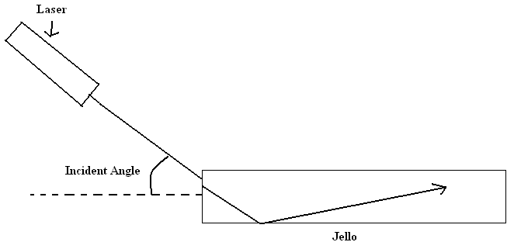

Conclusion:
1. Describe the path of the beam of light.

2. Describe the path and the brightness of the beam after you increased the angle.

3. What is the critical angle of the gelatin?

Going Further (Research on one of my computers):

1. What are fiber optic cables made-of?

2. How many signals can a fiber optic cable transmit at one time?

3. What is transmitted in a fiber optic cable? How does this differ from a metal cable?

4. In what ways are fiber optic cables an improvement over metal cables?

