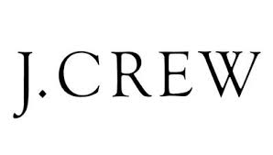
Market Segment Assignment

Shown below is an example of market segmenting and target market for J. Crew Group. Pick a retail company of your own and explain its segmenting strategy for each of the following categories.

Age
J. Crew Group targets its clothing and apparel towards 18-35 year olds.

Income
Targeted income level tends to be upper-middle class and higher.

Gender
Males and females are both targeted, with a slightly greater emphasis on the female consumer.

Family Life Cycle
Appeals to the bachelor, single woman, working mother/father, and the family with children.

Region
Large populated areas and locations where income levels are high, such as New York, Los Angeles, San Francisco, Chicago, Dallas, and other metropolis’ are targeted because of the abundance of people (J. Crew, 2001). Low populated, rural areas of the country are not targeted as part of the product market.

Lifestyle
An active, yet working lifestyle is targeted.

Attitude
A carefree attitude is targeted, yet maintaining a serious disposition.

Attitude
Region
Lifestyle
Family Lifestyle
Gender
Income
Age
Your Company:

