Investigative Series #2: The Effect of Heat on Water

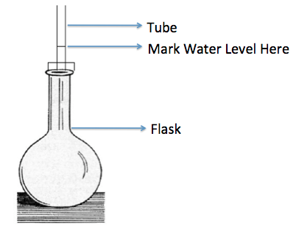
Materials:
Water to completely fill a large, flat-bottomed Florence Flask,
Stopper - one holed
Glass delivery tubing
Food coloring
Hot plate
Pipet
Ice Bath

Procedure:
- Add 1 drop of food coloring to a full flask of water.
- Insert the tube into the flask as shown in the diagram. Some of the water should go up into the tube, if not, use a pipet to add a few drops of water.
- Mark the water level as shown in the diagram.
- Set the flask on a hot plate. Make a prediction of what will happen:

- Watch the level of water in the tube. Mark the new level.
- Remove the flask from the hot plate and let it cool to room temperature… note the level again.
- Place the whole set up into the ice bath. Make a prediction of what will happen:

- Watch the level of water in the tube. Mark the new level.

Results:
For Heating:
1. What did we see?

2. What changed?

3. What is our evidence?

4. Was your prediction confirmed or refuted?

Investigative Series #2: The Effect of Heat on Water

Materials:
Water to completely fill a large, flat-bottomed Florence Flask,
Stopper - one holed
Glass delivery tubing
Food coloring
Hot plate
Pipet
Ice Bath

Procedure:
- Add 1 drop of food coloring to a full flask of water.
- Insert the tube into the flask as shown in the diagram. Some of the water should go up into the tube, if not, use a pipet to add a few drops of water.
- Mark the water level as shown in the diagram.
- Set the flask on a hot plate. Make a prediction of what will happen:

- Watch the level of water in the tube. Mark the new level.
- Remove the flask from the hot plate and let it cool to room temperature… note the level again.
- Place the whole set up into the ice bath. Make a prediction of what will happen:

- Watch the level of water in the tube. Mark the new level.

Results:
For Heating:
1. What did we see?

2. What changed?

3. What is our evidence?

4. Was your prediction confirmed or refuted?

Statement of Understanding:
Write a “Statement of Understanding” to explain what you saw in this activity. Use the guidelines below to help you.

We Investigated ….. what we used… what we did… what we saw… what we now know…
The evidence that something changed was that _____________________________.
It was _____________________________________ that caused that change to happen.

Extension – Cooling:

1. What did we see?

2. What changed?

3. What is our evidence?

4. Was your prediction confirmed or refuted?

