Interpretation of Bernoulli's Equation

Bernoulli's equation is one of the more popular topics in elementary physics. It provides striking lecture demonstrations, challenging practice problems, and plentiful examples of practical applications, from curving baseballs to aerodynamic lift. Nevertheless, students and instructors are often left with an uncomfortable feeling that the equation is clear and its predictions are verified, but the real underlying cause of the predicted pressure changes is obscure. The common description of the derivation of the equation is at best misleading.

The history of the physics of fluids is surprisingly anachronistic. Archimedes discovered the principle of buoyancy in the third century B.C. In the seventeenth century, Torricelli found the relationship of speed of a fluid emerging from the side of a container to the hydrostatic head of the fluid , Pascal enunciated the isotropic characteristic of pressure, and Newton described properties of viscosity. Daniel Bernoulli proposed his equation for fluid flow in 1738. Euler published his papers on fluid flow in 1755 and 1770. Hagen and Poiseuille described viscous flow in 1839 and 1840, respectively. Today we use Pascal's principle to explain buoyancy and Euler's equation to develop Bernoulli's equation, from which Torricelli's equation is obtained. There is no pretense, therefore, that the arguments given below are historically representative.
The most common form of Bernoulli's equation is

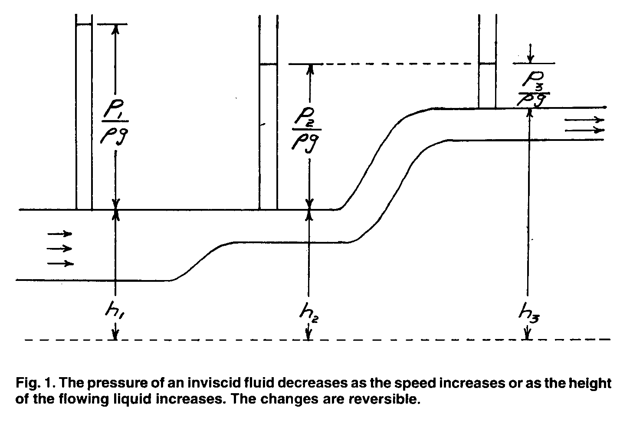

It shows that the pressure, P, of a fluid of density p decreases as the speed, u, increases or as the height, h, increases (Fig. 1). It is usually described as applicable to incompressible fluids.
As one looks carefully at the equation and its derivation, several questions arise. Is it really meaningful to treat air as an incompressible fluid? What is meant by the pressure in a flowing medium; is it isotropic or anisotropic? How is temperature defined when the velocity distribution is anisotropic?

Equally fundamental, why does pressure appear in Eq. (1) as a term along with a sum of energy densities? Although P has units of energy density, it is not an energy density. When we add PV to energy, E, we get a new quantity, called enthalpy, H≡ E + PV, which differs in several respects from energy. For example, enthalpy is not subject to a conservation law. If we look at the change in PV, we find it is not equal, in general, to a change in energy:
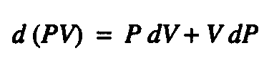
The first term represents energy transfer, as work, for the equilibrium condition assumed in Bernoulli's equation, but the second term is not work, nor even energy transfer.
Finally, Bernoulli's equation is derived from properties of the bulk fluid. Is there a simple, but meaningful, molecular-level interpretation of the Bernoulli effect?

Horizontal Flow of Incompressible Fluids
The standard textbook explanation of Bernoulli's equation, for smooth flow of an incompressible fluid (i.e., inviscid, irrotational, isochoric flow), is that the equation is a sum of energy density terms,
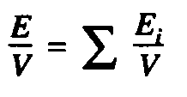
where the E_{i} values change along a streamline but the sum is the same for each point along a streamline. This is generally described as arising from the conservation of energy. The explanation is not correct.

Of course energy is conserved in this as in every other known process, including viscous and turbulent flow. However, the energy of the fluid is not constant along a streamline. That is, energy is not a constant of the motion. Bernoulli's equation is not a sum of energy densities that is constant along a streamline.

Consider a flow between two regions, one at a constant pressure P\ and the other at a constant pressure P₂. The system is taken as an element of fluid that reaches from point A, at pressure P₁, to point B, at pressure P₂ (Fig. 2). During the process under consideration, the volume of the system in the region at P₁ is decreased by an amount V₁, as the system is pushed from A to A', and the volume of the system in the region at P₂ is increased by the amount V₂> as ^{me} system progresses from B to B'. The total work done on the system is
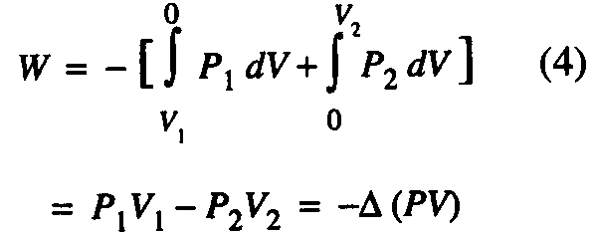

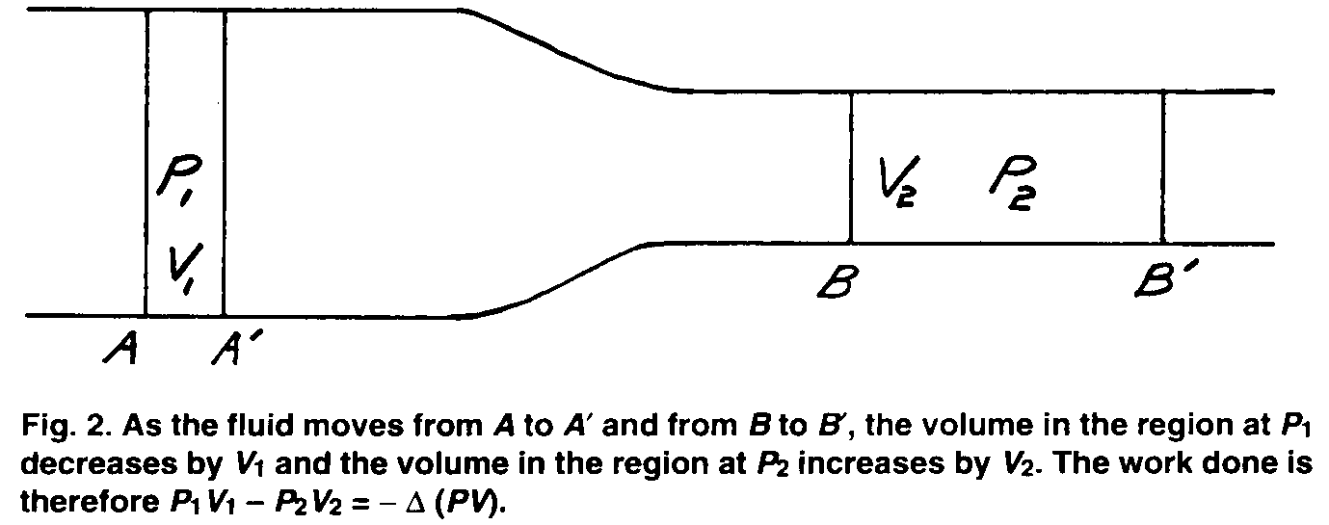
Even though Pj, Vj, P₂, and V₂ are not descriptive of the entire system, they are well defined locally for steady flow and they give the correct change in PV of the entire system because there is no change (with time) in properties between A' and B during steady flow.

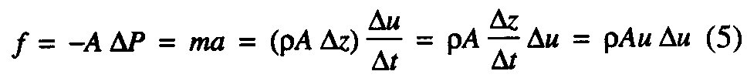
From Euler's equation, in one dimension (equivalent to Newton's second law), the force acting on a small volume element of length Δz, which moves its own length along the z axis in a time Δt is

Dividing by the cross-sectional area gives

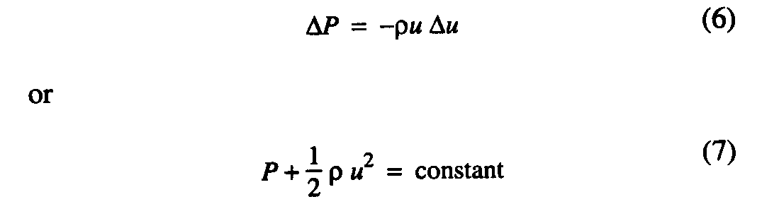
after integration.

For inviscid flow (zero viscosity), there is no change in entropy and no transfer of thermal energy between fluid segments; Q = Qwersible = 0. The internal energy of the incompressible fluid does not change, so the change in total energy of the fluid element is equal to the work done on the fluid. Therefore

The flow does not occur at constant energy. Although energy is constant at each point , because the flow is steady, along a streamline . Energy increases as pressure decreases along a streamline.

On the other hand, enthalpy, , is constant along the flow.
The flow is isenthalpic.
The process may be recognized as similar to a Joule-Thomson expansion. The pressure change is given, for each process, by the equation.
However, the Joule-Thomson experiment involves an irreversible pressure drop, whereas

Bernoulli's equation describes reversible flow.

Change of Height of Incompressible Fluids
If the flow is not horizontal, then we must choose between two descriptions. The first description is to consider the fluid element alone, apart from the gravitational field. According to this model, a ball thrown upward loses energy as it rises, giving up its kinetic energy to the gravitational field. As the ball falls, the gravitational field exerts a force on the ball in the direction of the motion and the ball gains kinetic energy on the way down.

Following this description, the system is the fluid only. In this case, for flow between two levels at a constant speed, enthalpy is no longer constant. The net work done on a fluid element by the surrounding fluid pushing from behind and being pushed ahead, as given by Eq. (4), is just equal to the work done by the fluid element against the gravitational field. For the liquid element, at constant u,
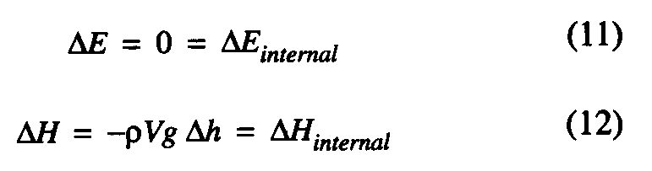
If, on the other hand, we follow the usual custom of including the gravitational field with the system, then the energy of a ball thrown upward remains constant, as kinetic energy (of the ball) is converted to potential energy (of the ball plus gravitational field). According to this model, energy of the fluid element moving at constant speed changes with height along the streamline, but enthalpy is constant:
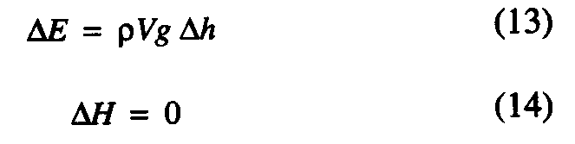
Bernoulli's Equation for Gases
The most common applications of Bernoulli's equation are to gas flows. Clearly, gases are not incompressible fluids. Like the flows of incompressible fluids, however, gas flows are generally adiabatic. That is, there is no (appreciable) flow of thermal energy to or from the fluid during the flow.
An ideal gas undergoing adiabatic flow from a region of one pressure to a region of lower pressure expands. This expansion increases the work done by the gas on the surroundings and thus decreases the net amount of work done on the fluid. To find the change in the product PV, for a given change in energy, it is necessary to know the heat capacity of the gas, which is predictable from the molecular composition.

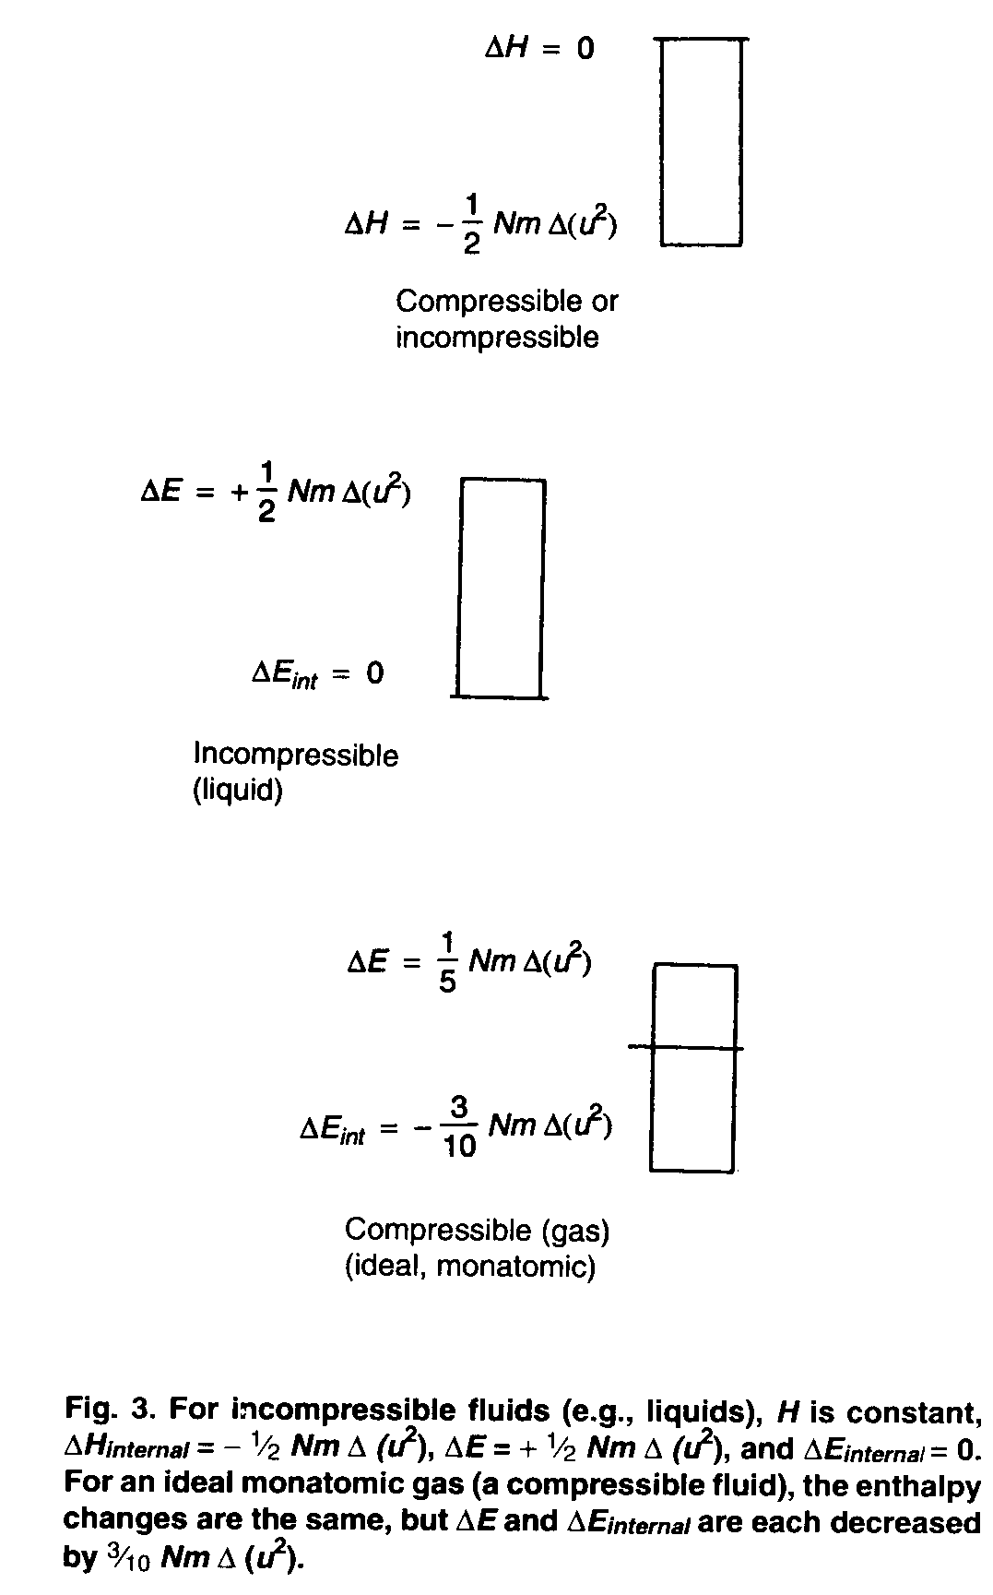
The problem may be solved by separating the problem of adiabatic, reversible expansion from the problem of acceleration (comparable to solving the problem of an expanding, accelerating spring, or an expanding spring in a gravitational field). For horizontal flow of the gas between two regions at fixed pressures, Eq. (4) is still valid. Enthalpy is constant along the flow, as for the incompressible fluid.
However, as the gas undergoes an adiabatic, reversible expansion, its temperature falls. The internal energy decreases with decreasing temperature, as the speed, and hence the kinetic energy, of the gas flow increases.
For a monatomic ideal gas, the decrease in internal energy amounts to 60% of the increase in kinetic energy. The net change in energy of the gas, which must be equal to the net work done on the gas as it expands, is only 40% of the change in kinetic energy (Fig. 3):
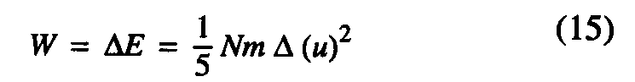
For more complex molecules, with n degrees of freedom contributing to the heat capacity, the change in energy is
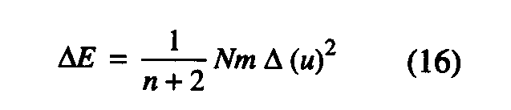
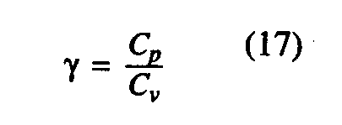
The internal energy change is negative and smaller than the kinetic energy term. The pressure depends on initial pressure and temperature, P₀ and T₀, and on the ratio of heat capacities,
which is (ideally) 7/5 for diatomic molecules and less for polyatomic molecules.

Comparison of Bernoulli's Equation for Liquids and Gases
We have seen that non-viscous liquids, considered as incompressible, undergo horizontal isenthalpic flow at constant temperature but not constant energy, as given by Eq. (7).
Ideal gases, ignoring viscosity, undergo isenthalpic flow in which the temperature decreases and the energy increases. The equation for such flow appears quite different from Bernoulli's equation. Expressed in terms of , the ratio of heat capacities, it is
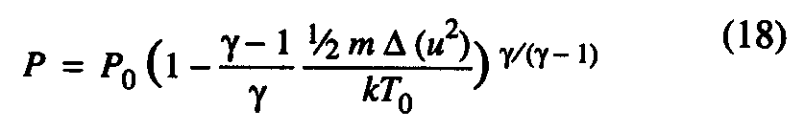
where P₀ and T₀ are initial values for the gas with u = 0.
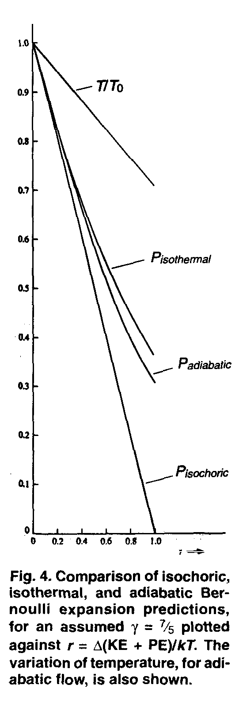
However, in the limit of small values of u, these two equations converge to the same values. This is shown in Fig. 4, which gives the pressures calculated for a gas of diatomic molecules (e.g., dry air) for isochoric, adiabatic, and isothermal flows, as well as the temperature for adiabatic flow, all as a function of energy of the fluid, expressed in terms of a parameter r, which is the change in kinetic energy plus potential energy, divided by kT. It can be seen that the differences are likely to be within experimental error for r  0.2. This corresponds to a flow speed up to 40% of the rms value of v_{z}, the component of molecular velocity along the direction of the flow (or an altitude difference up to 1600 m).

It is therefore a reasonable generalization that for inviscid flow of incompressible fluids or of ideal gases, at speeds small compared with the speed of sound, Bernoulli's equation should be a good approximation. For horizontal flow, enthalpy (H = E + PV) is constant but energy of the fluid is not. Temperature is constant for the incompressible fluid, but decreases with increasing speed for gases.
Bernoulli's Equation for Viscous Fluids
When the viscosity of a fluid is considered, there is a pressure drop even for horizontal flow at constant speed. The speed profile across the cross-section of a uniform tube, for an incompressible fluid, is
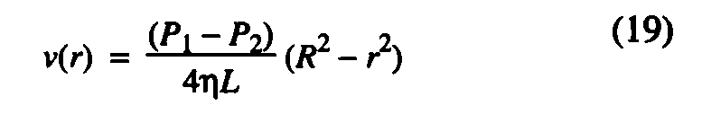
where r is distance from the center, R is the radius of the tube, is the viscosity coefficient, and L is the length of the tube between points at pressure P_{t} and pressure P₂. The speed varies linearly with radius, but the average speed (including weighting for greater volume at larger radius) is one-half the maximum speed for this profile. Integration across the tube gives the flow rate,

where u is the speed along the centerline. Combining these equations gives the pressure drop, ΔP = P_{l} - P₂, in terms of flow rate or speed,
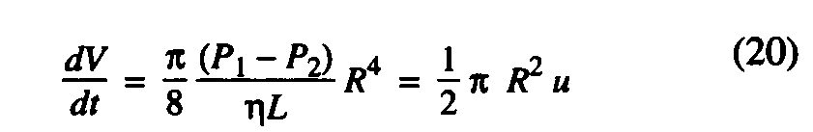
As Badeer and Synolakis pointed out, this pressure drop may be considered as an additive term to Bernoulli's equation, to correct for the energy loss into thermal energy, in viscous fluids. The complete equation would then be
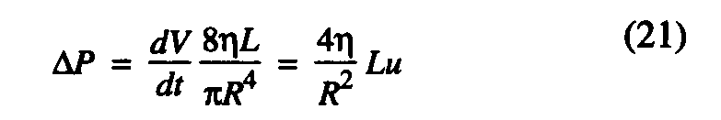
with the additional assumption that the maximum speed, u, is still the appropriate variable for the kinetic energy term. This could appropriately be called the Bernoulli-Hagen, or Bernoulli-Poiseuille, equation, but the effects of viscosity are usually considered small compared with other terms under the conditions for which the equation is applied.
We know that liquids have significant viscosities around room temperature, and even an ideal gas cannot be without viscosity, according to classical physics, because the fundamental cause of viscosity is the transport of momentum between adjacent layers moving at different speeds. The question then arises whether there is a class of flows for which viscosity may nevertheless be considered negligible. An important criterion is that the flow should be irrotational, which depends on the nature of obstructions to the flow as much as on the speed.

A qualitative estimation of the range of validity for neglecting viscosity is obtained by means of the Reynolds number. The Reynolds number, Re, represents the ratio of the pressure drag on the front side of an object to the viscous drag, or skin drag, on the same object:
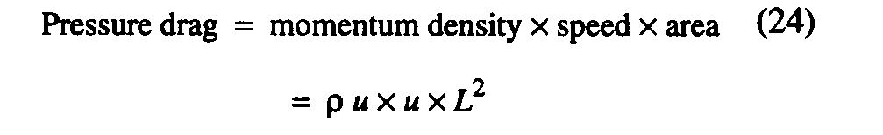
If the object has a size given by a characteristic length, L, the viscous drag is according to Stokes' law, where is the viscosity of the fluid. The pressure drag (a force) on the front side is given by the momentum transfer per time unit on the area of the front side.

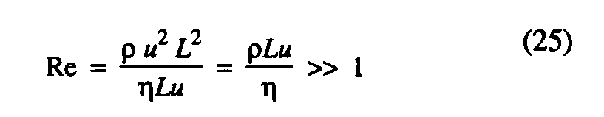
Therefore, the condition for viscosity to be negligible is

The Reynolds number must be large compared to one. The viscosity is , where v is the molecular speed and I is the mean free path, so the condition may also be written as . The ratio of flow speed to molecular speed must be much greater than the ratio of mean free path to object size, so the fluid cannot be too sparse or moving too slowly. On the other hand, the speed must not be too great. Otherwise turbulence arises, and higher-order correction terms in are required also. Thus Bernoulli's equation should be valid for intermediate Reynolds numbers.

Interpretation of Bernoulli's Equation
One possible interpretation of Bernoulli's equation is that there is a conversion of internal motion into directed motion. We have already shown that this cannot be applicable for incompressible fluids, for in that case the internal energy does not change.
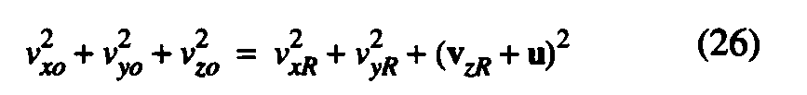
The explanation requires exploration for gases. If the initial kinetic energy is simply redistributed, then
where , etc. are the velocity components of a gas with u = 0, and , etc. are components relative to the center of mass moving with velocity u in the z direction.
However, if we add a constant velocity, u, to each velocity, .

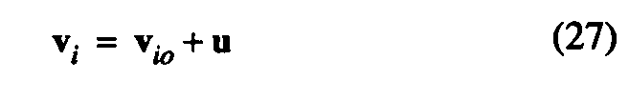
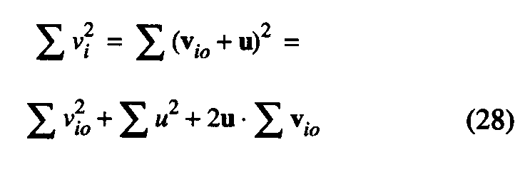
the sum of squares is

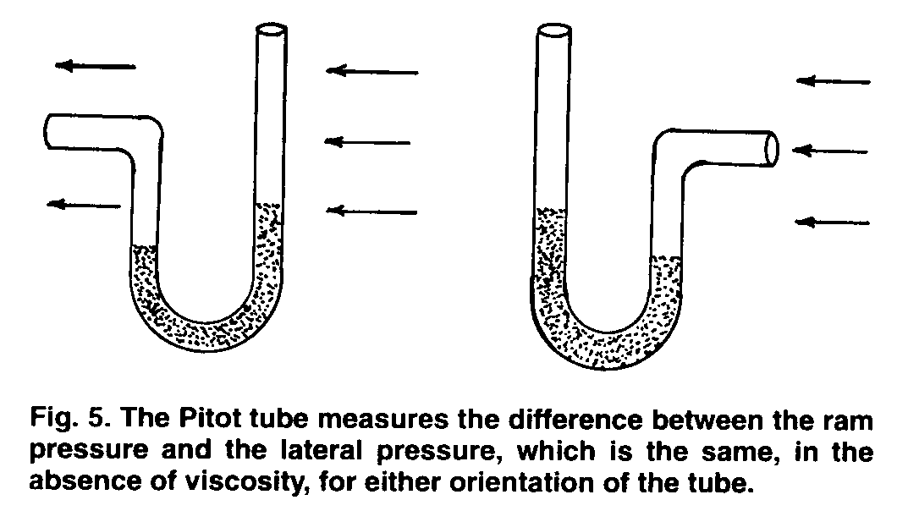
If the are symmetrically distributed, the last term vanishes, so the average values are
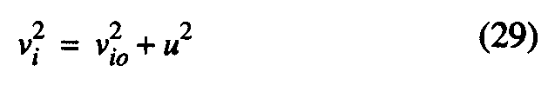
Hence, because is symmetrical,
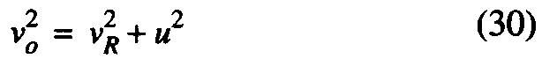
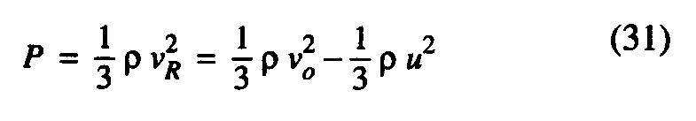
The pressure on the walls perpendicular to the flow is calculated by the standard method of kinetic theory, summing over two dimensions and dividing by the area of four walls. The pressure is

Therefore we find:
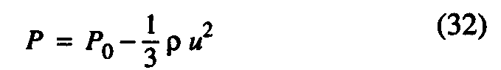
This is close to, but not equal to, the difference of expected from the Bernoulli equation. Thus we may recognize that conversion of internal energy to directed energy is a significant factor in the pressure change of a gas as it changes speed, but it is not the full explanation, and it is irrelevant for liquids.

The kinetic theory also suggests a possible explanation for the fact that the pressure at the inlet of a Pilot, or Prandtl, tube (Fig. 5), or at the stagnation point at the leading edge of a wing, is higher than the pressure measured in the uniform flow. It is well known that the pressure on a surface moving with respect to gas molecules, oriented perpendicular to the motion, is dependent on the relative motion. As in an elevator problem, motion of the surface toward the molecules increases their momentum transfer on collision, and motion away decreases momentum transfer. It is also generally recognized that if a Pilot tube is turned around, il registers a lower pressure. Can we explain the pressure differences in terms of differences in momentum transfer per collision caused by the difference in relative velocities?

The pressure exerted by an ideal gas on a moving piston, for low speeds, is proportional to
1 ± (8/7t) a + (8/n) a², where a is approximately the ratio of piston speed to average molecular speed, or approximately the Mach number. If Bernoulli's equation is cast into similar form, we find the pressure difference proportional to . The Bernoulli pressure change is a much smaller effect, and of different functional form, than the pressure on the moving piston. Thus the ram pressure, or stagnation pressure, is not explained in the same way as force on a moving piston.

We could also have anticipated this result from D'Alem-bert's paradox (ca. 1743). For inviscid streamline flow, D' Alembert showed there is no form drag (due to unbalanced pressure distribution) on an object.⁷ The pressure, , at the forward stagnation point (Fig. 6) is higher by than the free stream value, (far from the object). As the
speed increases, where the fluid moves around the object, the pressure drops below the free stream value, but it returns at the rear stagnation point to the same value, , as at the forward point.

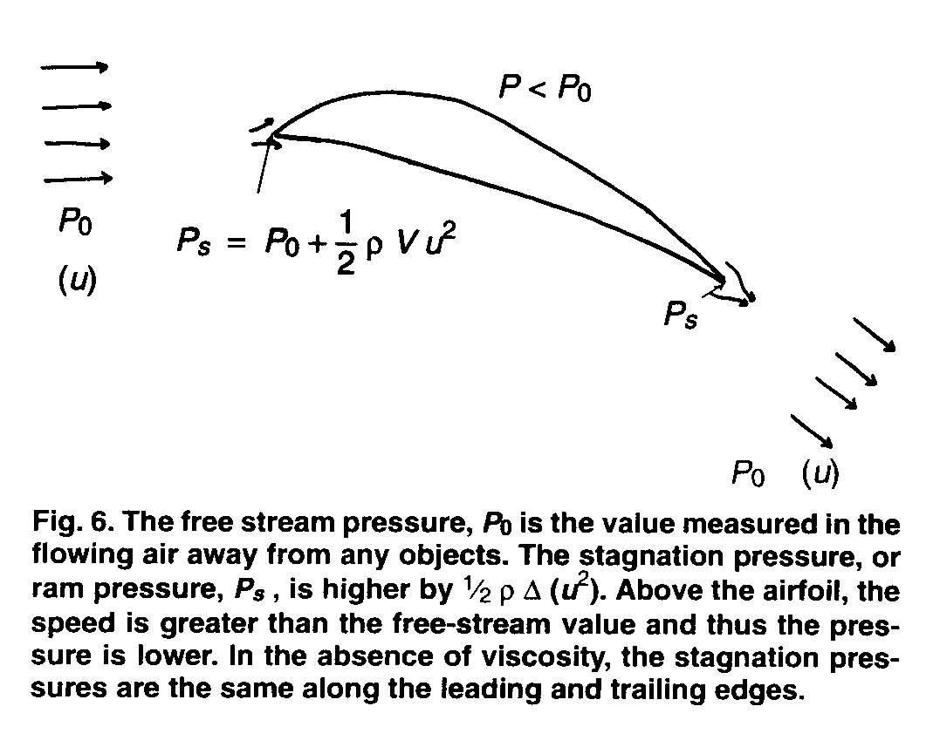
The difference in problems is that the piston problem assumes total reflection of incident molecules, which is a markedly different condition than streamline flow about the object. However, air is not without viscosity, so observed pressures at the rear stagnation point are less than predicted, and wings and Pilot tubes do exhibit drag.

We have left open the question of why there is a lower pressure for the fluid when it is moving faster. The answer lies primarily in recognizing the question as having been asked incorrectly. There is no reason that the pressure of even a static system need be constant. However, if there is a difference in pressure, the unbalanced force produces an acceleration. If you step on a grape, the grape juice accelerates and thereby lowers its pressure; the higher speed is thus associated with a lower pressure. There is no change in the internal energy of the liquid, hence no conversion from one form of motion to another.

Similarly, if a moving fluid element is to be brought to rest, an opposing pressure gradient is required. For non-viscous flow (no loss of kinetic energy along the way), the problem is symmetric with respect to acceleration and deceleration. The starting pressure difference and stopping pressure difference have the same magnitude.

Measured Properties of a Moving Fluid
It is obvious that Bernoulli's equation is based on an anisotropic velocity distribution. It is less obvious what effect this anisotropy has on the definitions and measurement of thermodynamic functions including temperature and pressure. The effects can be explored by considering a change of reference frame.

The Bernoulli effect can be observed equally well with an object (such as an airplane wing) moving through stationary air or with a stationary object in flowing air. For example, blowing on the edge of a newspaper is a well-known method of separating pages. The flow around the outside lowers the pressure relative to the residual air between the sheets. The two cases are illustrated in Fig. 7. In Fig. 7a, air flows along the z axis relative to the stationary thin, hollow sheet, or the separating pages. In Fig. 7b, the same thin, hollow sheet moves parallel to the z axis through stationary air. By the principle of relativity we know there can be no difference in observable effects. The reduced pressure that causes the stationary hollow sheet in Fig. 7a to bulge outward (or causes the newspaper pages to separate) must also cause the same sheet, moving through stationary air, to bulge outward in Fig. 7b.

If the flow of air past the wing causes a reduced air pressure, can it be that motion of the surface past the gas molecules reduces the pressure exerted by those molecules on the surface? That would be a surprising result. Of course there is no such effect. The examples are more obvious if we look at the value of P_{s} in each case.

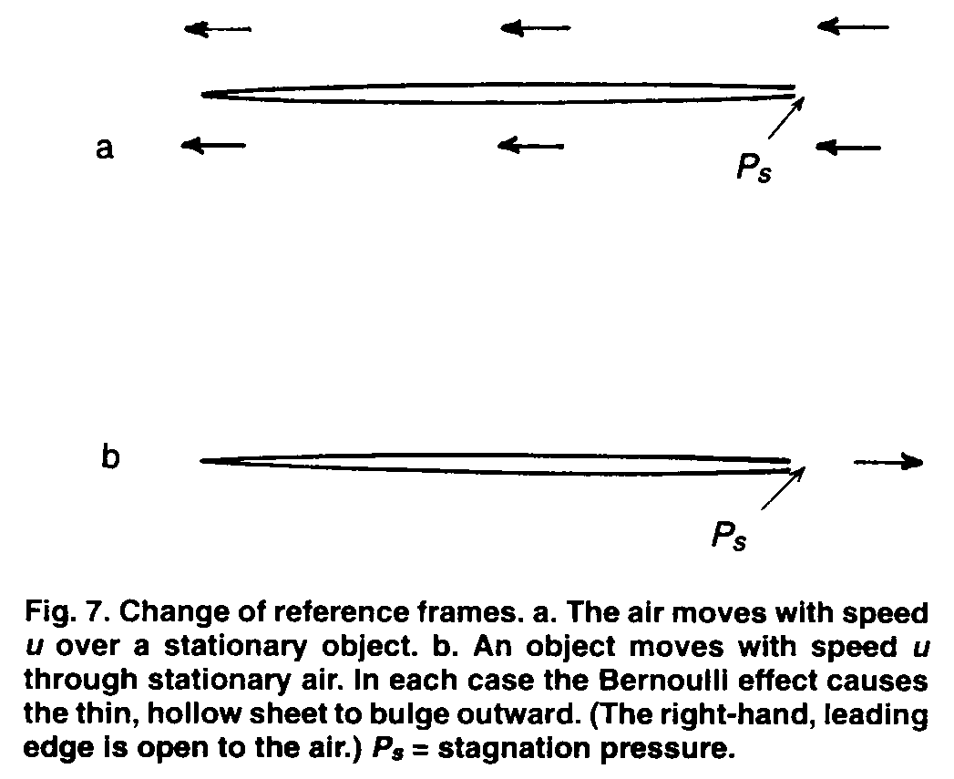
When the air is moving, the thin obstacle produces a stagnation point at the leading edge, which raises the pressure at that point relative to the pressure of the flowing gas. For ideal flow, P_{s} is equal to the pressure of the stationary air at the source; it was necessary to raise the pressure of the stationary air, relative to ambient pressure, to set the air in motion, and in Fig. 7a is equal to that higher pressure.

The argument is somewhat different in Fig. 7b, although the observable pressure differences are necessarily the same. As the thin object moves to the right, it carries air before it. It must compress this air, exerting a force on it to accelerate it to the speed of the object. The calculated and observed pressure differences are the same in 7a and 7b, but the value of , which is the pressure of "static" air, differs by the energy density difference associated with change of reference frames, .

If the object in Fig. 7 were somewhat thicker, there would be an additional effect, one that is associated with the airfoils. The speed of the air would change as it moved across the surface. We have ignored this complication here by assuming the object is very thin.

The examples of Fig. 7 are important in illustrating that the anisotropic velocity distribution in Fig. 7a may be readily transformed to the isotropic distribution of Fig. 7b, for which the thermodynamic properties are well defined, without changing the magnitude of the Bernoulli effect. Having determined E, T, P, and S, for example, for the stationary gas, we know that E will increase by when we transform to a reference frame moving at speed u relative to the original frame, but the internal properties, E_{internal}, T, P, and S, are unchanged by the change of reference frames.
It follows that to measure P in a flowing system we may either use a surface parallel to the motion, as in Fig. 7a, or use a surface perpendicular to the flow velocity that is moving with the flow at the same speed. That is, we put our barometer into Fig. 7b at rest in the air, and then keep it at rest with respect to the air (and thus in motion relative to the object) when we transform to Fig. 7a, if the pressure-sensitive surface is not parallel to the flow.

We saw in Fig. 4 that the pressure drop is greater for an adiabatic expansion than it would be for a (hypothetical) flow of the gas that is isothermal. However, it is not as great for adiabatic flow of the ideal gas as it would be for an incompressible fluid for the same change in speed of the fluid.
This result appears counterintuitive, for the gas is expanding. For a given value of A (PV), an increase in volume would seem to imply a compensating decrease in pressure.

The answer lies in the difference in meaning for pressure of gases as compared with condensed phases. Pressure measured for an incompressible substance (hence condensed) is entirely externally generated. Although there is a quantity called internal pressure, it does not affect a pressure gauge. As the external pressure is relieved for an escaping liquid, the pressure on the liquid can approach zero even at room temperature. Thus water is often reduced to a pressure below its vapor pressure by a rapidly moving propeller blade. This causes evaporation of water, producing gas pockets, or "cavitation," which may severely damage the blades.

In contrast, pressure measured for a gas is the internal pressure. It cannot fall to zero unless volume becomes infinite or temperature goes to zero (or below the condensation point).

Applications of Bernoulli's Equation
Although the phenomenology of Bernoulli's equation has been discussed many times, the conclusions have not always agreed. Smith has argued that Bernoulli's equation is not the appropriate description for lift on an airplane wing, apparently because the flow patterns over wings have so often been misrepresented in discussions of Bernoulli's equation and because there are additional considerations of turbulence and vortices that must be included in a detailed analysis.

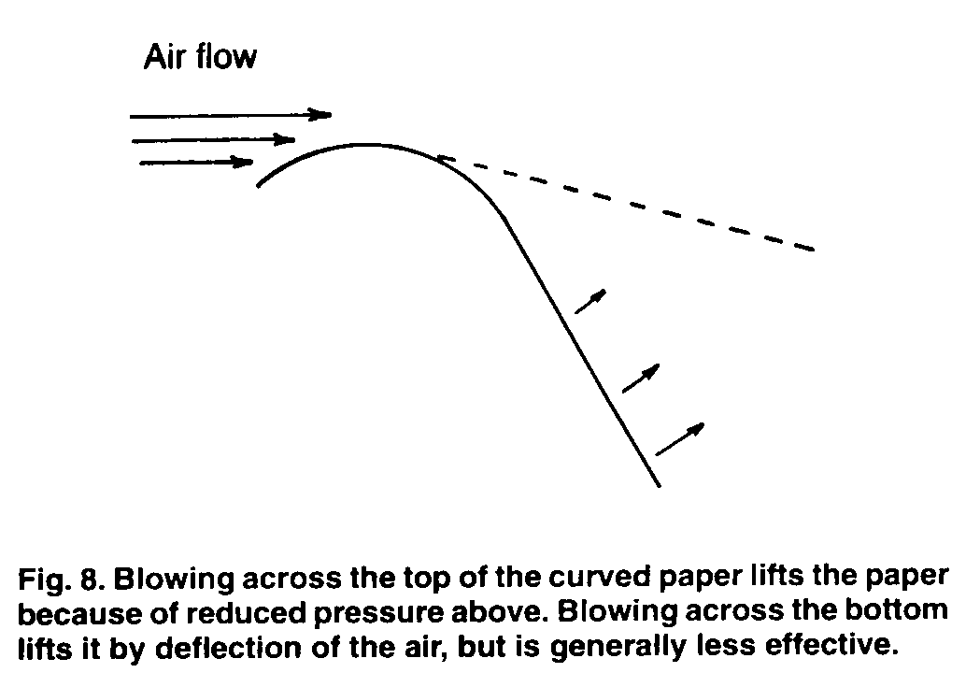
The relevance of Bernoulli's equation to lift is easily demonstrated in an experiment well known among teachers. Hold a sheet of paper with the edge horizontal such that the paper rises upward, away from the holder, then curves downward. Then blow across the top of the curved paper (Fig. 8) or, by raising it, blow against the lower surface. In one case, the lift that is readily observed is purely a consequence of the lower pressure across the top as given by Bernoulli's equation. In the second case, the lift is from the reflection of air from the lower surface. Although both cause the loose end of the paper to rise, it is usually found to be more effective to blow across the top rather than the bottom¹⁰.

In either case, the flow of air is no longer horizontal, but rather curves downward. In a steady-state flow, along each streamline the amount of air passing a plane perpendicular to the flow on the left must equal the amount of air leaving on the right and passing a plane perpendicular to the flow (Fig. 9). It is clear that the air traveling over the upper surface must travel farther. If we consider a wing passing through stationary air, the principal effect on the air is the downward thrust. To the approximation that this is the only net effect, the time required for passage over and under the wing is the same. The air above must therefore be traveling faster (relative to the wing) to keep up with the lower streamlines.
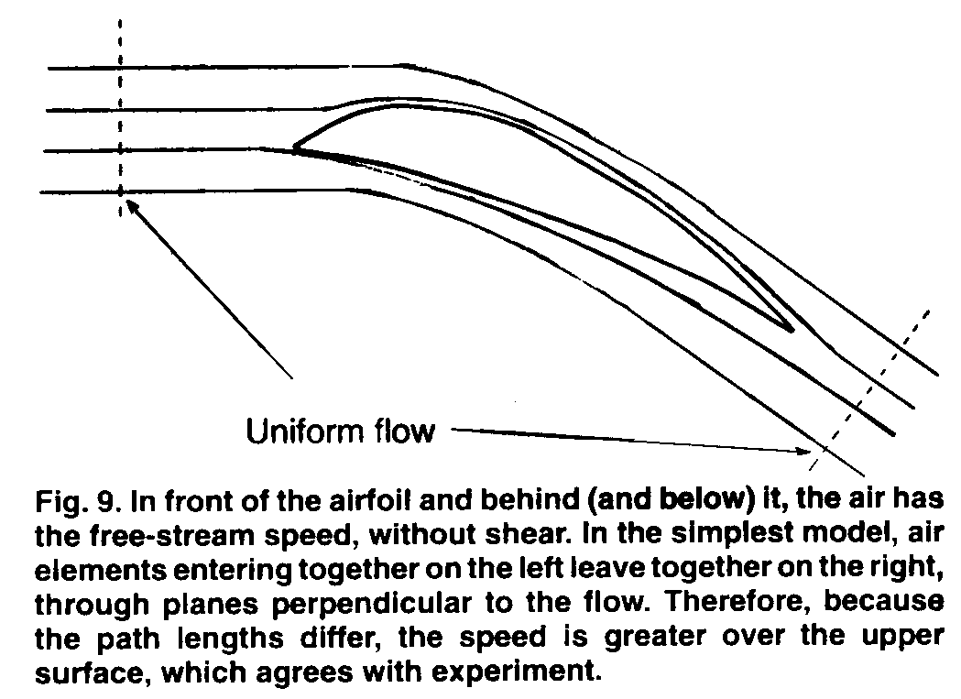
It is also important to recognize that the deflection of the air is downward, whether it is considered primarily because of the reflection of air from the lower surface or because of In contrast, pressure measured for a gas is the internal pressure. It cannot fall to zero unless volume becomes infinite or temperature goes to zero (or below the condensation point).

Applications of Bernoulli's Equation
Although the phenomenology of Bernoulli's equation has been discussed many times, the conclusions have not always agreed. Smith has argued that Bernoulli's equation is not the appropriate description for lift on an airplane wing, apparently because the flow patterns over wings have so often been misrepresented in discussions of Bernoulli's equation and because there are additional considerations of turbulence and vortices that must be included in a detailed analysis.

The relevance of Bernoulli's equation to lift is easily demonstrated in an experiment well known among teachers. Hold a sheet of paper with the edge horizontal such that the paper rises upward, away from the holder, then curves downward. Then blow across the top of the curved paper (Fig. 8) or, by raising it, blow against the lower surface. In one case, the lift that is readily observed is purely a consequence of the lower pressure across the top as given by Bernoulli's equation. In the second case, the lift is from the reflection of air from the lower surface. Although both cause the loose end of the paper to rise, it is usually found to be more effective to blow across the top rather than the bottom. ¹⁰

In either case, the flow of air is no longer horizontal, but rather curves downward. In a steady-state flow, along each streamline the amount of air passing a plane perpendicular to the flow on the left must equal the amount of air leaving on the right and passing a plane perpendicular to the flow (Fig. 9). It is clear that the air traveling over the upper surface must travel farther. If we consider a wing passing through stationary air, the principal effect on the air is the downward thrust. To the approximation that this is the only net effect, the time required for passage over and under the wing is the same. The air above must therefore be traveling faster (relative to the wing) to keep up with the lower streamlines.

It is also important to recognize that the deflection of the air is downward, whether it is considered primarily because of the reflection of air from the lower surface or because of
the bending of streamlines across the upper surface to follow the pressure gradients. This deflection of air downward indicates a downward force on the air, known to pilots as "down-wash," and known even to non-aviators as the downwash from helicopter blades (which are simply moving wings).

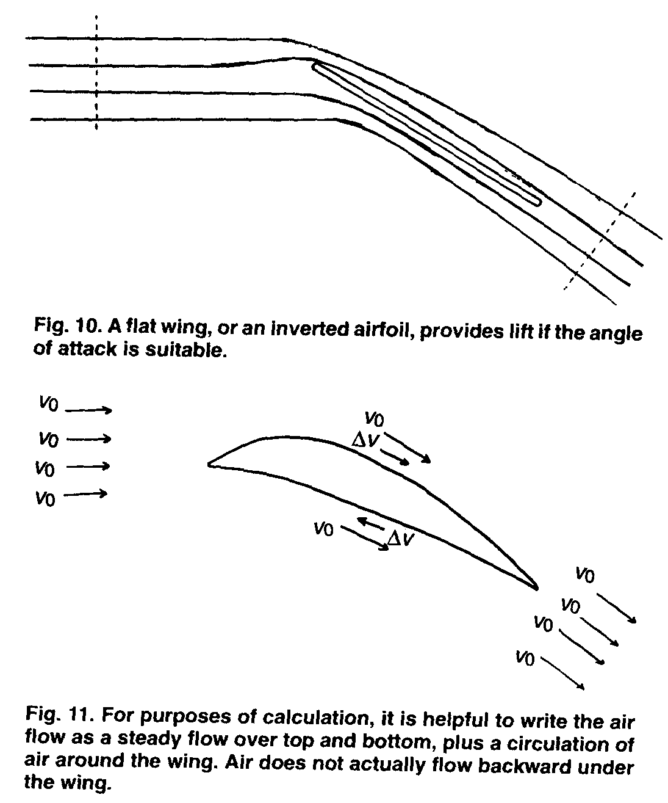
By Newton's third law, the force downward on the air must equal the force exerted upward by the air on the wing, which is called the lift on the wing. To eliminate Bernoulli's equation from this model, it would be necessary to postulate no difference in speed of air moving over the top of the wing and the bottom of the wing, which would be inconsistent with experiment.

More important, however, is that Bernoulli's equation does not represent any addition to Newton's laws. It is simply an application of Newton's laws, formulated in a manner that is easy to apply to moving fluids. Hence it cannot be separated from Newton's laws.

A recurring argument is that it is not necessary to have an airfoil shape to get lift on a wing, as shown also by the lift obtained on a wing when it is inverted. What is omitted in such arguments is that the angle of attack of a flat wing must be greater than that for a cambered wing. The air speed is then still greater on the high side of the wing, the air is pushed down, and the wing is pushed up (Fig. 10).

For mathematical convenience, aerodynamicists typically write the air flow across a wing in terms of an average air speed, for top plus bottom, plus an added flow on top and a decreased flow below. That is, the flow is considered as an average flow plus a "circulation," a circulatory flow of air passing forward over the upper surface and backward over the lower surface (Fig. 11). The mathematical fiction has apparently led to the common statement that one cannot explain lift in terms of irrotational flow. Of course for precise calculations of the performance of a wing, it is necessary to include the vortices that inevitably occur along edges and wing tips, but those effects are simply added to the primary lift.

A problem of particular interest in several parts of the world is the lift on a roof from winds passing over the roof. There appears to be a common perception that flat roofs are especially susceptible to this. Comparison with wing design, however, indicates that the greater the peak in the roof, the greater the lift for winds crossing perpendicular to the peak line. A remedy sometimes prescribed is to open the windows of the house, but it is easily seen that this can only be effective if the air flow through the house becomes an appreciable percentage of the speed of the hurricane winds, which would cause internal damage even if the roof remains in place.

Terminology
The terms in the Bernoulli equation have easily recognizable meanings. The pressure, P, is that measured with a pressure gauge; is a kinetic energy density of the flowing liquid; and , the hydrostatic pressure of the fluid produced by a column of height h, is also the potential energy density. (For gases moving over substantial height differences, it would be necessary to substitute the barometric equation to obtain the correct pressure difference.)

Badeer¹² has pointed out that there is a lack of clear terminology for describing components of the Bernoulli equation and the pressure values measured in its application. For example, he suggests that the P that appears in the equation, which must be measured with a gauge that is parallel to the flow (or moving with the flow) be called the lateral pressure, or tangential pressure. There seems to be merit in this, because it helps clarify the normal measurement.

The hydrostatic pressure, , exists for any value of the speed, including a static fluid, and does not depend on the motion, so the common label is appropriate and descriptive.

An alternative, gravitational pressure, would lead to confusion with the pressure arising in a star or other large fluid body because of the gravitational pull; this gravitational pressure, which is more akin to atmospheric pressure, is not equal to .

The other quantities that are regularly measured are often called the stagnation pressure, or rampressure, or sometimes impact pressure or total pressure. For non-viscous flow, the initial stagnation pressure (or driving pressure), the ram pressure (or leading-edge stagnation pressure), and the trail-ing-edge stagnation pressure are the same. For viscous flow, they differ. Thus with the possible exception of the ram pressure, it becomes necessary to identify which pressure is being measured.
A Pilot, or Prandtl, tube measures the difference between the ram pressure and the lateral pressure. This difference is sometimes called the dynamic pressure or kinetic pressure, although it would be more appropriate to call it a kinetic energy pressure drop, emphasizing it is a negative value, rather than a conversion of kinetic energy into a higher ram pressure. This pressure drop has also been called an accelerative pressure, but that is misleading because the quantity desired is evaluated at a point where there is, in general, no acceleration. Kinetic pressure is likely to suggest the pressure measured for the flowing liquid, for which lateral pressure seems better suited.

Badeer also has called attention to the need for a name for the pressure drop arising from viscosity. Again, it is a pressure decrease, rather than a positive contribution to the total pressure, so viscous flow pressure drop, viscous pressure drop, or energy density dissipation, would seem more appropriate than viscous flow pressure, which has been suggested. It is important to recognize that the expression gives the decrease in pressure as a function of length along the tube, rather than a measurable pressure at a point.

We should be particularly cautious about attempting to label each of the terms as pressures as if there were some total pressure, constant along the streamline, made up of component pressures that change in magnitude. That model is not helpful in visualizing the effects that take place in the flowing stream.

Conclusions
Bernoulli's equation

may be modified by including the effects of viscosity to give

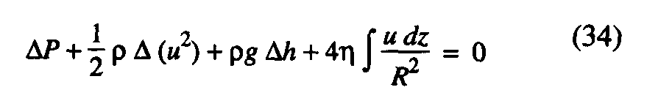
In either case, the equation is valid for non-turbulent flow, with no thermal energy transfer, either of an incompressible fluid or of a compressible fluid, provided the compressible fluid speed is less than 40% of the rms molecular velocity component along the direction of the flow.

Bernoulli's equation is an expression of Newton's laws, and therefore not distinguishable from Newton's laws. It is cast into a form that makes it convenient for fluid flow problems, including lift on airplane wings and the other demonstrations well known to physics teachers. It does not include effects of turbulence, or the deviations from the equation for incompressible flow at high speeds, which must be considered in careful airfoil design.

The important point is that teachers should feel comfortable with the standard explanations of lift on wing surfaces and other standard experiments (such as blowing touching pages apart). Bernoulli's equation does apply to these common demonstrations.

Appendix
The important equations and results for adiabatic flow of a fluid are summarized here.
- Horizontal flow (without viscosity) A. General

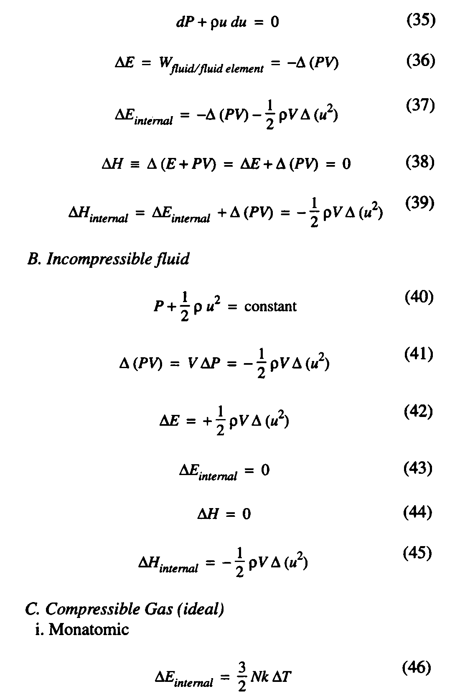
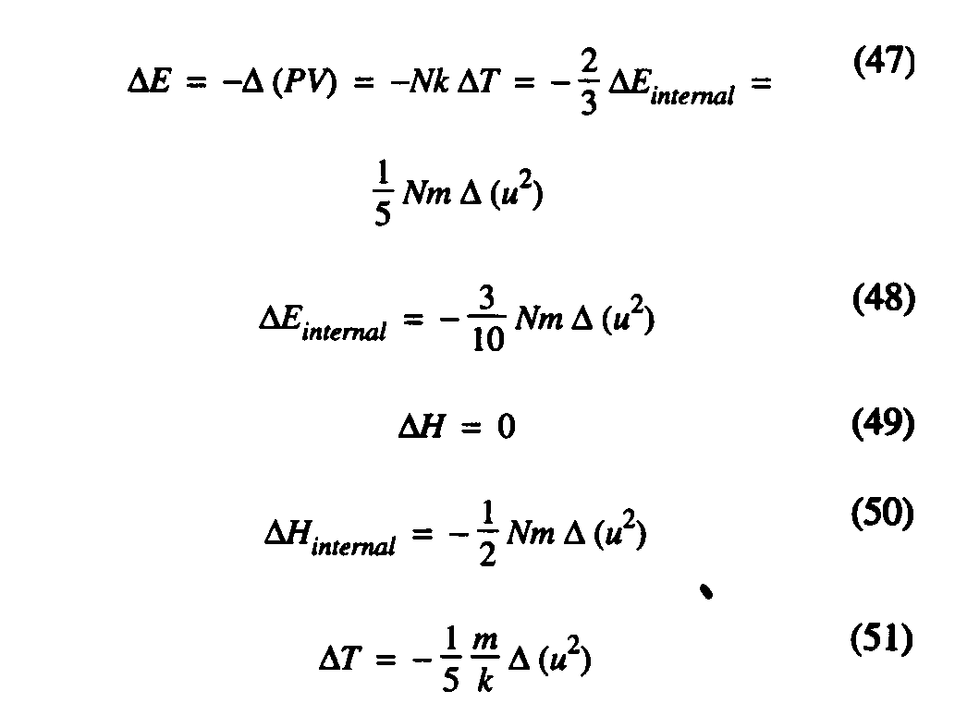
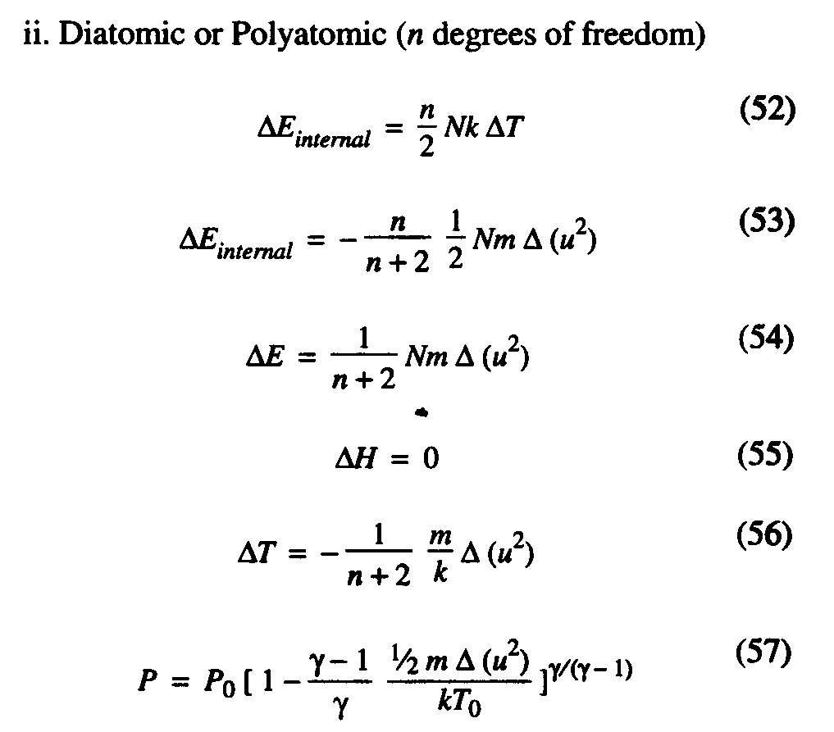
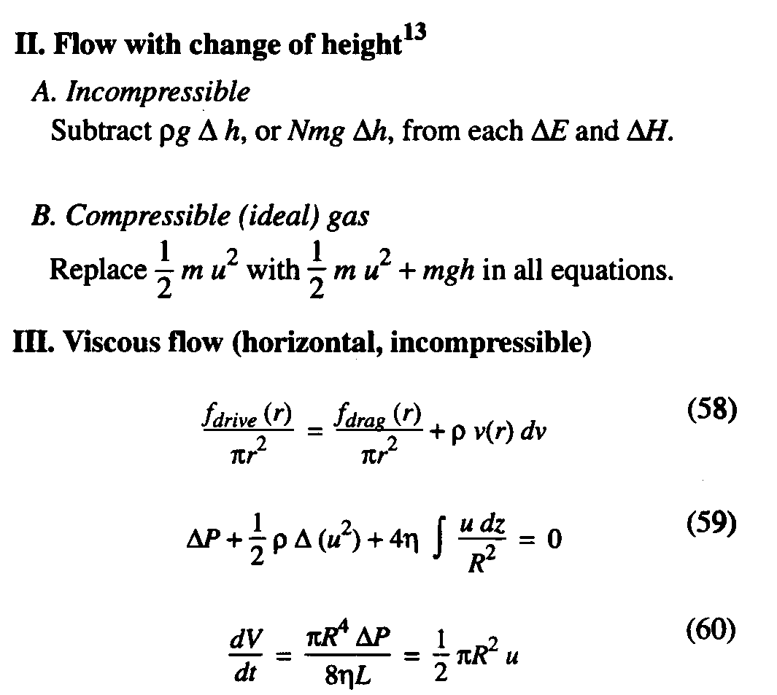

Please turn to the next page for the references.

References
1. See, among other sources, Arnold Sommerfield, Mechanics of Deformable Bodies, Lectures on Theoretical Physics, Vol. II (Academic Press, New York, 1964).
2. Robert P. Bauman, "Physics that textbook writers usually get wrong; II. Heat and Energy," Phys. Teach. 30, 353-356 (1992).
3. Robert P. Bauman, "Physics that textbook writers usually get wrong; I. Work," Phys. Teach. 30, 264-269 (1992).
4. Robert P. Bauman, Modern Thermodynamics with Statistical Mechanics (Macmillan, New York, 1992), pp. 144-154.
5. Henry S. Badeeer and Costas E. Synolakis, "The Bernoulli-Poiseuille equation," Phys. Teach. 27, 598-601 (1989).
6. Robert P. Bauman and Howard L. Cockerham, III, "Pressure of an ideal gas on a moving piston," Am. J. Phys. 37, 675-679 (1969). '
7. Barnes W. McCormick, Aerodynamics, Aeronautics, and Flight Mechanics (Wiley, New York, 1979), pp. 52-54.
8. It has been called to the authors' attention that Stephen Brusca has given a similar qualitative interpretation. S. Brusca, "Buttressing Bernoulli," Phys. Educ. 21, 14-18,262-263 (1986).
9. Norman F. Smith, "Bernoulli and Newton in fluid mechanics," Phys. Teach. 10,451-455 (1972). Smith makes the valid point that Bernoulli's equation does not replace Newton's laws, and that the same problems may be solved without Bernoulli's equation (just as classical orbit problems can be solved without the Lagrangian formulation of Newton's laws). Bernoulli's equation and its applications are applied Newtonian physics.
10. The relative importance of lift arising from the pressure drop across the top of a wing and the pressure increase on the bottom has long been recognized in aerodynamics. Lift occurs because of a pressure difference on upper and lower surfaces, which depends strongly on speed, as A(«²), rather than (A u)². Even at air speeds far below Mach 1 (e.g., 0.2), air above an airfoil may reach Mach 1. For a recent discussion of Bernoulli's equation and lift, see David Auerbach, "On the problem of explaining lift," Am. J. Phys. 56, 853 (1988).
11. McCormick, op. cit. pp. 44, 130.
12. Henry S. Badeer, loc. cit., and Phys. Teach. 32,426 (1994).
13. Expressions are for the fluid element only, rather than for the fluid plus gravitational field.

