Directions: Sketch your first, middle and last initials of your name. If you do not have a middle name, select a challenging letter for your middle initial.

Oblique
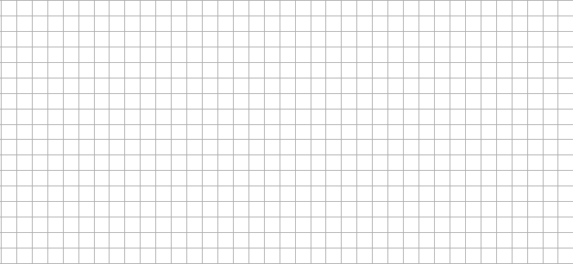

Isometric
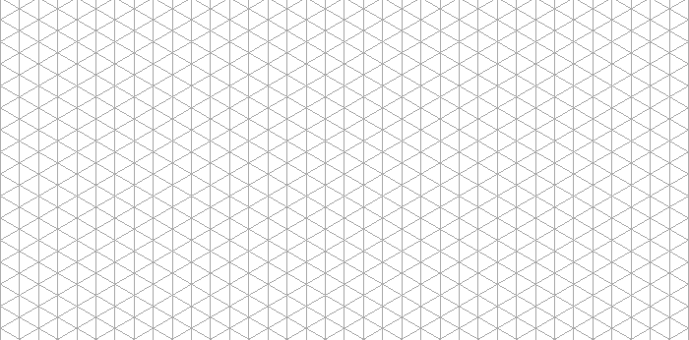
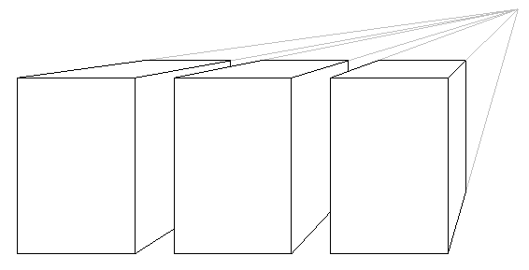
1 – Point Perspective

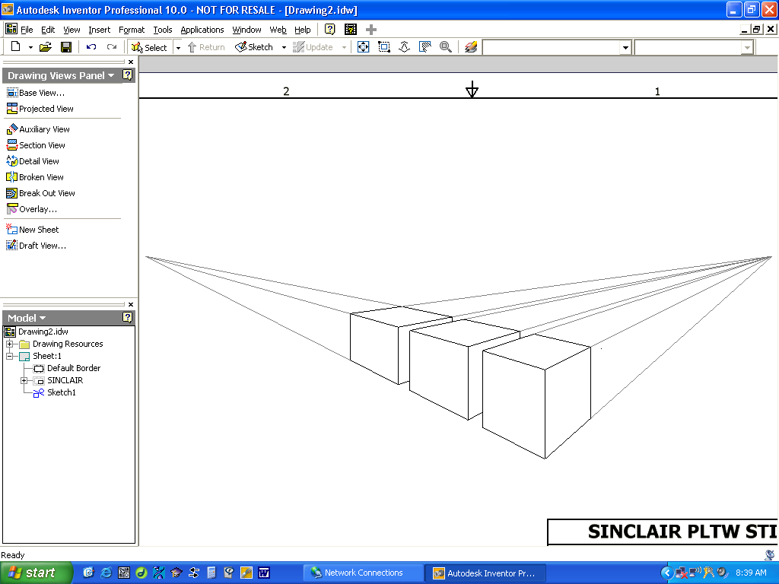
2 – Point Perspective

