Inertia – A Body in Motion
Objective:
In this experiment you will try to drop a tennis ball on a target as you run past the target. As you conduct this experiment, think of the challenges Air Force pilots had before the invention of the guided missiles that are used today. Pilots in World War II had to understand mathematics in order to drop bombs on targets while causing as little harm as possible to surrounding buildings and people. These are the same concepts that you will learn with this experiment.

Hypothesis:
Before you begin, try to guess what will happen. Try to figure out when you will need to release the ball in order to hit the target. Write down your predictions. Give the reasons why you think you are correct.
________________________________________________________________________________________________________________________________________________________________________________________________________________________________________________________________________________________________
________________________________________________________________________________________________________________________________________________________________________________________________________________________________________________________________________________________________

Materials:
• one tennis ball
• clearly-marked target(s), i.e., notebook paper, a chalk mark, or tape

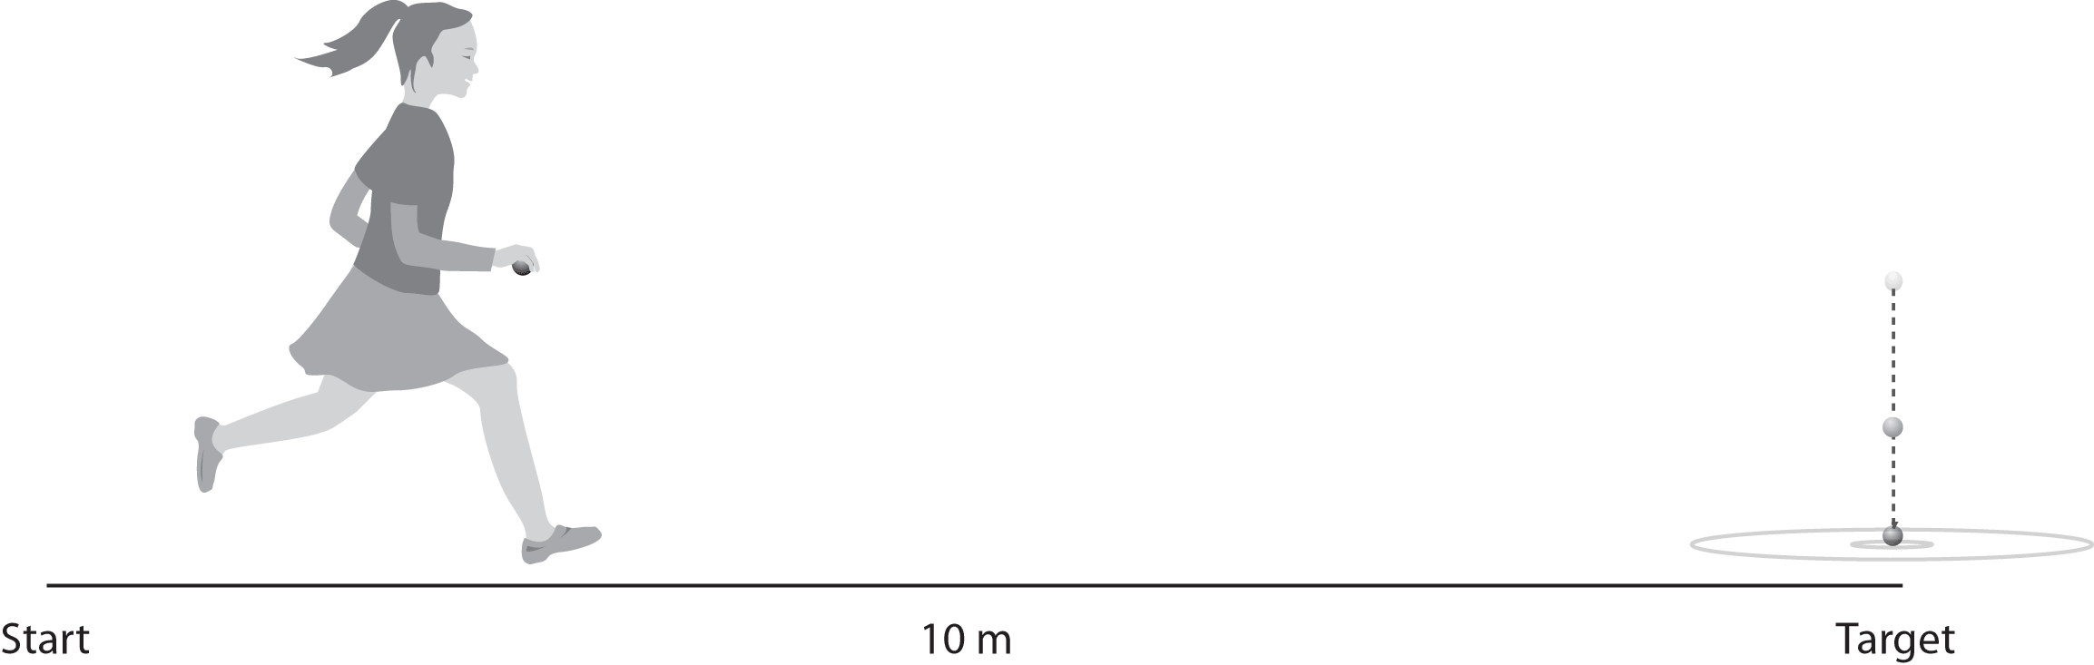

Procedure:
- Place a target 10 meters away from a starting line. Mark the starting line with chalk or tape.
- Hold the tennis ball and do not let your elbow leave your side as you run and drop the ball. Do not throw the ball. You should hold the ball from its sides so that you can release your grip as you let it drop. Remember to drop the ball and not throw it, otherwise you will change the intent of the experiment.
- Have your partner stand alongside (but slightly back from) the running path to act as an observer. Stand at the target so that you can see exactly where the runner rekleased the ball and where the ball strikes the ground. Ask the runner to sprint toward the target as fast as she or he can and try to drop the ball so that it lands on the target.
- Next, have the observer make a diagram of where the ball was released and where it landed. Repeat the experiment until the ball hits the target.
- Repeat Steps 2-4, sprinting at a slower speed.
- For the last trial, ask a student to walk toward the target. Repeat Steps 2-4.
- Write a summary of your results. Form conclusions based on the speed of the runner, the location of each ball’s release, and the exact point where each ball landed.

Diagrams:

Trial 1 – Sprinting

Trial 2 – Slower Sprint

Trial 3 - Walk

Conclusion:
Write a summary of your results. Form conclusions based on the speed of the runner, the location of each ball’s release, and the exact point where each ball landed.

